
LGA Consultation - Local government and legal responsibilities to act on climate change

https://www.local.gov.uk/about/campaigns/make-it-local/back-local-climate-action/local-government-and-legal-responsibilities

CSE ran an informal workshop with a dozen local authority partners with active climate programmes from the South West of England. Whilst all the local authorities we engaged with had declared a climate emergency, there was an overwhelming consensus that the lack of statutory duty and specific responsibilities to act on climate change was creating unnecessary uncertainty, inconsistency and insecurity.

In collating this response, we spoke to ten officers from seven local authorities:

- Bath and North East Somerset Council
- Bristol City Council
- Cheltenham Borough Council
- Dorset Council
- Gloucestershire County Council
- North Somerset Council
- South Gloucestershire Council
Contents
1. In a few words, please describe what one thing would assist your council to better lead climate action locally? 4
2.What do you consider to be the headline advantages of your suggestion in enabling local authority delivery? 4
3.What do you consider to be the risks of your suggestion in enabling local authority delivery? 4
4.What needs to be considered for your suggestion, for question 1, to be implemented effectively? 5
5.Assuming local government is provided required resources and wider support, what do you see as the key advantages and disadvantages of the following options 6 - 11? 5
6.A general duty, such as the current duty to ‘set the overall strategic direction and long-term vision for the economic, social and environmental well-being of a local area’. 6
7.A set of specific duties around individual responsibilities, such as the current duty to ‘enforce Minimum Energy Efficiency Standards’, this might be around plan making or retrofitting council housing. 6
Spatial Planning 7
Minimum Energy Efficiency legislation for private rented accommodation 7
Cold homes and Fuel Poverty 7
Local transport 8
Procurement and divestment 8
8.A set of specific duties around achieving targets or objectives, such as decarbonising the local government estate (scope 1), or deliver heat and buildings decarbonisation across an area (scope 2&3). 8
9.A set of specific duties around new tasks that contribute to the objectives; as an example, to create a local area energy plan, or to bring together local partners to develop an area-wide action plan. 9
10.Duties around reporting on progress, such as mandatory reporting of action taken to adapt to climate change, or to reduce emissions. 9
11.Integrating a responsibility to have regard to climate change into the existing statutory duties, for instance around transport, housing, energy, nature social care, either at a strategic planning level, or detailed delivery level. 9
12.Please state your preferred options / preferences from questions 6 - 11. 10
13.Related to statutory duties, would you like to see a greater level of statutory and non-statutory guidance for local authorities on tackling climate change? 10
14.How important is it that councils receive new burdens for any new statutory duty? What deliverables would be reasonable? 11
15.What do you see as the key advantages and risks of a statutory duty, where local authorities are under a legal requirement? 11
16.What do you see as the key advantages and disadvantages of outcomes frameworks, where local authorities are accountable to deliver outcomes from resources or powers? 11
17.What do you see as the key advantages and risks of agreement arrangements/contracts, where local authorities are accountable to deliver outputs or actions in return for resources or powers? 11
18.What do you see as the key advantages and risks of wider legal and regulatory requirements to the whole of society / economy, including local authorities e.g. requiring old gas boilers to be replaced with heat pumps or Future Homes and Building Standard impacting homes being built by councils? 12
19.Are there other options for bringing about further accountability? 12
20.What are the opportunities and challenges created by the English Devolution White paper in bringing forward new statutory duties on local government to act on climate change? 12
Climate mitigation 12
Climate adaptation 13
21.What are the opportunities and challenges created by the prospect of local government reform in bringing forward new statutory duties on local government to act on climate change? 13
22.What do you consider to be the best distribution of statutory duties across Strategic Authorities and constituent authorities? 14
23.Are there other public bodies that you think should have new duties to act on climate change? If so, which other public bodies and what might those duties look like? 14
24.How might a statutory duty requiring partnership working between public bodies be set out to be productive, work well and achieve success? 15
25.When should new statutory duties, and the associated reforms necessary for local authorities to deliver on those duties, be introduced? 15
26.What does local government need to help lead local climate action for mitigation? Please rank the following in order of importance 15
27.What does local government need to help lead local climate action for adaptation and resilience? Please rank the following in order of importance 15
28.What does local government need to help lead local climate action for nature restoration? Please rank the following in order of importance 16
29.Please use this space to make any other points you would like to make 16

1. In a few words, please describe what one thing would assist your council to better lead climate action locally?

The most prominent issue raised was that of resource and investment. All officers reported that their work was necessarily treated differently; sometimes a ‘nice to have’ rather than being core function as a result of not being seen as a statutory function. They reported a huge amount of uncertainty around funding climate posts and activities, as well as increased reliance on short-term competitive funding, increased politicisation and missed opportunities to fully integrate a longer-term climate perspective into local policies, investments and activities. It was clear therefore that the priority in leading climate mitigation, climate adaptation and nature restoration were resources and the certainty of funding. There was however a recognition that funding alone would not be enough.

2.What do you consider to be the headline advantages of your suggestion in enabling local authority delivery?

A Mandate.

The provision of a statutory duty to address climate mitigation and adaptation, with specific requirements and funding would provide political neutrality and certainty for both the work and accompanying climate officer roles.

Imposing a statutory duty would allow more justification for local authorities around spending/resource, but the funding should come from central government rather than from council tax. Progressing work without resources and funding is very difficult, e.g. schools have a new duty to create a climate action plan, but without additional funding there’s been little new activity.

With clear annual transparent reporting requirements, a statutory duty would also provide accountability.

3.What do you consider to be the risks of your suggestion in enabling local authority delivery?

A key concern that council officers raised was whether authorities would be sufficiently funded to deliver the duty stating:

“It's important to realise that just because it’s a statutory duty, it doesn’t mean the work will get done.”
“Without sufficient funding and support, a duty could be used to blame local authorities for not delivering, rather than a tool to support with delivery.”

“Authorities must be funded and supported to act on any duty.”

The local authorities we engaged with raised concerns that depending on how the duty is worded, it could limit the ownership, ingenuity and aspirations of some councils. There’s currently lots of flexibility, and creativity in how councils address climate considerations, and the ability for councils to do what suits their strengths and capabilities as a team. There is a concern that the statutory duty will fail to acknowledge differences between councils and the communities they serve. Any duty therefore both needs to be a floor for less established councils that doesn’t create a ceiling for more established councils and give local authorities freedom to operate in way that draws on local needs, strengths and opportunities.
In this context, we support the proposal, set out in the National Procurement Policy Statement to introduce a new public interest test for contracting authorities to assess whether work should be outsourced or if it could be done more effectively, and drive better value for money, in-house. Councils should adopt this principle when planning their climate programmes.

4.What needs to be considered for your suggestion, for question 1, to be implemented effectively?

Alongside increased investment and resource provision, the clarity of the mandate that a statutory duty could provide is crucial. It would provide a long overdue recognition of the vital role that we need all local authorities to play.

To make best use the funding and resources there would also need to be a clearer and more strategic centrally coordinated approach to learning (building on what has been done and learnt by pioneering authorities rather than trying to reinvent the wheel); officer training, recruitment and development (to reduce turnover and dependency on external actors and to increase the ability of officers to procure astutely); to develop shared tools and resources and create economies scale for the products and services that all local authorities require (for activities such local area energy planning).
As important as the funding itself, is the way it is made available to local authorities. It would be important that funding was made available on the basis of outcomes for local areas (rather than outputs for central government), was predictable and complimentary to local funding from other central government departments.

The consensus of opinions on options 6-11 was for a specific set of duties, pulling together existing relevant council responsibilities together with emerging policy areas. Government should also develop a dataset of national indicators for government to report back on with standardised reporting and benchmarking. Reporting should happen annually and be made public.

5.Assuming local government is provided required resources and wider support, what do you see as the key advantages and disadvantages of the following options 6 - 11?
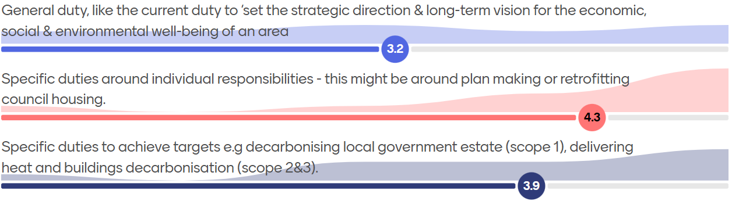
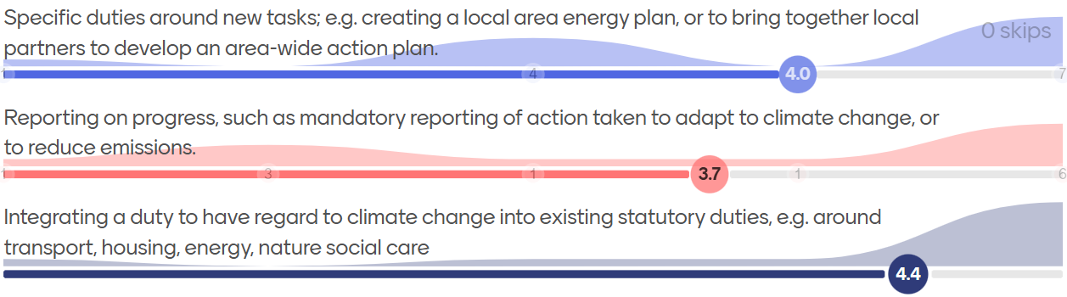

6.A general duty, such as the current duty to ‘set the overall strategic direction and long-term vision for the economic, social and environmental well-being of a local area’.

There is a need for a general duty as this will provide the necessary mandate for councils to take a lead role as a key actor on climate change. However, the councils we spoke to raised concerns about a general duty, which could be seen as insufficient: easy to work around and difficult to enforce. This option received the least support out of all the six options put forward.

One local authority commented:

“We wouldn’t want a general duty that’s just waffle, we want a national indicator dataset.”
One of the councils we engaged with raised concerns that a weak duty with few resources might result in councils retreating to that level of engagement.

We agree. We doubt that a general duty would change how local authorities operate on its own. It is unlikely that local authorities with no active climate mitigation or adaptation programmes at present would accelerate action were such a duty to be introduced in isolation from more specific duties.
We would like to highlight comments in the independent review of net zero that “given their role as place-makers rather than simply as service delivery partners, tackling climate change should be an integral purpose of local authorities, and part of their future role and responsibilities.”

In this context an overarching duty requiring local authorities to address climate change mitigation and adaptation in accordance with central government commitments would be helpful. However, to ensure that action takes place, it should be complemented with specific duties and minimum outputs which have to be reported on.

7.A set of specific duties around individual responsibilities, such as the current duty to ‘enforce Minimum Energy Efficiency Standards’, this might be around plan making or retrofitting council housing.

The councils we spoke to were most supportive of this option. There’s a range of powers and duties already in place which are not fully used or exploited:

Spatial Planning
The spatial planning system has a huge potential role to play in mitigating and adapting to climate change, providing a democratic way of planning and co-ordinating land use in the UK in the medium to long-term. It is the only regulatory system capable of addressing the spatial components of climate mitigation and adaptation and nearly all development passes through the planning system in one way or another. It offers a key opportunity to disaggregate our national carbon budget to local areas.
At present there is no direct connection between the thousands of planning decisions and hundreds of plans in England and our legislated carbon budgets and the Climate Change Committee’s latest climate change adaptation report reveals insufficient progress in ensuring the planning system prioritises climate resilience.
Therefore, in addition to any other climate duty, we would support a specific duty requiring local planning authorities to have special regard to the mitigation of, and adaptation to, climate change in preparing plans and making decisions. The full text of the recommended duty has been put forward as an amendment to the planning and infrastructure bill by the Climate Change Working Group of the Better Planning Coalition.
In the absence of national standards, and in advance of the Future Homes Standard, many local planning authorities are using their powers under the Planning and Energy Act 2008 to create binding zero carbon standards for new development. Where development is viable, they should be supported in doing so.

Minimum Energy Efficiency legislation for private rented accommodation

The minimum energy efficiency standards for privately rented homes set a minimum standard of EPC E for private rented accommodation and empower local authorities to enforce these standards, issue compliance notices and impose financial penalties. A recent consultation proposes to tighten these standards to EPC C. But local authorities lack funding to enforce this regime and standard implementation approaches. Analysis from MCS suggests that only 39% of authorities are proactively enforcing the standards, with 25% not enforcing the standards at all, leaving tenants with no way of ensuring that their home meets the required standard. We would support a tighter duty requiring local authorities to enforce these standards, with funding and support from central government to do so.

Cold homes and Fuel Poverty

Vulnerable people are particularly susceptible to the impacts of living in a cold home. Cold homes have been shown to cost the NHS at least £1.5Bn every year. By insulating the homes of vulnerable people, we can reduce carbon emissions whilst delivering the co-benefits of affordable warmth. NICE has published guidance calling for local single‑point‑of‑contact health and housing referral services and there is potential to integrate such provision within the Warm Homes Plan.
Local authorities also have a statutory duty to use the Housing Health and Safety Rating System (HHSRS) to assesses housing standards. Damp and mould and cold are both category one hazards which are deemed to pose serious and immediate risk to a person's health and safety. But local authorities lack the resources to fully utilise the HHSRS to tackle cold homes.

Vulnerable households are also at risk from extreme weather events arising from climate change, both in their physical resilience to heat waves for example, and in their ability to recover from events such as floods.

As such councils have a key role to play in enabling home energy retrofit locally, particularly focused on the most vulnerable households and tackling the associated health risks from cold homes and extreme weather.

Local transport

Local authorities are in the best position to support local transport decarbonisation through their management of local transport networks, public places, traffic regulation and ability to shape places around active, zero carbon travel.

We are not qualified to advise on whether a specific duty should be developed for councils in respect of transport decarbonisation, and we suspect that further funding and support would be needed to support councils going further. Our perception is that the strategy for transport emission reduction is weighted towards the take-up of EVs rather than a modal shift to walking, cycling and public transport. The latter would be more equitable, lower carbon, wider co-benefits (e.g. health and wellbeing outcomes) and have less impact on our electricity distribution system.

Procurement and divestment

There are huge opportunities for local authorities to achieve emission reductions through their supply chains and procurement approaches (e.g. using social value). Carbon credits associated with offsetting from new developments or major capital works could also be used to deliver emissions reductions.

8.A set of specific duties around achieving targets or objectives, such as decarbonising the local government estate (scope 1), or deliver heat and buildings decarbonisation across an area (scope 2&3).

This option received mixed support from the councils we spoke to i.e. ranging from low to high scores.

Those that raised concerns felt that the proposed duty for councils to deliver heat and buildings decarbonisation (scope 2 and 3) is not well defined. Duties to aid heat decarbonisation are already covered in part by the emerging heat network zoning regime and would not need further legislation or duties.

There is a significant opportunity for local authorities to support building decarbonisation, and for councils to fund local one stop shops providing householders with trusted advice on retrofitting their homes and supply chain support. We believe however that there is scope to do this through the Warm Homes Plan and through strategic authorities, which are proposed to have a role in the devolution white paper. We believe that one stop shops would be an effective way of supporting the retrofit sector and increasing retrofit rates amongst the able to pay market. Support and funding to set up these services would be as important as a duty in achieving this.

It would be positive to encourage councils to decarbonise their estates, albeit only a tiny proportion of the emissions reductions we need.

9.A set of specific duties around new tasks that contribute to the objectives; as an example, to create a local area energy plan, or to bring together local partners to develop an area-wide action plan.

This received moderate support and came third in the ranking of duties, however there was little clarity as to what new duties should be put in place.

There is clear potential for all local authorities to support and inform Regional Energy Spatial Plans and / or undertake their own Local Area Energy Plans (LAEP). Our view however is that more helpful than a duty to draft and engage with these plans would be capacity support, training and funding to do so, plus support to turn LAEPs into deliverable projects.

There is huge potential for local authorities to use their convening power to support area wide action planning around energy. For example, in South Kensington London, a group of 22 institutions is looking at collective area-based responses to the climate crisis, including biodiversity enhancement, sustainable transport initiatives and energy initiatives such as district heating and cooling and renewable energy. This small geographical area includes significant civic uses like the Natural History Museum, Science Museum, the Victoria and Albert Museum, Royal Albert Hall, Imperial College London. This constellation of significant civic uses is likely to be unique, but there is nevertheless clear potential in some circumstances for local authorities to act as convening bodies to support area-based initiatives.

10.Duties around reporting on progress, such as mandatory reporting of action taken to adapt to climate change, or to reduce emissions.

CSE would support councils having mandatory duties to report progress against a nationally defined dataset of indicators, which should be co-created in association with local authorities to avoid unintended outcomes. Agreed definitions and methodologies should be created to support and simplify reporting. Whilst we think that reporting is important to recognise and report successes and reveal action (or the lack of it), it should be proportionate and be secondary to taking action.

In the context of transport decarbonisation where the least progress is being made, one council officer advised that having to report on progress might facilitate and catalyse more difficult conversations that need to happen.

11.Integrating a responsibility to have regard to climate change into the existing statutory duties, for instance around transport, housing, energy, nature social care, either at a strategic planning level, or detailed delivery level.

Of all the options this received the most support from the councils we spoke to.
As discussed in response to questions 6 and 7, through their close relationship with the public and the many services they provide, councils are in a unique position to address climate mitigation and adaptation and add to national efforts. It is vital therefore to integrate a duty to contribute to climate change mitigation and adaptation across all council services. Further detail is given in response to question 7.

12.Please state your preferred options / preferences from questions 6 - 11.

Of the councils we spoke to, there was a clear consensus in favour of local authorities having a climate duty. This duty would help protect existing resources and depoliticise future conversations about council priorities. However, as noted throughout no new duties can come without additional resource to support it.

Local authorities have huge potential to support and undertake climate action both through their existing statutory duties and new emerging areas of work. Given the irrefutable science of climate change and the broadening and deepening impacts, we do not see how in the medium term, councils can competently provide services without integrating climate considerations across their work. Furthermore, local authorities have great potential to fulfil a convening role, supporting communities to take climate action themselves.

Overall, we think a statutory duty is vital to safeguard climate functions and roles within councils.
We would support:
- A general duty to address and integrate climate resilience (spanning mitigation and adaptation) in accordance with our national commitments across all council activities and responsibilities, and
- Specific sets of duties, integrating climate change into existing statutory duties - such as spatial planning, public health, transport and a stronger duty to enforce MEES, together with emerging policy areas, and
- Standardised reporting and benchmarking approaches with a dataset of national indicators to report back on, co-created with local government.
- The Government examining existing reporting best practice before publishing their own methodology. Several of the local authorities we spoke to are already developing methodologies that enable them to report on progress on a yearly basis.
However, as can be seen from our response, there is a balance to be struck between setting minimum requirements all councils should meet, whilst allowing the flexibility and creativity for local authorities to plan actions which are locally relevant and impactful with their constituents. It’s key that if a statutory duty is created, it should create a floor rather than a ceiling on ambition.

13.Related to statutory duties, would you like to see a greater level of statutory and non-statutory guidance for local authorities on tackling climate change?

The councils we spoke to wished for more guidance in the following areas:

- Assessing transport schemes - we assume in terms of their carbon impact
- Central consistent tools and methodologies
- Energy planning and support engaging with the emerging Regional Energy Spatial Plans
- Clarify roles with National Energy System Operator
- Clarifying reporting scopes
- Planning and integrated transport planning
As detailed in our study for the Climate Change Committee, there is a long-standing need for reliable carbon auditing methodologies, clearer policy and guidance from government to ensure local plans and significant development proposals are in alignment with the climate change act, and that councils understand how to assess the carbon impacts of new development proposals.

14.How important is it that councils receive new burdens for any new statutory duty? What deliverables would be reasonable?

It’s clear that council’s do not feel able to take on any additional duties (or burdens) without the appropriate level of additional resource. As such it’s impossible to comment on what are reasonable deliverables.

15.What do you see as the key advantages and risks of a statutory duty, where local authorities are under a legal requirement?

Most councils we spoke to supported the principle of a statutory climate duty as a way of de-politicising climate action. In the words of a participant at our workshop:

“There are councils where climate work is like a ‘ping pong’ between parties, with almost no certainty. A statutory duty would make it difficult for politicians to scrap large pieces of work and get rid of climate posts… however, there is a risk that without support and funding, a statutory duty could be used to blame local authorities for not delivering, rather than a tool to support with delivery.”

16.What do you see as the key advantages and disadvantages of outcomes frameworks, where local authorities are accountable to deliver outcomes from resources or powers?

We raise concerns about local authorities being contractually obligated to deliver specific levels of emission reduction, particularly where they do not have many of the levers necessary to deliver those, for example in respect of Scope 3 emissions. Such an approach might militate against greater ambition rather than encourage it.

Furthermore, due to the resource disparities between large unitary urban authorities and small rural authorities, and existing competitive funding processes, we already see a gap between the ambition and capacities of the leading authorities and those struggling to catch up. Any climate duty should seek to narrow this gap.

17.What do you see as the key advantages and risks of agreement arrangements/contracts, where local authorities are accountable to deliver outputs or actions in return for resources or powers?

We support this approach, though as discussed above in relation to question 16, duties and funding should support more local authorities to act, not gatekeep funding to those authorities who already have active and diverse climate programmes.

18.What do you see as the key advantages and risks of wider legal and regulatory requirements to the whole of society / economy, including local authorities e.g. requiring old gas boilers to be replaced with heat pumps or Future Homes and Building Standard impacting homes being built by councils?
Local authorities have many opportunities to address climate mitigation and adaptation. Given broadening and deepening climate impacts, we do not see how in the medium term, councils can competently provide services without integrating climate considerations across their work. Through their close relationship with civic society including parish councils, they are also in a unique position to support community action, both in terms of climate mitigation and adaptation. We also agree that through the Warm Homes Plan and their local plans, councils can support the rollout of air source heat pumps in existing homes and the full decarbonisation of new homes.

However, any duty should be realistic about the emissions reductions local authorities can guarantee delivering.

19.Are there other options for bringing about further accountability?

20.What are the opportunities and challenges created by the English Devolution White paper in bringing forward new statutory duties on local government to act on climate change?

Climate mitigation

The devolution white paper offers key opportunities in addressing climate change. Under the new system, strategic authorities and mayors will have a role in many aspects of decarbonisation, with responsibilities to control retrofit funding, a strategic role in the delivery of the Great British Energy Local Power Plans plus heat network zoning and leading Local Nature Recovery Strategies. The new strategic authorities and mayors therefore have an opportunity to bring together different aspects of decarbonisation under one roof, opening the potential for a wholistic approach. Strategic authorities also have the potential to offer rural authorities the economies of scale they currently lack, and which many large unitary or city authorities already possess and to address existing policy barriers.

However, council officers raise concerns about delivery:

“It’s really difficult to think about the alignment of multiple strategies across areas, we’re likely to be thinking about this for years to come.”

A key risk arising from the proposed creation of strategic authorities is a possible loss of manpower and resource from local authorities. We’re concerned that with the creation of strategic authorities, impetus could be lost in local authorities. Strategic authorities might disregard existing work done to date by local authorities and the change could result in a loss of institutional knowledge. We support the introduction of a duty to ensure that the valuable work done by local authorities continues.

Climate adaptation
CSE sees a major opportunity for strategic authorities to address adaptation on a regional basis. Research that we undertook for the Climate Change Committee with the TCPA showed that individual local planning authorities lacked the geographical scope to address adaptation issues around water management at catchment scale and in extreme situations the planned relocation of communities in areas of critical flood risk or coastal erosion, as discussed in this quote from a representative from a local authority:

“We can see that within the next 200 to 300 years some settlements may have to be abandoned. Then it has to be a national programme of investment in infrastructure to enable that to happen, because it cannot be done at the district or even county level, you just couldn’t do it.”

Whilst the planning system has tools to manage flood risk in existing settlements, it currently lacks the capacity to relocate these settlements, resulting in residents of affected communities like Fairbourne in South Wales (which from 2054 is no longer likely to be flood defended and may be de-commissioned) suffering from long term planning blight. The planned relocation of communities like this, and other communities on the east coast would be likely to require a regional approach with cooperation from multiple local authorities. Where this is necessary, there is significant potential for strategic authorities to offer a framework for this work and for the potential creation of new planning delivery tools such as Resilience Development Corporations.

21.What are the opportunities and challenges created by the prospect of local government reform in bringing forward new statutory duties on local government to act on climate change?

Local government reform, in particular the amalgamation of two-tier authorities into unitary authorities offers significant opportunities in terms of addressing climate mitigation and adaptation, offering greater critical mass to act and bringing together all local government functions into one council body. Council officers had experienced problems in two-tier local authorities where responsibilities are not allocated. For instance, a district council left tackling transport emissions that they cannot action (because the county council is the responsible transport authority).

Council officers spoke of the potential to integrate green skills into local growth funding, of more strategic approaches to farm diversification and land use change through spatial development strategies and of the potential to integrate the outputs of Local Area Energy Plans and Regional Energy Spatial Plans into strategic development plans.

22.What do you consider to be the best distribution of statutory duties across Strategic Authorities and constituent authorities?

CSE undertakes a substantial amount of work for local authorities, as a client or a delivery partner. We’re unsure of the complete distribution of statutory duties across strategic authorities and local authorities but would make the following comments about the potential roles of each. It would be beneficial for both strategic and local authorities to have a consistent overall duty in respect of climate mitigation and adaptation. It would be regrettable if the creation of strategic authorities led local authorities to stop their work on climate mitigation and adaptation.

Strategic authorities have great potential to address issues which span authority boundaries and where combined approaches from multiple authorities would be beneficial or more cost effective, for example:
- Facilitating engagement of constituent local authority partners with Regional Energy Spatial Plans.
- Regional adaptation strategies and boards covering catchment scale water management (i.e. based around the geography of river and water catchments) and in extreme cases resilience development corporations to enable the planned relocation of communities which must be abandoned because of flooding or sea level rise, such as Fairbourne in Wales.
- Supporting their host local authorities to create binding zero carbon standards and create the supporting evidence. Frequently local authorities combine expertise and resources to create these policies.
There is as yet little clarity around the content of development strategies that strategic authorities will be tasked with writing, however at present local authorities have the clearest opportunity to fully integrate climate mitigation and adaptation into their planning processes, ensuring that their local plans (and any planning decisions they make) are compatible with our climate budgets.

23.Are there other public bodies that you think should have new duties to act on climate change? If so, which other public bodies and what might those duties look like?
Local authorities are conveners and enablers of partnerships in places, and the response to climate change demands whole system change and partnership. Therefore, we would be interested in the potential role for new statutory duties on climate change on other public sector partners, and how they may interrelate with new duties on local authorities.

Given that global emissions are still increasing and the Paris Climate Accord target of 1.5 degrees of warming is now in severe doubt, climate impacts can be expected to worsen in severity and become more common. Successive or overlapping climate events (for example a prolonged drought followed by unprecedented rainfall resulting in flash floods; or drought followed by a heat dome raising fire risk) could result in worsened hazard levels, greater impacts and lessened resilience. It would be helpful for public bodies to work collaboratively to address these risks.

To our knowledge the most obvious public bodies, such as the NHS, Environment Agency and (via Ofgem) Distribution Network Operators already have statutory duties relating to climate adaptation and mitigation.

24.How might a statutory duty requiring partnership working between public bodies be set out to be productive, work well and achieve success?

We have doubts that a statutory duty for partnership working would be particularly effective. Since 2011, local planning authorities have had a statutory duty to cooperate in accommodating their housing requirements, however it has not been particularly effective, and the government now propose to repeal it. However, we agree that partnership working between local authorities and between local authorities and other service providers would be very helpful.

Our view is that strategic authorities offer a potential framework through cooperation and partnership working can occur, plus regional structures like Regional Energy Spatial Plans.

25.When should new statutory duties, and the associated reforms necessary for local authorities to deliver on those duties, be introduced?
As soon as possible.

26.What does local government need to help lead local climate action for mitigation? Please rank the following in order of importance
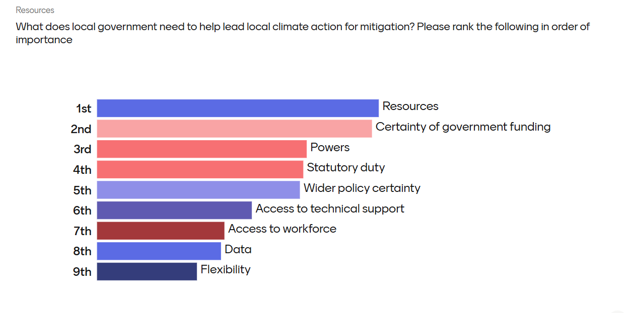

27.What does local government need to help lead local climate action for adaptation and resilience? Please rank the following in order of importance
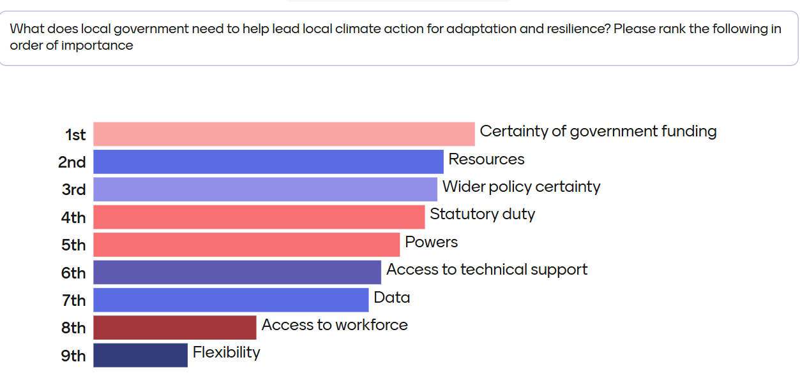

28.What does local government need to help lead local climate action for nature restoration? Please rank the following in order of importance
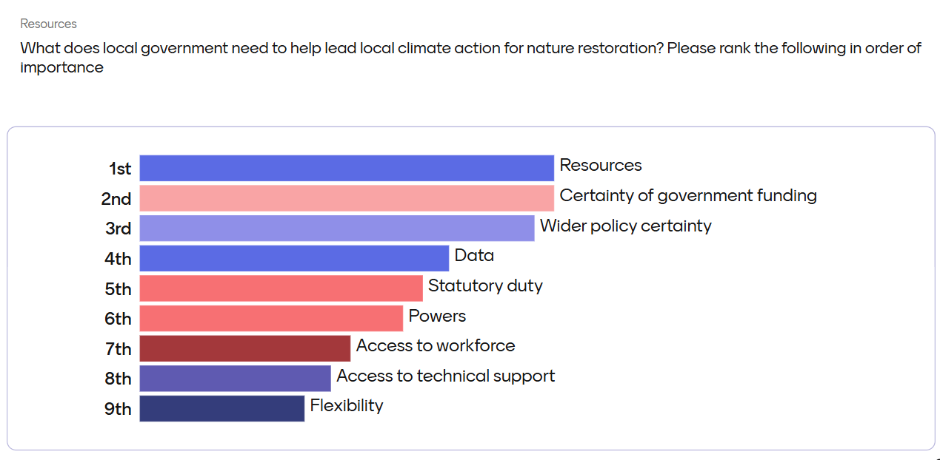

29.Please use this space to make any other points you would like to make

https://assets.publishing.service.gov.uk/media/67ab330e1a116437c7ed88da/E03274856_National_Procurement_Policy_Statement_Elay.pdf
Independent Review of Net Zero - https://assets.publishing.service.gov.uk/media/63c0299ee90e0771c128965b/mission-zero-independent-review.pdf#:~:text=Government%20should%20introduce%20a%20statutory,of%20local%20roles%20and%20responsibilities
www.theccc.org.uk/publication/progress-in-adapting-to-climate-change-2025/
Climate and planning duty: amendment to Planning and Infrastructure Bill - https://publications.parliament.uk/pa/cm5901/cmpublic/PlanningInfrastructure/memo/PIB19.htm
https://mcsfoundation.org.uk/news/one-in-four-councils-unable-to-enforce-legal-standards-in-private-rented-homes/
https://www.endfuelpoverty.org.uk/wp-content/uploads/Estimating-the-cost-to-the-NHS-of-the-Governments-Winter-Fuel-Payment-Cut.pdf
NICE guidance on Excess winter deaths and illness and the health risks associated with cold homes https://www.nice.org.uk/guidance/ng6
South Ken Zen+ - An initiative of Discover South Kensington - www.southkenzen.com/
www.theccc.org.uk/wp-content/uploads/2023/07/Spatial-planning-for-climate-resilience-and-net-zero-CSE-TCPA.pdf
Spatial Planning for Climate Resilience & Net Zero - Barriers & opportunities for delivering net zero and climate resilience through the local planning system - A report for the Climate Change Committee - July 2023 www.theccc.org.uk/wp-content/uploads/2023/07/Spatial-planning-for-climate-resilience-and-net-zero-CSE-TCPA.pdf
This is a wake-up call’: the villagers who could be Britain’s first climate refugees - www.theguardian.com/environment/2019/may/18/this-is-a-wake-up-call-the-villagers-who-could-be-britains-first-climate-refugees
Building national resilience to the climate crisis: the case for Resilience Development Corporations in England – Town and Country Planning Association www.tcpa.org.uk/wp-content/uploads/2021/11/REVISED_National_Resilience_Act_2020_004.pdf

