Thrive Renewables Community Benefit Programme – Round 10

October 2026

Guidance for applicants

Overview
The Thrive Renewables Community Benefit Programme awards grants for local communities to take action to address the climate emergency, through projects which have a positive environmental and social impact. It’s funded by Thrive Renewables and administered by the Centre for Sustainable Energy (CSE).

The deadline for applications is 12pm (noon) on Thursday 26 November 2026.

These notes outline the eligibility criteria and application process. To give yourself the best chance of success, please take the time to read them before submitting your application.

If you’d like to talk through your idea, or you have any questions about the scheme and application process. please get in touch with us at thrive@cse.org.uk

What kind of projects will be funded?
Grants will be awarded for proposals which respond to a locally identified need and provide benefits for nature, climate, energy efficiency and/or sustainability. Here are some examples of the kind of ideas that might be supported.

Energy and fuel poverty: Supporting cleaner energy, lower energy use and more affordable, comfortable buildings.

- Initiatives that help households reduce energy costs.
- Energy advice, outreach and practical education.
- Energy-efficiency improvements to community facilities.
- Community renewable energy and feasibility studies.

Nature and biodiversity: Protect and enhance local habitats, wildlife and green spaces.

- Community gardens and wildlife spaces.
- Local clean-up and litter picks.
- Community-led conservation projects.

Climate action and resilience: Reduce carbon emissions and help communities adapt to climate change.

- Community climate action projects.
- Low-carbon travel and community behaviour-change initiatives.
Sustainable living: Reduce waste and help your community adopt more sustainable practices.

- Repair cafés, reuse schemes and sharing libraries.
- Food growing, composting and food waste reduction.
- Community education and practical sustainability skills.

Eligibility

To be eligible to apply, you’ll need to show that:
- You are a constituted not-for-profit community or voluntary group or organisation, with a bank account.
- Your group or organisation has established links within the community.
- The activity will be taking place within a set radius of a Thrive Renewables installation listed below – in rural locations, activities should be taking place within a 15 mile radius. In urban locations, activities should be taking place within a 5 mile radius. You can use the following tool to check whether your building is within the radius: https://tinyurl.com/ycky4ut4
- If this grant only covers part of the total cost of the project, the remaining funding must already be secured.
- You are willing for Thrive Renewables or CSE to use your project as a case study for publicity purposes – which may include photographs and testimonials.

Eligible locations
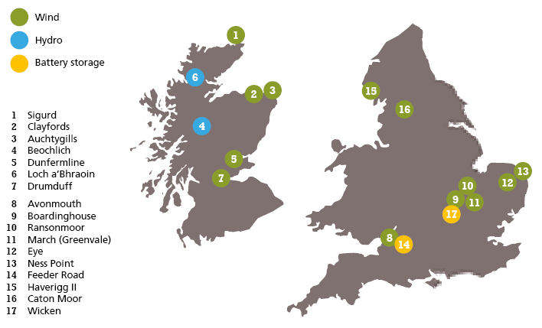
Locations
Auchtygills AB43 6RQ | Dunmow CM6 3AN
Avonmouth BS11 0YS | Eye IP23 8BW
Beochlich PA33 1BW | Haverigg LA18 4NB
Boardinghouse PE15 0YN | March PE15 0UW
Caton Moor LA2 9HF | Ness Point NR32 1UZ
Clayfords AB43 6RQ | Sigurd KW17 2NL
Dunfermline KY11 8UD | Wicken MK19 6BS

Grant applications
The maximum grant you can apply for is £4,500 and the minimum is £1,000.

Grant applications will be accepted until the deadline of 12pm (noon) on 26 November 2026. Applications will be assessed after this deadline. Awards will be made to projects which can demonstrate the strongest benefits for nature, climate, energy efficiency and/or sustainability, and where the idea has come from the local community. The decision on whether or not to award a grant shall be at the discretion of Thrive Renewables and the Centre for Sustainable Energy.

You must be able to complete the project within 6 months of receiving the grant. If the grant does not fully cover costs of the project, the remaining funding must already be in place.

Submitting your application – deadline 12pm (noon) 26 November 2026

Email the completed application form and a copy of your organisation’s governing document to thrive@cse.org.uk

If you can’t email your application, you can send by post to:
Martine Fitt, Thrive Renewables Community Benefit Programme, Centre for Sustainable Energy, St James Court, St James Parade, Bristol BS1 3LH. Your application must arrive before the deadline.

Decision process
Your application will be assessed for:
- Eligibility (proximity to a Thrive Renewables site, type of group, constitution).
- Connection within your community.

Applications will be accepted until 12pm (noon) Thursday 26 November 2026. Grants will be paid via BACS.

Future contact and data protection
CSE will process and store your information and will share your details with Thrive Renewables plc but with no other organisations. Thrive Renewables may contact you directly to arrange a visit to check that the grant was spent appropriately.

At the end of the project you will need to complete a brief report telling us how the project went and what the outcomes were. CSE and Thrive Renewables may also contact you directly for the purposes of publicity, photographs and writing up case studies to promote the programme.

Any questions?

For enquiries, including questions about postcode eligibility, please email thrive@cse.org.uk

