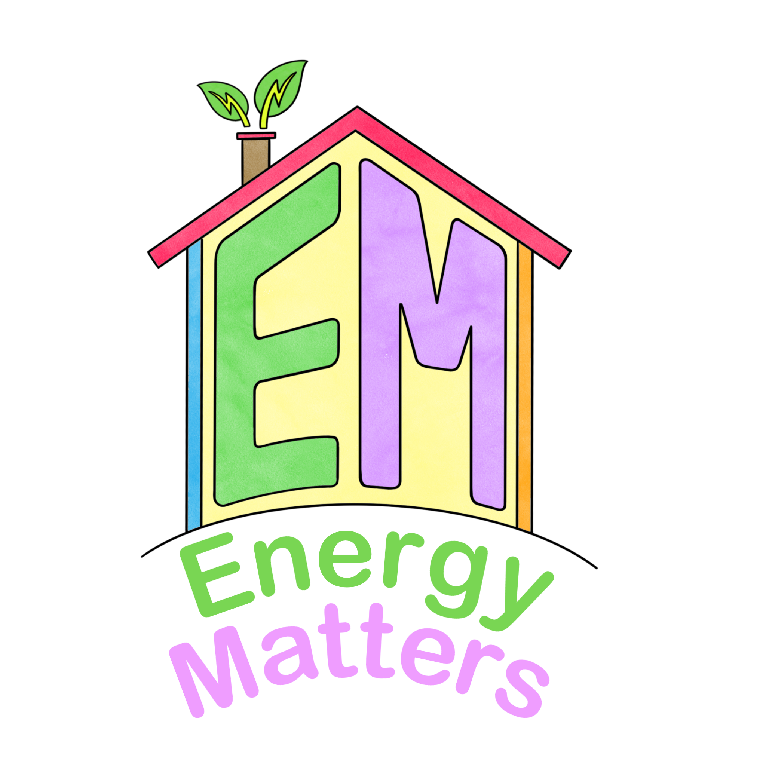
Useful videos for teachers
Energy | Video | Notes
Solar | Solar power: an introduction - YouTube | 9-minute watch
How solar panels work | How do solar panels work? - Richard Komp - YouTube | 5-minute watch
What is the national grid? | What is National Grid? | What does National Grid do? - YouTube | 2-minute watch
Hydro power | Hydropower 101 - YouTube | 3-minute watch
Wind power | How do wind turbines work? - Rebecca J. Barthelmie and Sara C. Pryor - YouTube | 5-minute watch
Wind power | Wind Power 101 - YouTube | 2-minute watch
Nuclear power | Nuclear Energy Explained: How does it work? 1/3 - YouTube | 5-minute watch
Tidal power | Tidal Power 101 - YouTube | 2-minute watch
Biomass | https://www.youtube.com/watch?v=yHWcddUZ35s | 4-minute watch

Climate change | Video | Notes
Climate change basics | What is climate change? | WaterAid - YouTube | 5-minute watch
Climate change in 2 minutes | https://www.youtube.com/watch?v=-n4A0BssFd0 | 2-minute watch
Climate change (explained by a kid) | https://www.youtube.com/watch?v=Sv7OHfpIRfU | 2-minute watch
Climate change projected impacts | https://www.theguardian.com/environment/video/2021/oct/25/2050-what-happens-if-we-ignore-the-climate-crisis-video-explainer | 2-minute watch

Impacts of climate change | Video | Notes
Impacts of climate change | Impacts of climate change | WaterAid - YouTube | 6 minute watch
Difference between global warming and climate change, greenhouse gases. | Climate Change and Global Warming: Explained in Simple Words for Beginners - YouTube | 6 minute watch
Warming effects in the Arctic | https://www.youtube.com/watch?v=5zSNSxjCwZ0 | 4-minute watch
How human activities are impacting the world effects on habitats | https://www.youtube.com/watch?v=dIsjcG7hTmo | 7-minute watch
Longer-term impacts of climate change | https://www.youtube.com/watch?v=ifrHogDujXw&t=10s | 5-minute watch

Supporting young people | Video | Notes
Getting climate confident | https://www.eco-schools.org.uk/eco-projects/climate-confident/ | 6-minute watch
Global agenda on climate change | https://www.youtube.com/watch?time_continue=1&v=ljinS8xJbRQ&embeds_euri=https%3A%2F%2Fwww.eco-schools.org.uk%2F&feature=emb_logo | 7-minute watch
Eco anxiety | https://www.youtube.com/watch?v=mfiLcPl4wS8&embeds_euri=https%3A%2F%2Fwww.eco-schools.org.uk%2F&feature=emb_logo | 7-minute watch
Using your school environment | Climate Confident #4 - Using Your School Environment (Eco-Schools) - YouTube | 7-minute watch
Climate change and your curriculum | https://www.youtube.com/watch?time_continue=1&v=dDFG3f0uXeY&embeds_euri=https%3A%2F%2Fwww.eco-schools.org.uk%2F&feature=emb_logo | 7-minute watch

