- 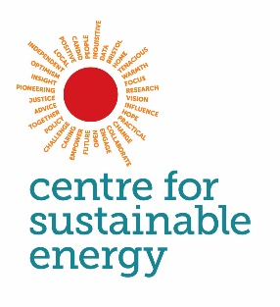

- Ofgem energy consumer archetypes:
- Final report

Centre for Sustainable Energy
St James Court
St James Parade
Bristol BS1 3XN
www.cse.org.uk
Charity no: 298740 Company no: 2219673
Produced for: Ofgem (contact: Dennis Berg)
This version of report: Final Report
Date: 12 March 2020
Lead author and contact: Toby Bridgeman, CSE (toby.bridgeman@cse.org.uk)

Release authorised by: Simon Roberts, CSE

Centre for Sustainable Energy, St James Court, St James Parade, Bristol, BS1 3LH
www.cse.org.uk @cse_bristol Company: 2219673 Charity: 298740

Contents

Introduction 1
Summary of method 1
Archetypes summary 1

MAINS GAS ARCHETYPES 5
Archetype A1 6
Archetype A2 10
Archetype B3 14
Archetype B4 18
Archetype C5 22
Archetype D6 26
Archetype D7 30
Archetype E8 34
Archetype E9 38

OFF-GAS ARCHETYPES 43
Archetype F10 44
Archetype G11 48
Archetype H12 52
Archetype H13 56

Appendix A –Methodology 60

Introduction
In 2019, CSE were commissioned by Ofgem to segment the population of Great Britain into a set of distinct groups of energy consumers, or archetypes, which together represent all households across the country. The archetypes were designed to assist with identification and understanding of different types of energy consumers. This includes those in vulnerable situations in order to better understand the impacts that changes in the energy system may have on these groups. The archetypes can also suggest which types of consumers are most likely to engage with and/or benefit from the energy system transition.

Overview of method
The archetypes presented here were produced by segmenting an ‘energy consumer data set’, derived from the Living Costs and Food (LCF) Survey. Supplementary data sets containing additional household or consumer characteristics were appended to the data where possible. The majority of the characteristics described for each archetype are taken directly from information contained in this core data set and are based on statistical analysis of each archetype.
However, the lack of some desirable information in the data meant that it was not possible to directly include information on certain consumer characteristics. Therefore, some external analysis has also been included that reports on technology ownership, energy activities and consumption behaviours by different socio demographic groups. Where possible this information has been linked to relevant archetypes through inference (i.e. finding common attributes) in order to add further details to their descriptions. In addition, characteristics of households with positive attitudes and values towards environment issues were profiled using Experian Mosaic data to identify the types of households who most strongly showed concern for the environment and awareness of environmental issues. These findings were then cross referenced with existing studies.
Full details of the method applied to produce the archetypes can be found in Appendix A. This includes references to the external research described above.

Using the archetypes and general limitations
The key objective of this work was to segment representative survey (and supplementary) data into distinct consumer or household archetypes. The archetypes derived from this analysis and presented here are intended as a tool that enables a more detailed review of different consumer issues across the energy sector. In particular, it is intended that the archetypes will help enhance understanding of the different experiences and needs of different energy consumers, the different drivers that may exist for households to engage in energy related policies, and enable a more considered and nuanced approach to policy design and promotion of energy technologies or smart energy systems.
However, it should be recognised that the descriptions of the archetypes presented here represent the most typical characteristics, predominant features or average statistics (e.g. household income) across all households in these groups. Within groups there exists a degree of variation in all characteristics and statistics. For some characteristics such as income and energy consumption, distributions within the archetypes have been presented to help illustrate and remind users of this.
Furthermore, segmenting the population into thirteen archetypes has resulted in group sizes varying between 500,000 and 3.6 million households. Grouping households together in archetypes of this size will not always reveal the multitude of vulnerable situations and circumstances that different households can experience.
Several of the archetypes presented here have differing levels of certain vulnerabilities (e.g. higher rates of long-term health conditions or being on very low incomes), and some archetypes will be more disadvantaged than others. However, it was never the objective of this exercise to present a detailed profile of different and multiple vulnerabilities and the extent to which these predominate across the population. Therefore it should be recognised that the archetypes do not serve as a tool which enables users to examine complex vulnerabilities with relation to energy. It should also be recognised that vulnerabilities can exist in all households and that these vulnerabilities can vary significantly in magnitude, severity and duration.
The archetypes themselves are intended to be used to understand how different policies may impact on a selection of different types of households and energy consumers. They may be used to investigate existing or proposed policy designs or to help rebalance any policies which have been identified as unintentionally overlooking or disadvantaging certain households. However, for the reasons mentioned above, they are not intended to be used as the main source of information when considering policy design. For example, they are not intended to be used as the main tool to accurately identify or locate vulnerable households or to design detailed eligibility criteria for policies. Nor do the archetypes themselves represent a distributional analysis tool. However, they can be used to consider what distributional impacts may have when considering each of these archetypes and using existing knowledge and data regarding policies.

Summary of archetypes
The archetypes are split in to two distinct sets: nine archetypes which use mains gas to heat their homes, and a further four who are ‘off gas’ – i.e. they use fuels other than mains gas as their main heating fuel. The archetypes are presented in a set of seven groups (labelled A to G) containing one or two archetypes. The archetypes have been paired into groups where they are related by some common characteristics but differ on a number of key aspects such as income, tenure, or energy consumption.
Typically, the pairings are of a less vulnerable and a more vulnerable archetype. For example, Group E is a set of younger private renters. Archetype E8 is a low income group who are in part-time employment or out of work, whereas consumers in Archetype E9 are also younger private renters but on much higher incomes and in full time employment.
Some headline statistics for all archetypes are presented below in Table 1. This shows the variation in size, income, and energy consumption levels and provides a brief summary of some of the other key characteristics of each group. The archetypes vary significantly across a number of other characteristics and these are described in more detail in the individual archetype profiles later in this report. (Note: the descriptions and headline statistics of each archetype describe two types of incomes; net household incomes before housing costs (BHC) and net household incomes after housing costs (AHC). These acronyms are used from here on.)
Table 2 shows how the archetypes rank across different consumer-related categories and allows the archetypes to be ordered by a range of different vulnerability characteristics or consumer attributes.

Table 1: Headline statistics and summary descriptions of energy consumer archetypes
Archetype |  | Numbers of hhlds | Heating fuel | Average hhld income (BHC)  (GB avg: £34k) | Elec kWh  (GB avg: 3,980) | Gas kWh (GB avg: 13,180) | Main attributes (key words)
A | A1 | 2,761,000 | Mains gas | £48,000 | 3,250 | 9,650 | High incomes, owner occupied, working age families, full time employment, low consumption, regular switchers.
A | A2 | 2,916,000 | Mains gas | £54,600 | 4,920 | 20,520 | High incomes, owner occupied, middle aged adults, full time employment, big houses, very high consumption, solar PV, environmental concerns.
B | B3 | 3,674,000 | Mains gas | £28,600 | 3,670 | 15,350 | Average incomes, retired, owner occupied - no mortgage, electric vehicles, environmental concerns, lapsed switchers, late adopters.
B | B4 | 2,323,000 | Mains gas | £40,600 | 4,090 | 15,630 | High incomes, owner occupied, part-type employed, high consumers, flexible lifestyles, environmental concerns.
C | C5 | 1,922,000 | Mains gas | £15,200 | 2,570 | 11,270 | Very low incomes, single female adult pensioners, non-switchers, prepayment meters, disconnected (no internet or smart phones).
D | D6 | 1,547,000 | Mains gas | £18,100 | 3,920 | 12,340 | Low income, disability, fuel debt, prepayment meter, disengaged, social housing, BME households, single parents.
D | D7 | 1,205,000 | Mains gas | £34,000 | 4,140 | 15,600 | Middle aged to pensioners, full time work or retired, disability benefits, above average incomes, high consumers.
E | E8 | 2,356,000 | Mains gas | £23,400 | 3,620 | 11,950 | Low income, younger households, part-time work or unemployed, private or social renters, disengaged non-switchers.
E | E9 | 3,093,000 | Mains gas | £37,000 | 3,200 | 10,440 | High income, young renters, full time employments, private renters, early adopters, smart phones.
F | F10 | 1,912,000 | Oil, Electric | £38,900 | 5,750 | 0 | Middle aged to pensioners, full time work or retired, owner occupied, higher incomes, oil heating, rural, environmental awareness, RHI installers, late adopters.
G | G11 | 1,510,000 | Electric, Oil | £30,200 | 5,250 | 0 | Younger couples/single adults, private renters, electric heating, employed, average incomes, early adopters, BME backgrounds, low engagement.
H | H12 | 644,000 | Electric, Oil | £14,500 | 4,030 | 0 | Elderly, single adults, very low income, medium electricity consumers, never-switched, disconnected, fuel debt.
H | H13 | 526,000 | Electric, Oil | £22,000 | 5,360 | 0 | Off gas, low income, high electricity consumption, disability benefits, over 45s, low energy market engagement, late adopters.
Table 2: Energy consumer archetypes ranked by metrics (Note: highest ranking order for categories relates to the ‘best’ or ‘least bad’ situation)
Archetype | Average net household income (BHC)  (1 = highest income) | Internet connection in the home  (1 = highest %) | Using smart phone to access the internet  (1 = highest %) | Engagement with energy market in last 12mths  (1 = most engagement) | Households on disability benefits  (1 = lowest %) | Have been in arrears on electricity or gas bills (1 lowest %) | Electric or hybrid vehicle ownership  (1 = highest ownership)
A1 | 2 | 1 | 2 | 1 | 1 | 6 | 6
A2 | 1 | 2 | 1 | 3 | 1 | 3 | 4
B3 | 8 | 5 | 9 | 6 | 1 | 1 | 1
B4 | 3 | 3 | 3 | 2 | 5 | 2 | 2
C5 | 12 | 12 | 13 | 13 | 7 | 5 | 10
D6 | 11 | 11 | 10 | 10 | 12 | 13 | 11
D7 | 6 | 4 | 7 | 5 | 13 | 11 | 3
E8 | 9 | 9 | 6 | 9 | 9 | 12 | 9
E9 | 5 | 6 | 4 | 11 | 1 | 8 | 7
F10 | 4 | 7 | 8 | 4 | 8 | 4 | 5
G11 | 7 | 8 | 5 | 8 | 10 | 7 | 8
H12 | 13 | 13 | 12 | 12 | 6 | 9 | 12
H13 | 10 | 10 | 11 | 7 | 11 | 10 | 12

MAINS GAS ARCHETYPES

The following section presents a set of nine archetypes all of which use mains gas as their main heating system fuel.
Each archetype profile for the mains gas archetypes includes the following:
- Headline statistics
- Summary description of the archetype highlighting key features
- Statistical profile
- Graphs showing the income, gas and electricity consumption distribution of each archetype in deciles (e.g. income decile)
- Map showing the proportion of the population in each English region and devolved nation that the archetype represents

Archetype A1

Headline statistics
Archetype A1: Key statistics |  | GB-wide statistics
Number of households: | 2,761,000 | 26,390,000
Average net household income (BHC) | £48,000 | £34,100
Average net household income (AHC) | £40,900 | £29,400
Average electricity consumption (kWh) | 3,250 | 3,980
Average mains gas consumption (kWh) | 9,650 | 13,630

Key words: High incomes, owner occupied, working age families, full time employment, low consumption, regular switchers.

Summary Description
These are working age families in full time employed households on higher than average salaries, owning their own homes. Typically they live in 3 bedroom terraces, semi-detached or detached houses heated with mains gas in predominantly urban areas. Most households are families with children where the adults in the households are in full time employment, and nearly all are aged between 25 and 54. Many have only recently bought their homes, with approximately 60% having lived in their (current) homes for less than 5 years.
These households all have access to the internet at home, with a high proportion being able to gain access via a smart phone. They are the most educated archetype, with nearly half having a degree qualification or higher. They have a very high level of engagement with the energy market (with 94% estimated to have engaged in the last 12 months). None are on disability benefits, only a very low percentage are likely to have been in arrears on their gas or electricity bills.
These households also have significantly lower gas consumption than other mains gas heated archetypes, and slightly lower electricity consumption than the GB average, likely a result of living in more efficient dwellings. The characteristics of this archetype – presence of children, full time employment, and higher incomes – suggest that these households are likely to have a more ‘peaky’ energy consumption profile that other households, however the low overall annual energy consumption of this group means that this peak is likely to be significantly smaller in magnitude than other households.
Archetype A1 has a favourable attitude to new technology with almost half stating a desire to buy new products when they appear on the market. Nearly all (95%) pay their utility bills via Direct Debit.

Summary profile
Archetype A1: Profile
 | Archetype | GB profile
Age profile  (head of household) | 25-34: 30%  35-44: 36%  45-54: 26% | 16-24: 3%  25-34: 14%  35-44: 17%  45-54: 20%  55-64: 17%  65-74: 15%  75+: 14%
Main tenure(s) | Owner occupied: 100% | Housing association: 8%  Local authority: 8%  Owner occupied: 65%  Private rented: 18%
Household composition | Couple: 29%  Couple with children: 46% | Couple: 34%  Couple with children: 20%  Single adult: 28%  Single parent: 5%  Other: 11%
Households with children | 54% | 29%
Economic status (head of household) | Full-time employee at work: 99%  Self-employed: 1%
Main heating fuel of dwelling | Mains gas
 | Archetype | GB average
Internet in the home | 100% | 88%
Use smart phones to access the internet | 68% | 46%
Any engagement with energy market in last 12mths | 94% | 41%
Have a degree qualification (or higher) | 46% | 26%
Long term health conditions that affect daily activities a lot (HoH) | 2% | 12%
Households on disability benefits | 0% | 13%
Households in poverty (income below 60% of national median) | 2% | 20%
Been in arrears on electricity or gas bills | 1.1% | 2.3%
Electric or hybrid vehicle ownership | 1.0% | 0.8%
Rural population | 15% | 22%

Figure 1: Archetype A1 – Equivalised income distribution (OECD equivalised income decile)
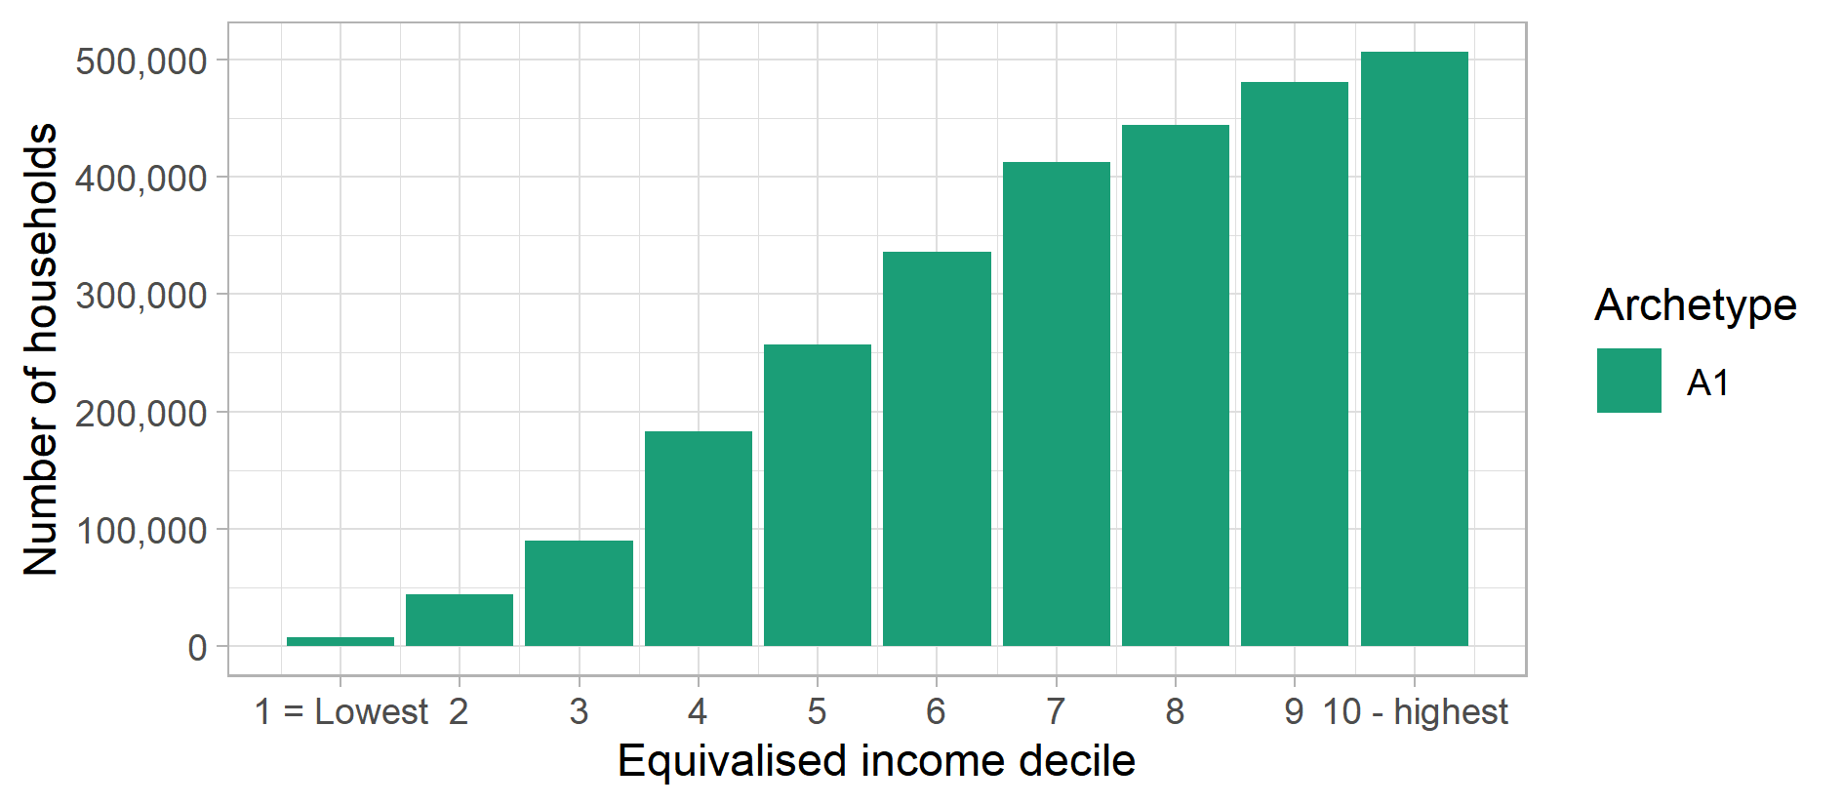
Figure 2: Archetype A1 – Gas consumption distribution (Mains gas kWh decile)
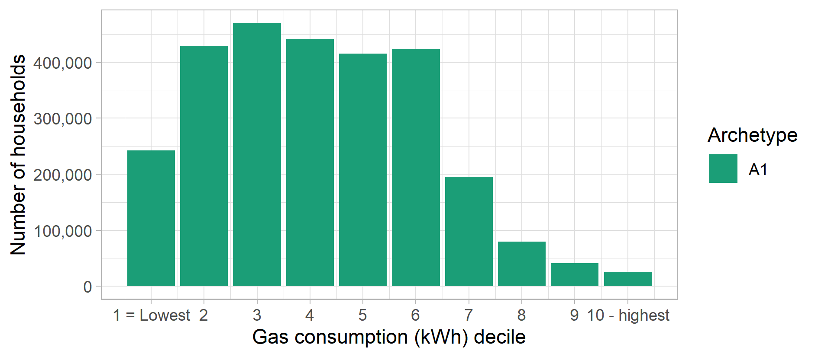
Figure 3: Archetype A1 – Electricity consumption distribution (Electricity kWh decile)
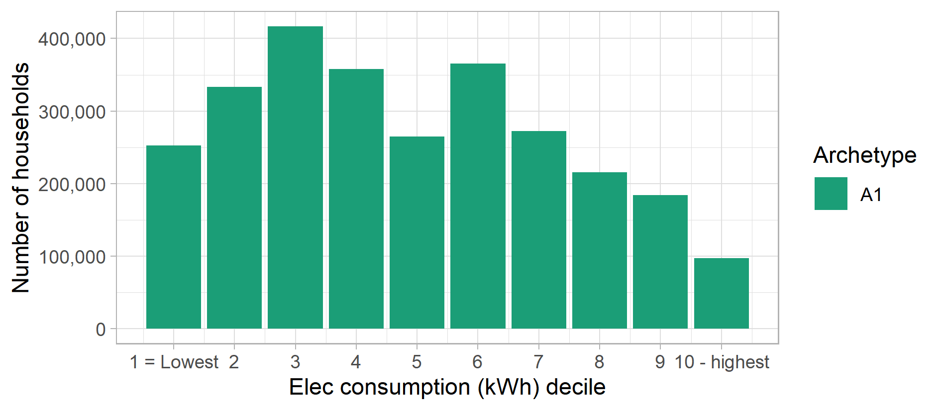

Figure 4: Archetype A1 – Proportion of population in each English region and devolved nation of Great Britain
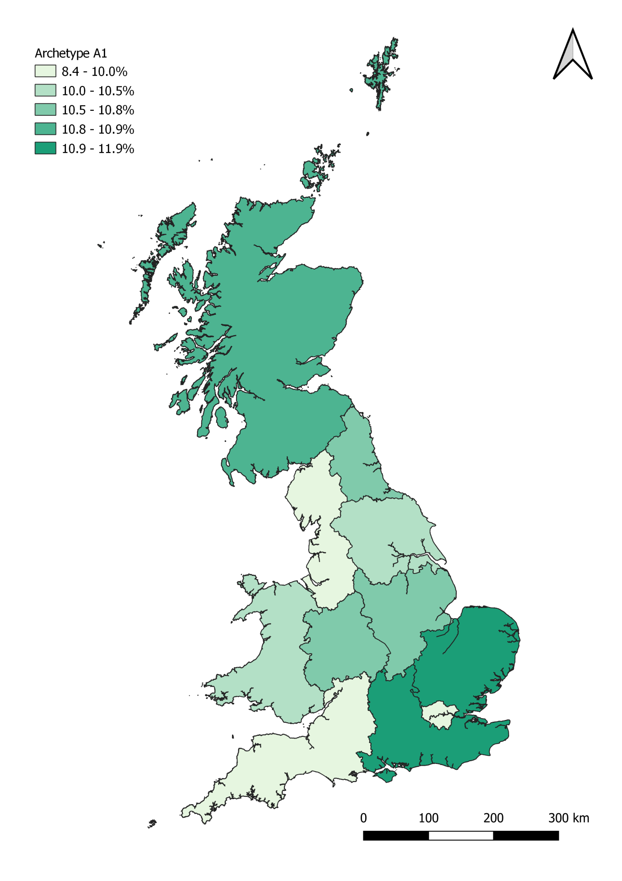

Archetype A2

Headline statistics
Archetype A2: Key statistics |  | GB-wide statistics
Number of households: | 2,916,000 | 26,390,000
Average net household income (BHC) | £54,600 | £34,100
Average net household income (AHC) | £48,200 | £29,400
Average electricity consumption (kWh) | 4,920 | 3,980
Average mains gas consumption (kWh) | 20,520 | 13,630

Key words: High incomes, owner occupied, middle aged adults, full time employment, big houses, very high consumption, solar PV installers, care for the environment.

Summary Description
Archetype A2 is the second archetype in group A. A2 households are, on average, the wealthiest of all archetypes and generally older than households in Archetype A1, although still of working age. The average net household salary of this group is £48k after housing costs are taken into account, and they have the second highest rate of university graduates (43% have a degree qualification or higher).
These consumers live in larger (3 or 4 bedroom) semi-detached and detached houses in predominantly suburban areas. Most of these households have lived in their homes for at least 5 years, with 45% having lived in the same home for over 10 years.
These households all have access to the internet at home, with a high proportion being able to gain access via a smart phone. They demonstrate a much higher than average level of engagement with the energy market (although not as high as Archetype A1). None are on disability benefits, only 2% report any long term health conditions, and only a very low percentage are likely to have been in arrears on their gas or electricity bills.
These households also have very high average annual gas consumption and significantly higher electricity consumption than the GB average. In addition to their high consumption, the characteristics of this archetype – presence of children, full time employment, and higher incomes – suggest that these households are likely to have the highest peak of energy consumption in their daily profile. They are also unlikely to be able to be flexible with their energy use, particularly in the working week. This group is likely to have strong environmental concerns and a high proportion of households who have installed solar PV panels.

Summary profile
Archetype A2: Profile
 | Archetype | GB profile
Age profile  (head of household) | 35-44: 26%  45-54: 40%  55-64: 25% | 16-24: 3%  25-34: 14%  35-44: 17%  45-54: 20%  55-64: 17%  65-74: 15%  75+: 14%
Main tenure(s) | Owner occupied: 100% | Housing association: 8%  Local authority: 8%  Owner occupied: 65%  Private rented: 18%
Household composition | Couple: 31%  Couple with children: 34%  Multiple adults: 18% | Couple: 34%  Couple with children: 20%  Single adult: 28%  Single parent: 5%  Other: 11%
Households with children | 43% | 29%
Economic status (head of household) | Full-time employee at work: 100%
Main heating fuel of dwelling | Mains gas
 | Archetype | GB average
Internet in the home | 100% | 88%
Use smart phones to access the internet | 70% | 46%
Any engagement with energy market in last 12mths | 65% | 41%
Have a degree qualification (or higher) | 43% | 26%
Long term health conditions that affect daily activities a lot (HoH) | 2% | 12%
Households on disability benefits | 0% | 13%
Households in poverty (income below 60% of national median) | 1% | 20%
Been in arrears on electricity or gas bills | 0.7% | 2.3%
Electric or hybrid vehicle ownership | 1.4% | 0.8%
Rural population | 19% | 22%

Figure 5: Archetype A2 – Equivalised income distribution (OECD equivalised income decile)
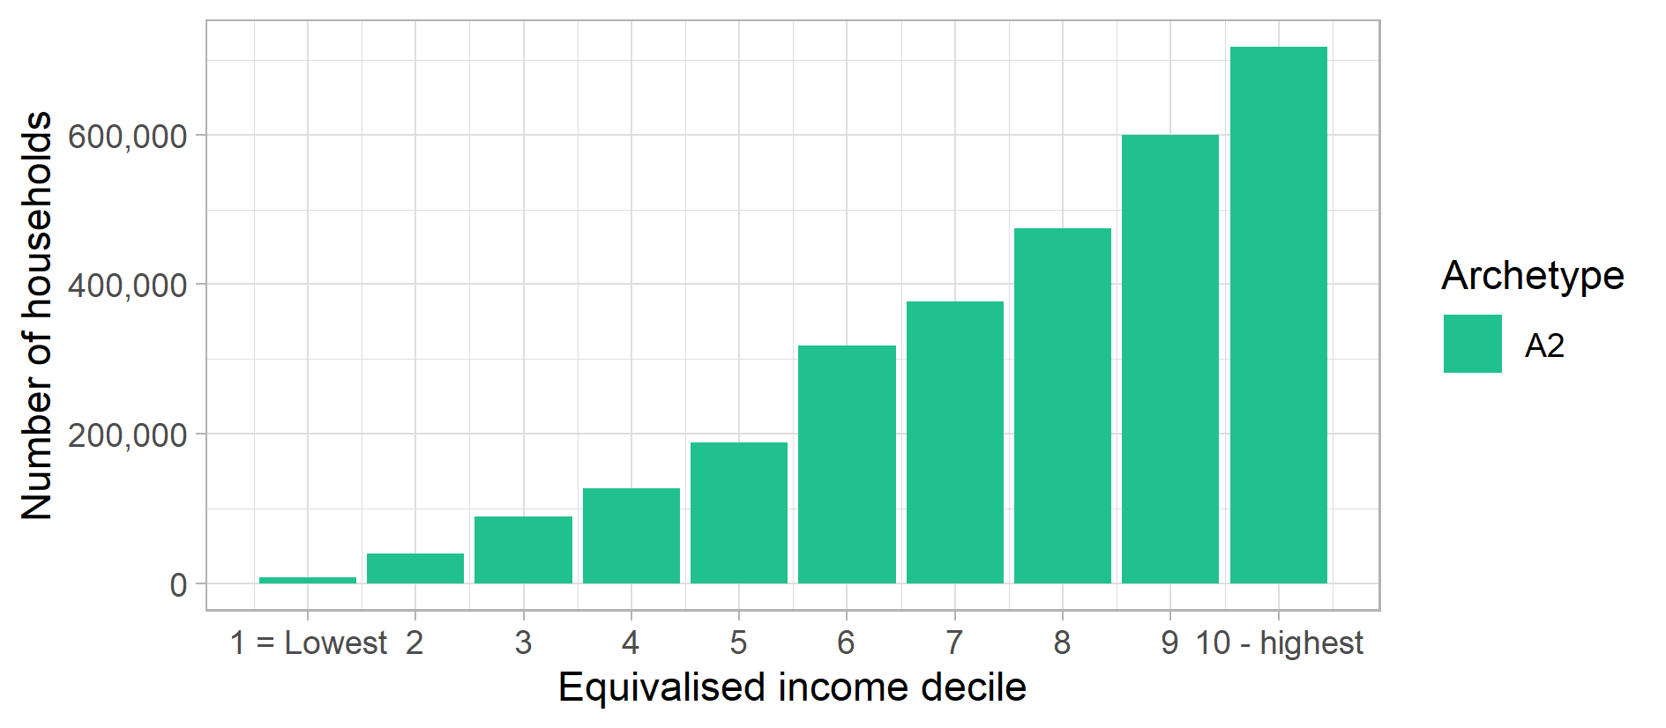
Figure 6: Archetype A2 – Gas consumption distribution (Mains gas kWh decile)
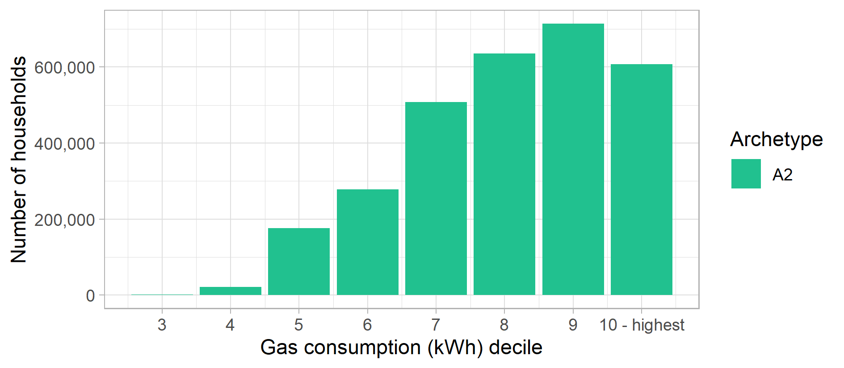
Figure 7: Archetype A2 – Electricity consumption distribution (Electricity kWh decile)
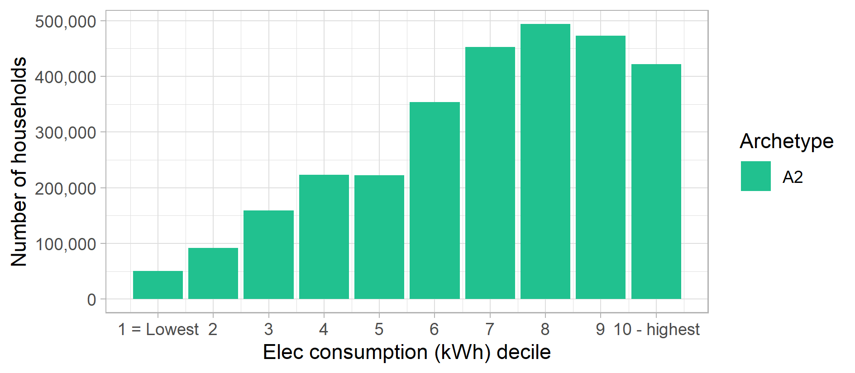

Figure 8: Archetype A2 – Proportion of population in each English region and devolved nation of Great Britain
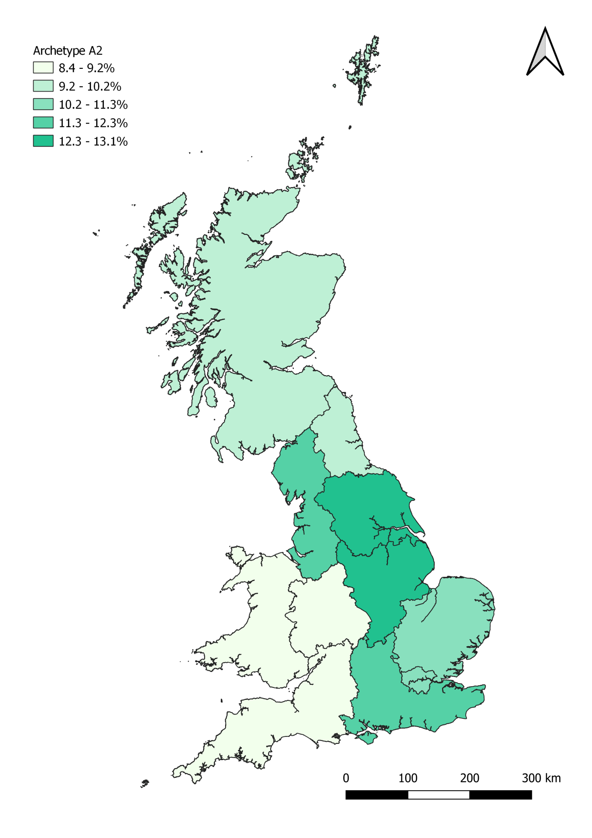

Archetype B3

Headline statistics
Archetype B3: Key statistics |  | GB-wide statistics
Number of households: | 3,674,000 | 26,390,000
Average net household income (BHC) | £28,600 | £34,100
Average net household income (AHC) | £28,000 | £29,400
Average electricity consumption (kWh) | 3,670 | 3,980
Average mains gas consumption (kWh) | 15,350 | 13,630

Key words: Average incomes, retired, owner occupied - no mortgage, electric vehicles, environmental concerns, lapsed switchers, late adopters.

Summary Description
These households are retired home owners with lower than average incomes, but who have paid off their mortgage and own their own homes outright. Most are married couples, although a significant proportion are (widowed) single adults households. They are typically over 65 years of age, but have low levels of disabilities, with no households claiming disability benefits. A minority report having a significant long-term limiting health condition, but this is comparable to the national average and significantly lower than other groups with a similar age profile.
The majority live in semi-detached or detached houses with 3-5 beds, in both rural and urban areas. Most have been in their homes for more than 10 years, and over half have lived in their current homes for more than 20 years. Their energy consumption levels are higher than average for mains gas (although are below average for electricity), and this is predominantly related to living in larger homes. However, nearly all pay by Direct Debit (>90%), and this group has some of the lowest rates of being in arrears on utility bills.
They have access to the internet at home and use home computers, but most do not use smart phones. They demonstrate a slightly higher than average level of engagement with the energy market, particularly when compared to other archetypes of a similar age. In addition, households in this archetype are the most likely of all the archetypes to own electric or hybrid vehicles. They are also likely to have significant concerns about the environment and take steps to reduce their impact in certain aspects of their lives, such as not wasting energy. Despite this, however, these households register as having some of the least favourable attitudes to new market products and technology.
Being retired, on middle incomes and having no children, these households are unlikely to have a particularly high consumption peak.

Summary profile
Archetype B3: Profile
 | Archetype | GB profile
Age profile  (head of household) | 55-64: 16%  65-74: 46%  75+: 33% | 16-24: 3%  25-34: 14%  35-44: 17%  45-54: 20%  55-64: 17%  65-74: 15%  75+: 14%
Main tenure(s) | Owner occupied: 96% | Housing association: 8%  Local authority: 8%  Owner occupied: 65%  Private rented: 18%
Household composition | Couple: 55%  Single adult (man): 13%  Single adult (woman): 21% | Couple: 34%  Couple with children: 20%  Single adult: 28%  Single parent: 5%  Other: 11%
Households with children | 4% | 29%
Economic status (head of household) | Retired & above pension age: 81%  Retired & under pension age: 17%
Main heating fuel of dwelling | Mains gas
 | Archetype | GB average
Internet in the home | 99% | 88%
Use smart phones to access the internet | 31% | 46%
Any engagement with energy market in last 12mths | 48% | 41%
Have a degree qualification (or higher) | 14% | 26%
Long term health conditions that affect daily activities a lot (HoH) | 12% | 12%
Households on disability benefits | 0% | 13%
Households in poverty (income below 60% of national median) | 18% | 20%
Been in arrears on electricity or gas bills | 0.2% | 2.3%
Electric or hybrid vehicle ownership | 1.6% | 0.8%
Rural population | 22% | 22%

Figure 9: Archetype B3 – Equivalised income distribution (OECD equivalised income decile)
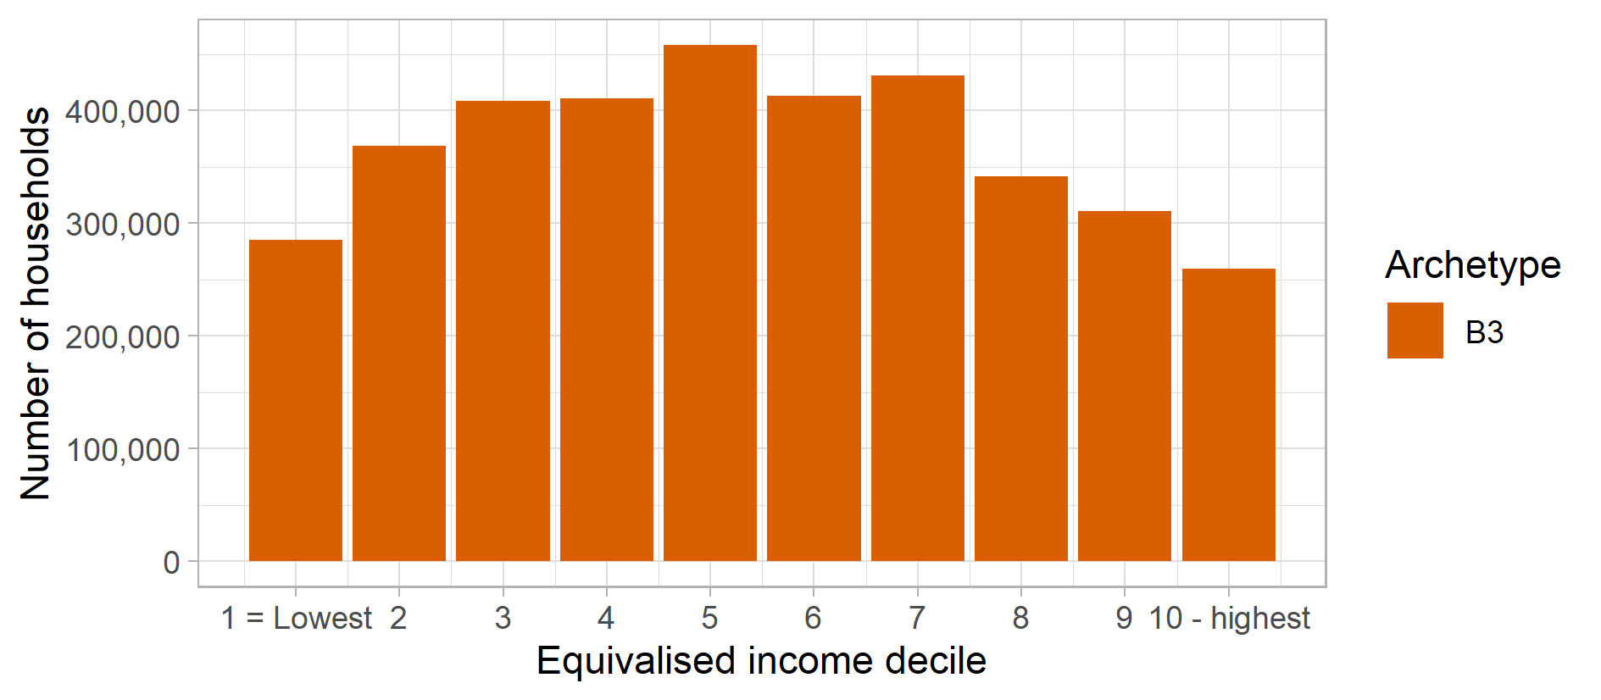
Figure 10: Archetype B3 – Gas consumption distribution (Mains gas kWh decile)
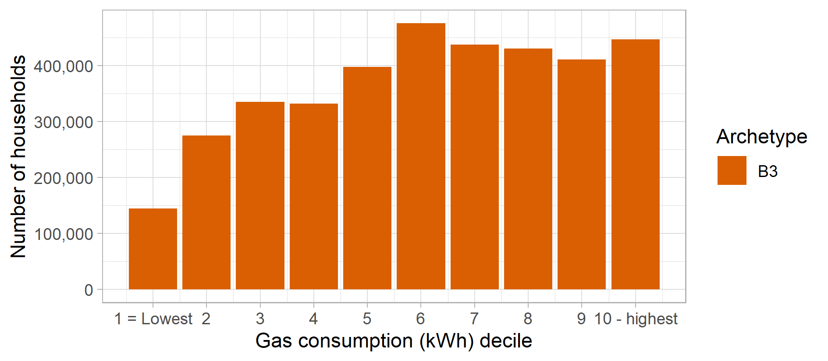
Figure 11: Archetype B3 – Electricity consumption distribution (Electricity kWh decile)
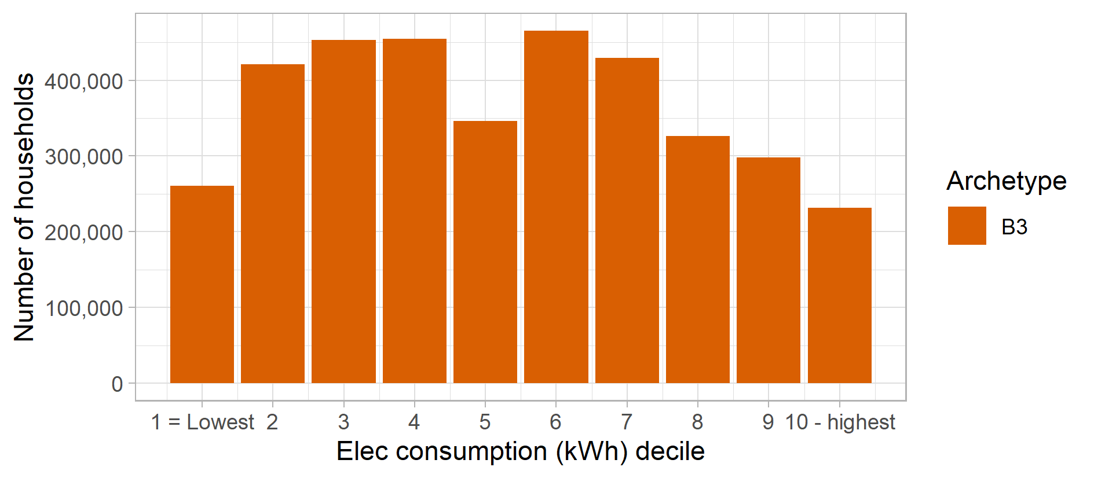

Figure 12: Archetype B3 – Proportion of population in each English region and devolved nation of Great Britain
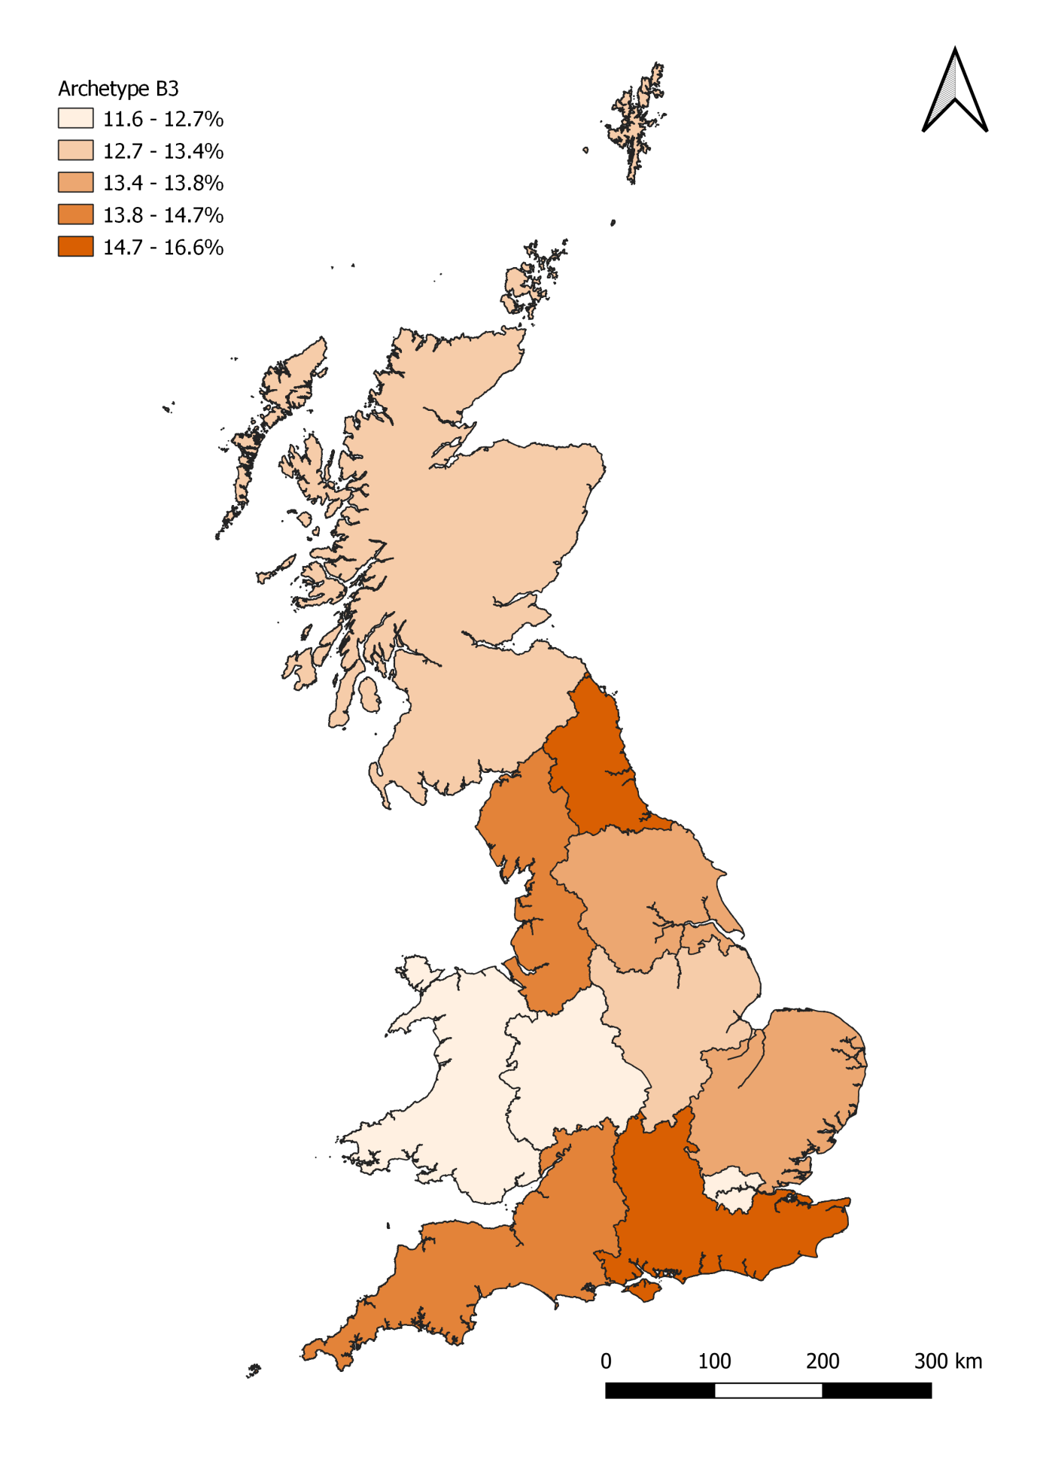

Archetype B4

Headline statistics
Archetype B4: Key statistics |  | GB-wide statistics
Number of households: | 2,323,000 | 26,390,000
Average net household income (BHC) | £40,600 | £34,100
Average net household income (AHC) | £36,600 | £29,400
Average electricity consumption (kWh) | 4,090 | 3,980
Average mains gas consumption (kWh) | 15,630 | 13,630

Key words: High incomes, owner occupied, part-type employed, high consumers, flexible lifestyles, environmental concerns.

Summary Description
Archetype B4 is a group of middle-aged households, working and on good salaries who own their own homes, predominantly in urban areas. These dwellings are typically larger semi-detached or detached houses.
They are predominantly couples or families but also include single adult households. A high proportion of these households have a female head of the household.
All have internet and personal computers, in their homes and a high number are smart phone users. They are regular switchers, with approximate 70% having engaged with the energy market in the last 12 months and have higher than average electric or hybrid vehicle ownership. However, they are less keen to buy new products when they appear on the market.
On average, they also have high mains gas consumption. However, none of this group is in full time employment and are either self-employed or work part-time. And while some are families with children, most are not. Thus, this archetype is the mostly likely to contain households with high consumption peaks. However, the fact that none of these households are working in full time employment, have a high level of engagement with the energy market and show higher than average rates of EV ownership, they are the most likely group to be able and willing to be flexible with their energy use over the course of the working week.
This group is likely to demonstrate above average levels of ‘green behaviours’ and identify as having concerns about environmental issues.

Summary profile
Archetype B4: Profile
 | Archetype | GB profile
Age profile  (head of household) | 35-44: 19%  45-54: 27%  55-64: 32%  65-74: 13% | 16-24: 3%  25-34: 14%  35-44: 17%  45-54: 20%  55-64: 17%  65-74: 15%  75+: 14%
Main tenure(s) | Owner occupied: 97% | Housing association: 8%  Local authority: 8%  Owner occupied: 65%  Private rented: 18%
Household composition | Couple: 33%  Couple with children: 25%  Single adult: 17% | Couple: 34%  Couple with children: 20%  Single adult: 28%  Single parent: 5%  Other: 11%
Households with children | 38% | 29%
Economic status (head of household) | Part-time employee at work: 53%  Self-employed: 47%
Main heating fuel of dwelling | Mains gas
 | Archetype | GB average
Internet in the home | 100% | 88%
Use smart phones to access the internet | 60% | 46%
Any engagement with energy market in last 12mths | 69% | 41%
Have a degree qualification (or higher) | 30% | 26%
Long term health conditions that affect daily activities a lot (HoH) | 3% | 12%
Households on disability benefits | 0% | 13%
Households in poverty (income below 60% of national median) | 12% | 20%
Been in arrears on electricity or gas bills | 0.5% | 2.3%
Electric or hybrid vehicle ownership | 1.4% | 0.8%
Rural population | 20% | 22%

Figure 13: Archetype B4 – Equivalised income distribution (OECD equivalised income decile)
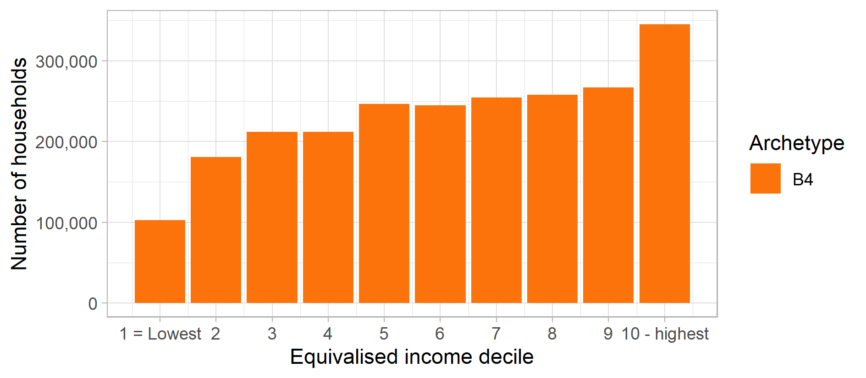
Figure 14: Archetype B4 – Gas consumption distribution (Mains gas kWh decile)
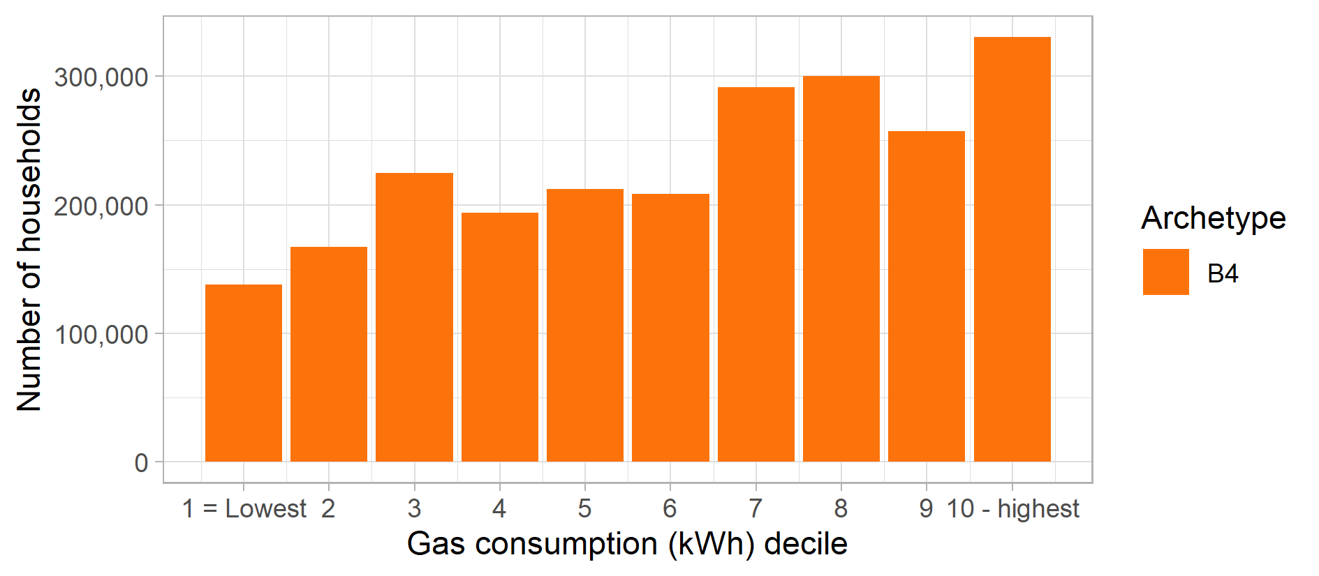
Figure 15: Archetype B4 – Electricity consumption distribution (Electricity kWh decile)
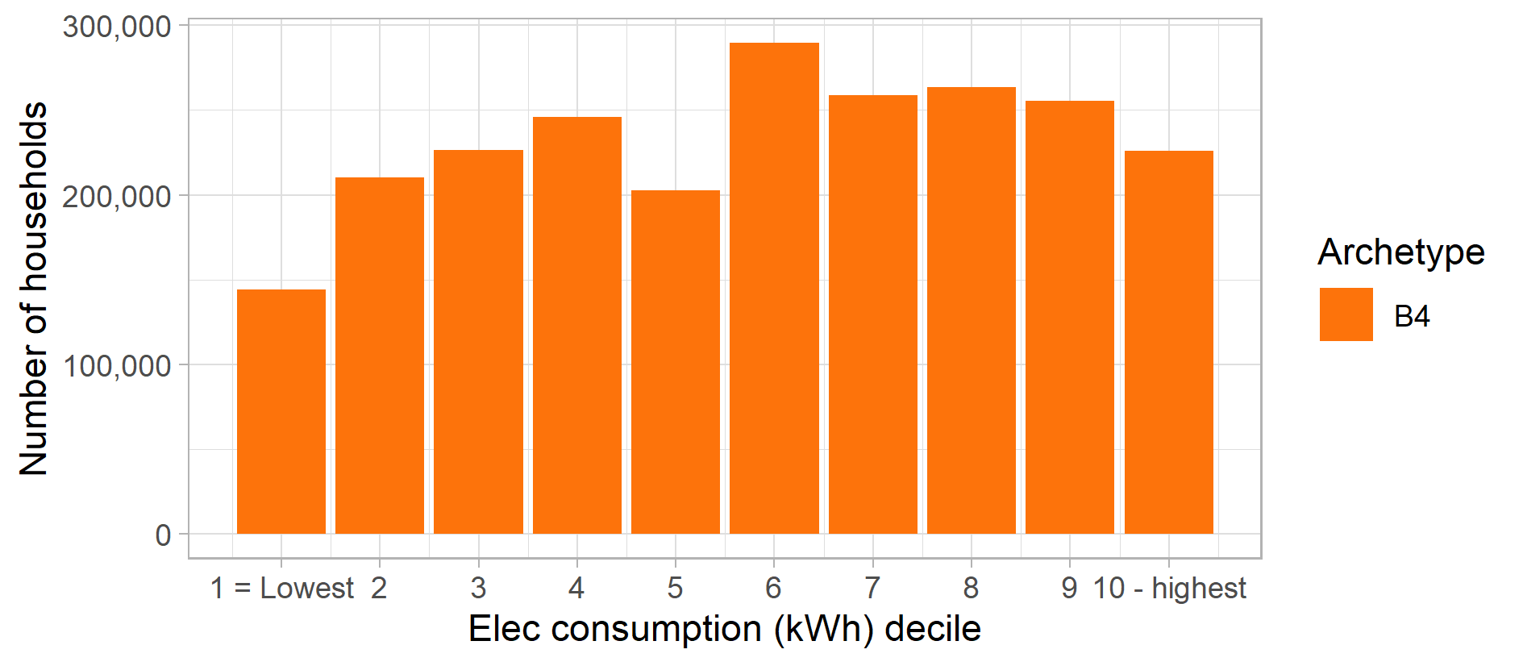

Figure 16: Archetype B4 – Proportion of population in each English region and devolved nation of Great Britain
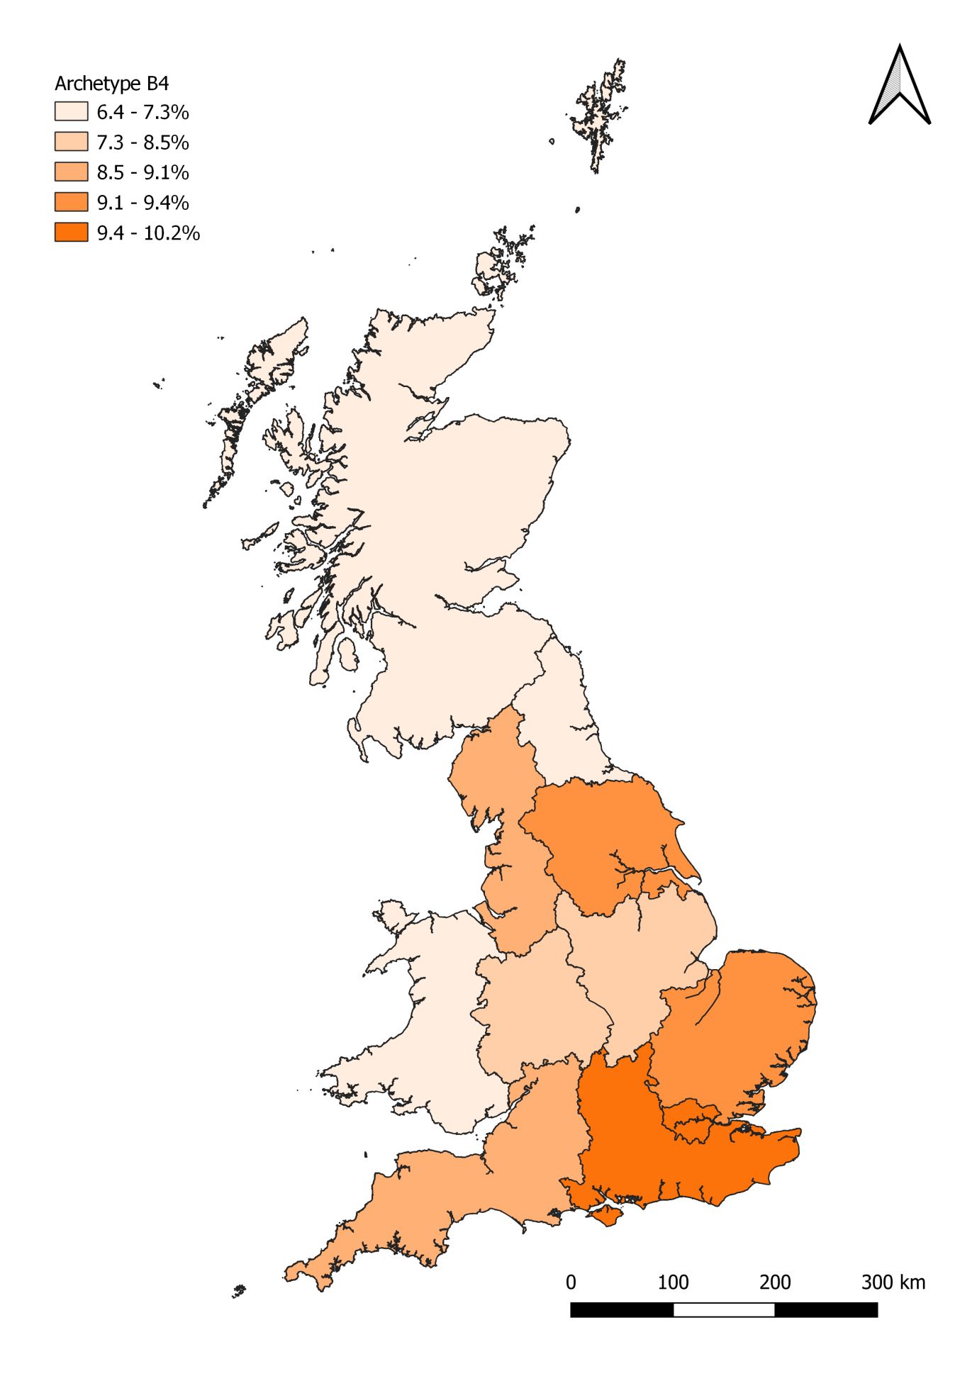

Archetype C5

Headline statistics
Archetype C5: Key statistics |  | GB-wide statistics
Number of households: | 1,922,000 | 26,390,000
Average net household income (BHC) | £15,200 | £34,100
Average net household income (AHC) | £13,200 | £29,400
Average electricity consumption (kWh) | 2,570 | 3,980
Average mains gas consumption (kWh) | 11,270 | 13,630

Key words: Very low incomes, single female adult pensioners, non-switchers, prepayment meters, disconnected (no internet or smart phones).

Summary Description
This is a group of single adult elderly pensioners on very low incomes, with 45% estimated to be living below the poverty line. Half are single female households and more than half are over 75 years of age. While few are in receipt of specific disability benefits, a fifth have a long term limiting health condition that affects daily activities a lot, and a further 20% have less significant long term health conditions.
Over half live in their own homes, with the rest living in either housing association or local authority properties. These homes are typically semi-detached or terrace houses, or purpose built flats. Many have lived in these homes for a significant period of time, with 35% having lived in their home for more than 30 years.
Only very few of these households (7%) have access to the internet at home and they do not engage with the energy market at all, most having never switched supplier. They are the least likely archetype to buy new market products and none own smart phones.
These are relatively low energy users, and have low percentage of being in arrears on fuel bills. While some use Direct Debit to pay for bills, a significant proportion pay quarterly or use prepayment meters.

Summary profile
Archetype C5: Profile
 | Archetype | GB profile
Age profile  (head of household) | 55-64: 9%  65-74: 22%  75+: 56% | 16-24: 3%  25-34: 14%  35-44: 17%  45-54: 20%  55-64: 17%  65-74: 15%  75+: 14%
Main tenure(s) | Housing association: 12%  Local authority: 19%  Owner occupied: 61% | Housing association: 8%  Local authority: 8%  Owner occupied: 65%  Private rented: 18%
Household composition | Couple: 22%  Single adult (man): 24%  Single adult (woman): 49% | Couple: 34%  Couple with children: 20%  Single adult: 28%  Single parent: 5%  Other: 11%
Households with children | 4% | 29%
Economic status (head of household) | Retired: 83%
Main heating fuel of dwelling | Mains gas
 | Archetype | GB average
Internet in the home | 7% | 88%
Use smart phones to access the internet | 0% | 46%
Any engagement with energy market in last 12mths | 0% | 41%
Have a degree qualification (or higher) | 3% | 26%
Long term health conditions that affect daily activities a lot (HoH) | 23% | 12%
Households on disability benefits | 0% | 13%
Households in poverty (income below 60% of national median) | 45% | 20%
Been in arrears on electricity or gas bills | 0.9% | 2.3%
Electric or hybrid vehicle ownership | 0.2% | 0.8%
Rural population | 17% | 22%

Figure 17: Archetype C5 – Equivalised income distribution (OECD equivalised income decile)
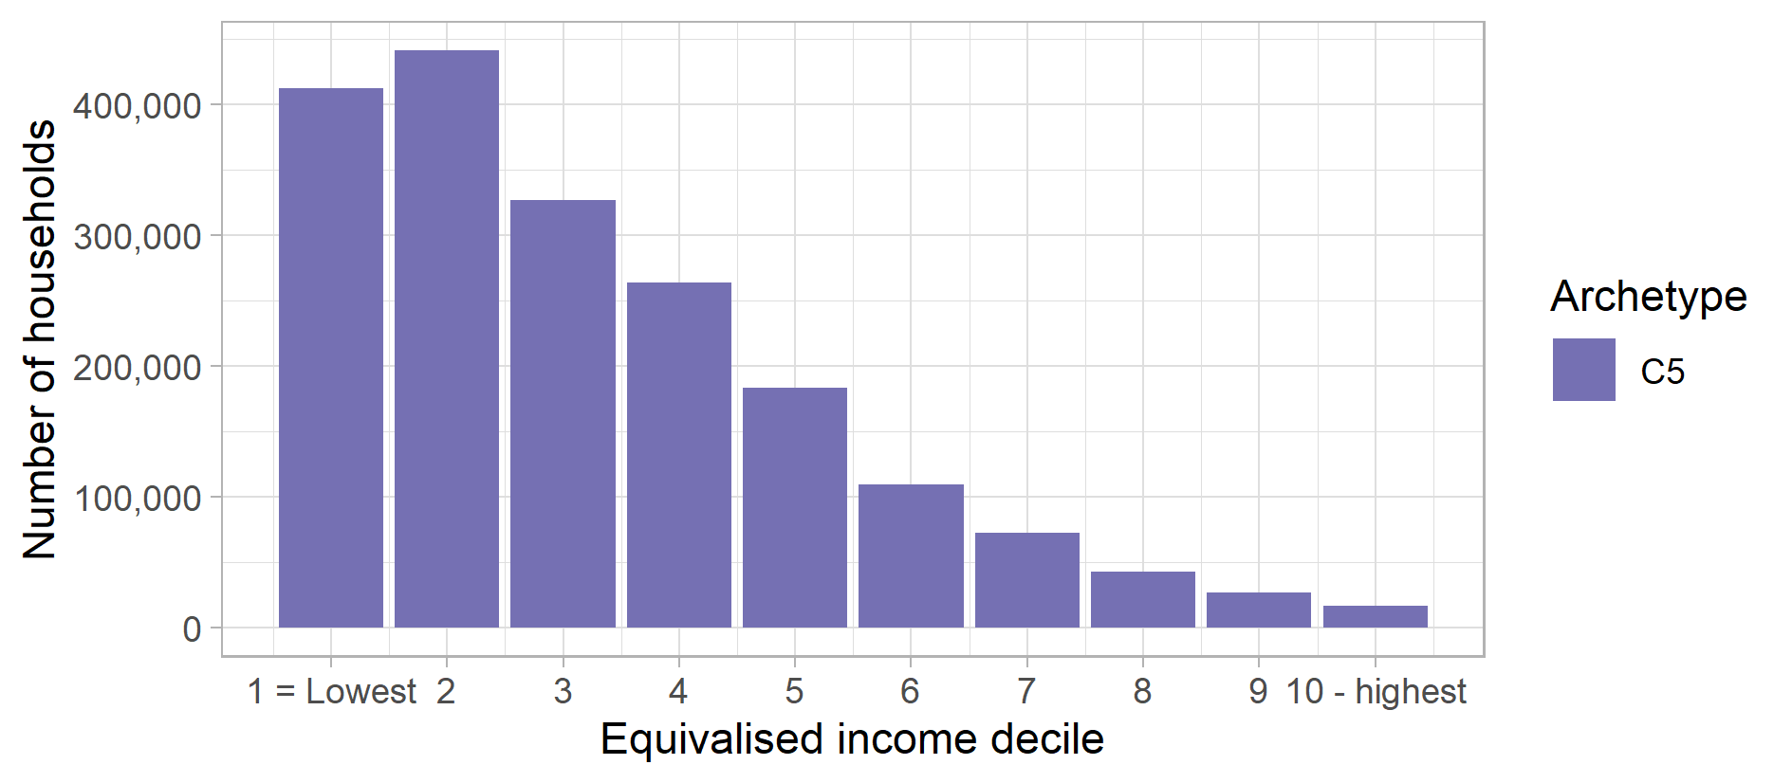
Figure 18: Archetype C5 – Gas consumption distribution (Mains gas kWh decile)
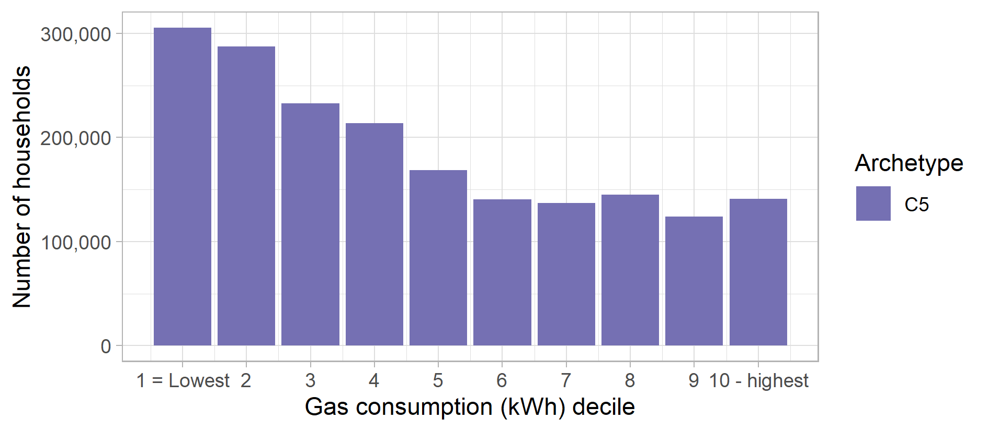
Figure 19: Archetype C5 – Electricity consumption distribution (Electricity kWh decile)
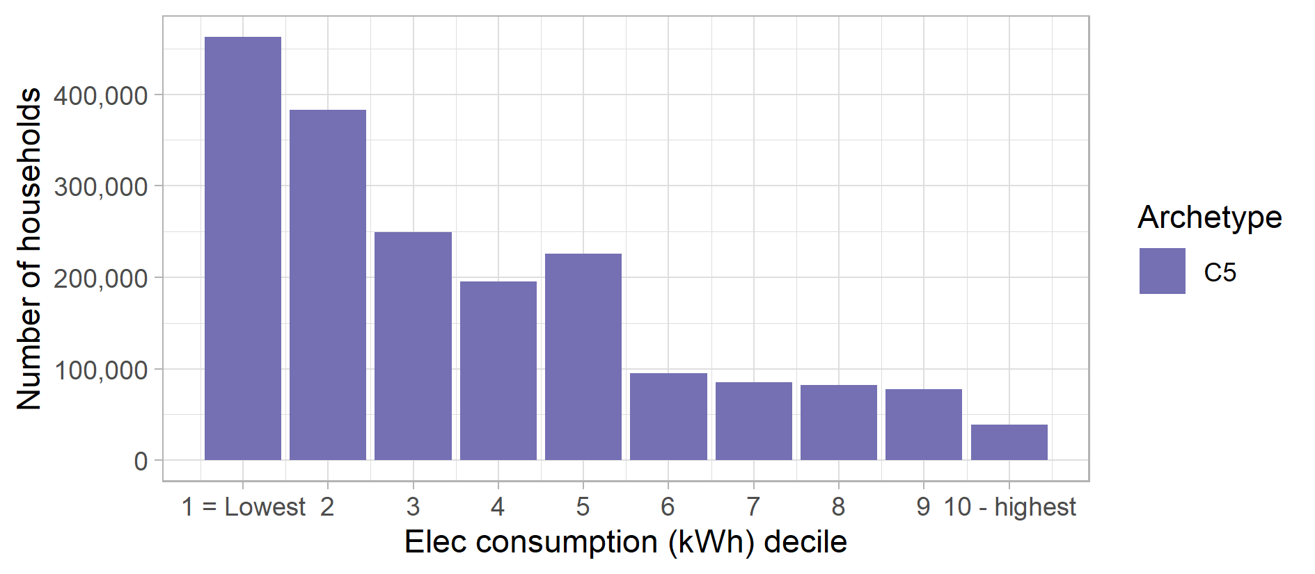

Figure 20: Archetype C5 – Proportion of population in each English region and devolved nation of Great Britain
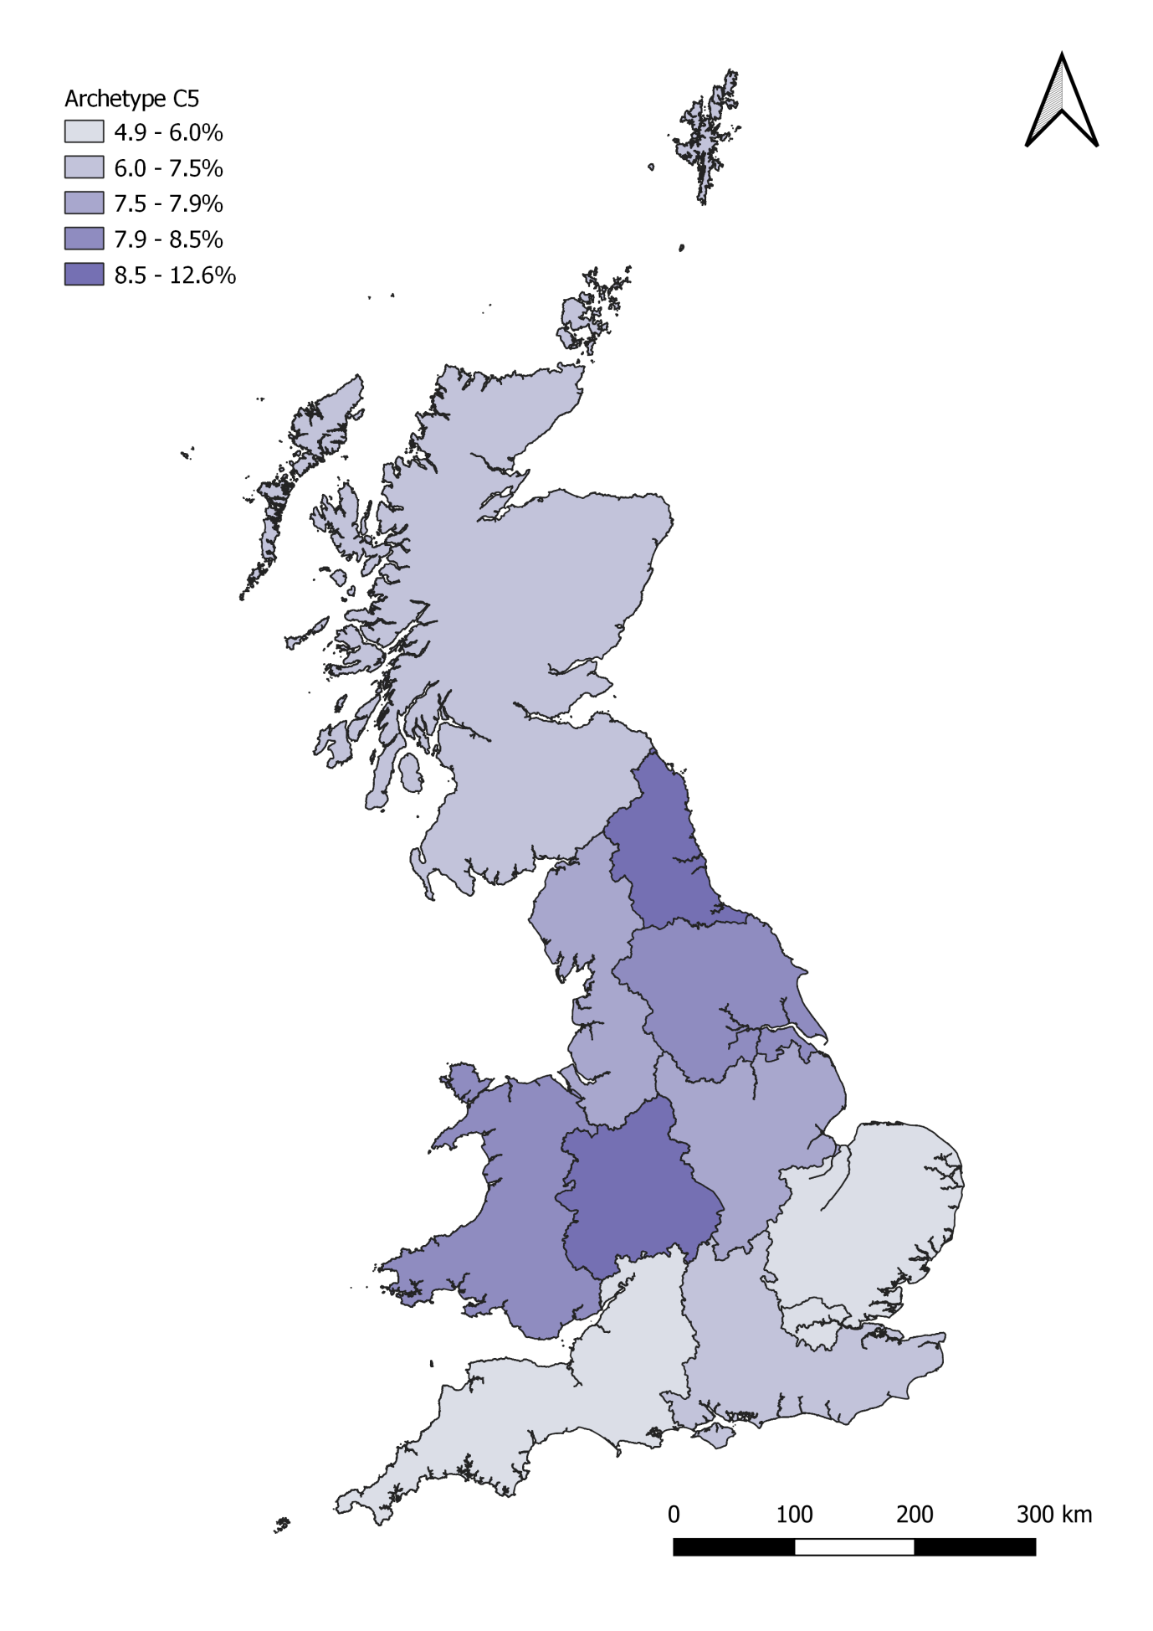

Archetype D6

Headline statistics
Archetype D6: Key statistics |  | GB-wide statistics
Number of households: | 1,547,000 | 26,390,000
Average net household income (BHC) | £18,100 | £34,100
Average net household income (AHC) | £13,600 | £29,400
Average electricity consumption (kWh) | 3,920 | 3,980
Average mains gas consumption (kWh) | 12,340 | 13,630

Keywords: Low income, disability, fuel debt, prepayment meter, disengaged, social housing, BME households, single parents.

Summary Description
These households are below retirement age, on low incomes and in receipt of disability benefits, with more than half estimated to be in poverty. Many are out of work due to health issues (56%) or retired (27%). Over half (55%) have long term limiting health conditions that significantly affect day-to-day activities. Only 5% have a degree qualification.
Households are single adults, couples or families, including a high proportion of single parents. Most live in socially rented flats or terraces, with 15% privately renting. Being predominantly social housing, these homes tend to be quite energy efficient – it is estimated that around 50% of homes are rated in EPC band C or higher – and on average this group consumes less electricity and gas than typical GB consumption rates.
However, these consumers are the most likely to have experienced difficulty in paying their utility bills, with 8% getting in arrears recently. The most common method of paying for electricity and gas is via a prepayment meter, possibly as a result of some of them having fallen into arrears. Only 12% have considered changing their energy supplier the last year and nearly 80% have never switched supplier at all.
Two-fifths of the group does not have a personal computer in their home, while a third don’t have internet connection and only 30% have a smart phone. Very few are interested in new technology and market products.

Summary profile
Archetype D6: Profile
 | Archetype | GB profile
Age profile  (head of household) | 25-34: 11%  35-44: 16%  45-54: 22%  55-64: 23%  65-74: 12% | 16-24: 3%  25-34: 14%  35-44: 17%  45-54: 20%  55-64: 17%  65-74: 15%  75+: 14%
Main tenure(s) | Housing association: 34%  Local authority: 34%  Private rented: 15% | Housing association: 8%  Local authority: 8%  Owner occupied: 65%  Private rented: 18%
Household composition | Couple: 24%  Couple with children: 14%  Single adult: 38%  Single parent: 9% | Couple: 34%  Couple with children: 20%  Single adult: 28%  Single parent: 5%  Other: 11%
Households with children | 28% | 29%
Economic status (head of household) | Not working & under pension age: 56%  Retired & above pension age: 27%
Main heating fuel of dwelling | Mains gas
 | Archetype | GB average
Internet in the home | 67% | 88%
Use smart phones to access the internet | 30% | 46%
Any engagement with energy market in last 12mths | 12% | 41%
Have a degree qualification (or higher) | 5% | 26%
Long term health conditions that affect daily activities a lot (HoH) | 55% | 12%
Households on disability benefits | 100% | 13%
Households in poverty (income below 60% of national median) | 52% | 20%
Been in arrears on electricity or gas bills | 8.5% | 2.3%
Electric or hybrid vehicle ownership | 0.0% | 0.8%
Rural population | 11% | 22%
Figure 21: Archetype D6 – Equivalised income distribution (OECD equivalised income decile)
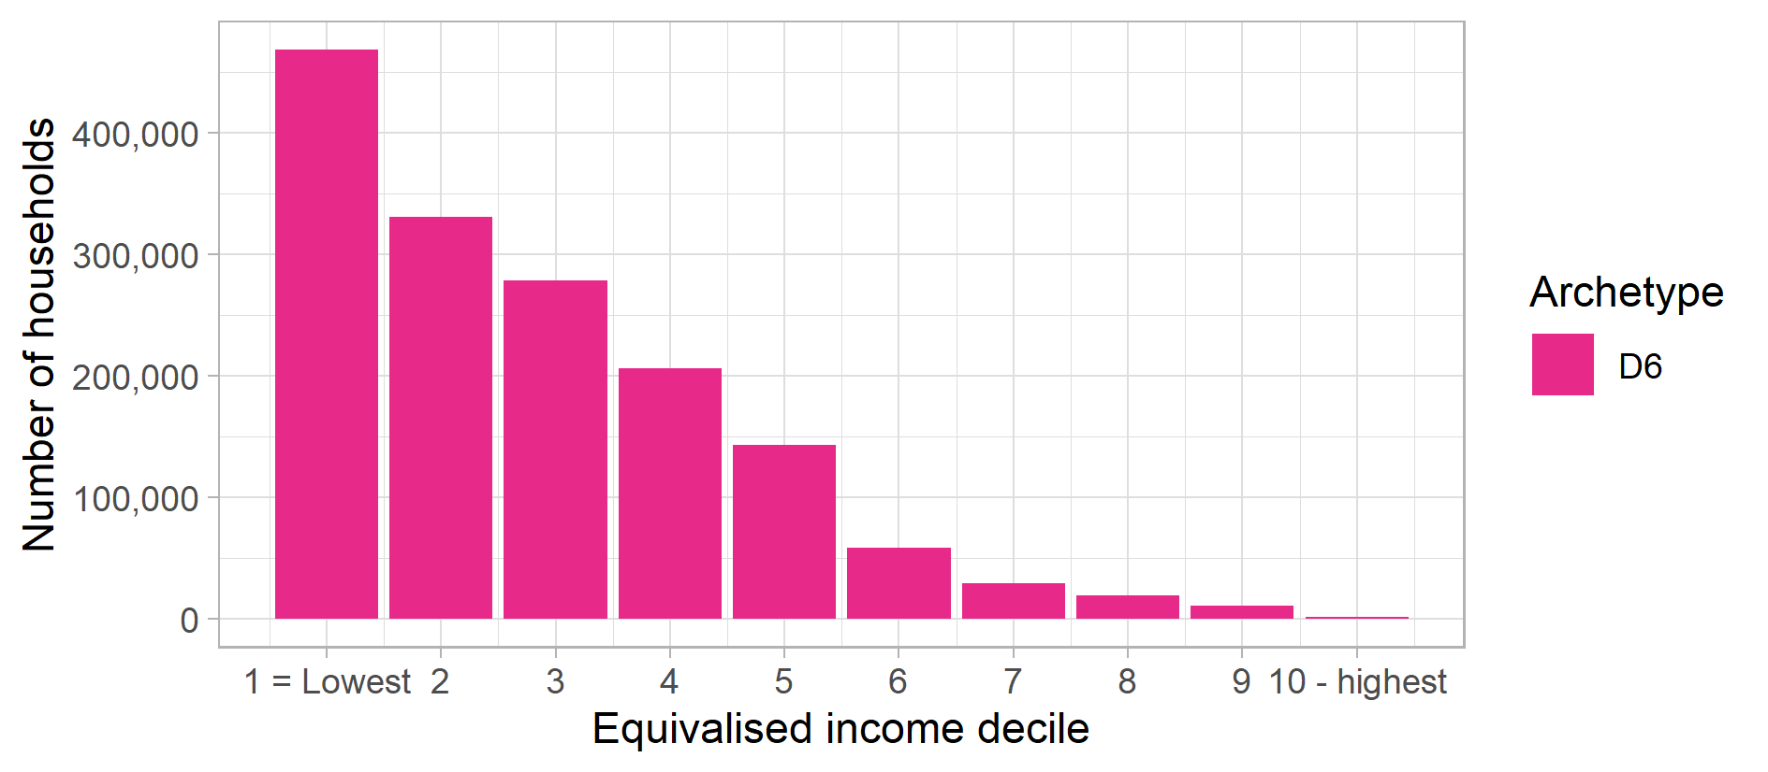
Figure 22: Archetype D6 – Gas consumption distribution (Mains gas kWh decile)
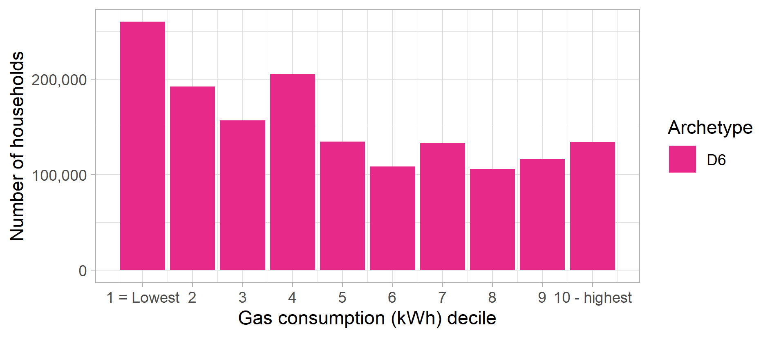
Figure 23: Archetype D6 – Electricity consumption distribution (Electricity kWh decile)
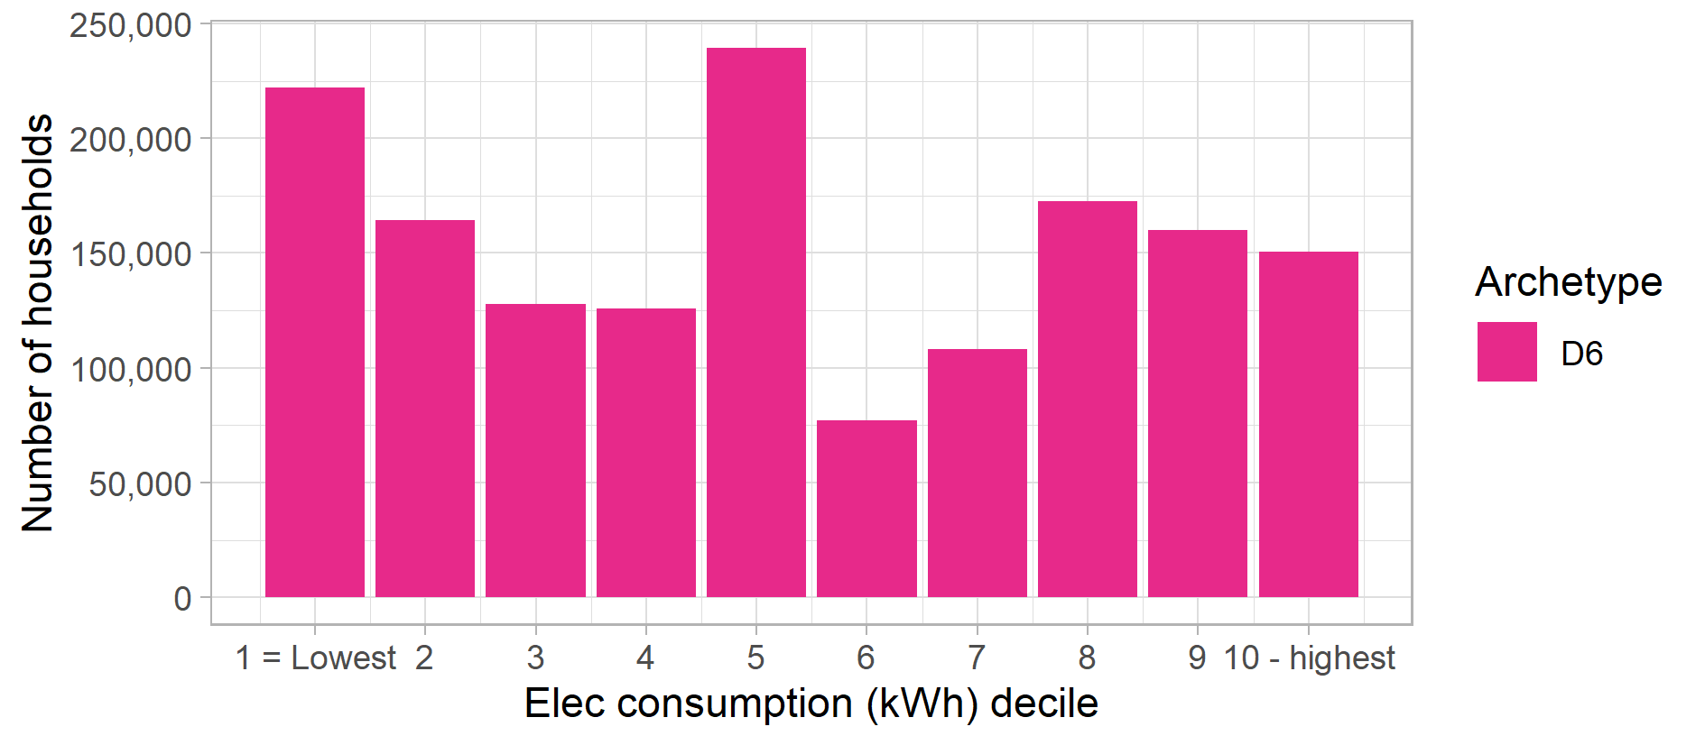

Figure 24: Archetype D6 – Proportion of population in each English region and devolved nation of Great Britain
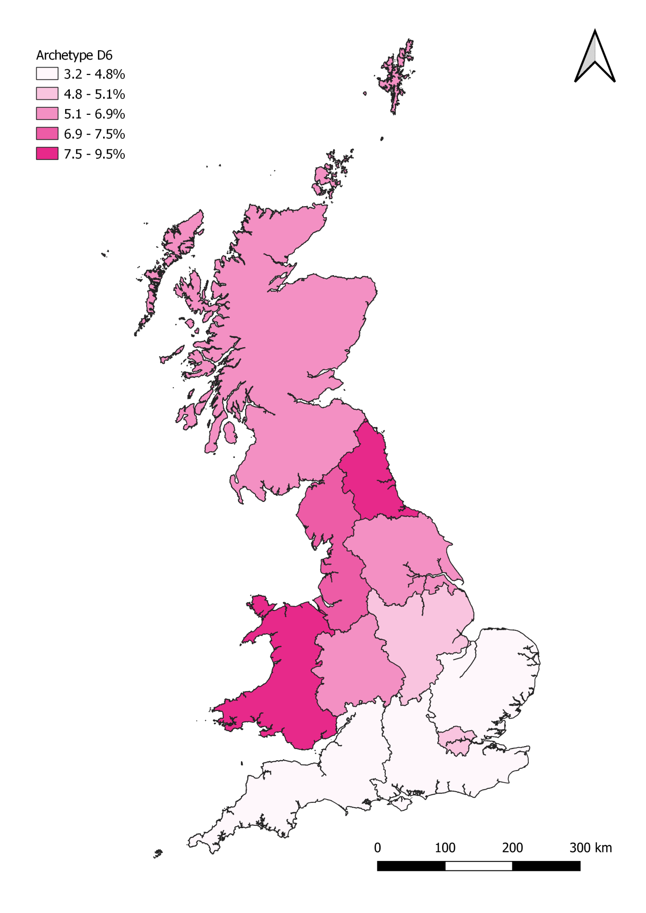

Archetype D7

Headline statistics
Archetype D7: Key statistics |  | GB-wide statistics
Number of households: | 1,205,000 | 26,390,000
Average net household income (BHC) | £34,000 | £34,100
Average net household income (AHC) | £30,400 | £29,400
Average electricity consumption (kWh) | 4,140 | 3,980
Average mains gas consumption (kWh) | 15,600 | 13,630

Key words: Middle aged to pensioners, full time work or retired, disability benefits, above average incomes, high consumers.

Summary Description
This is a group of middle aged or older households who are on disability benefits, but are on average incomes. They mostly own their own homes, although a small minority rent privately, which are either detached, semi-detached or terraced houses. Around a half of these households have long term health conditions which either slight impact (18%) or significantly impact (32%) on their day to day activities.
This archetype is a mix of couples, families, multiple adult households, and single adult households. A third are in full time employment, a third are retired, and a further 20% are below the retirement age and not working due to long term health conditions. Only 14% are estimated to be below the poverty line, compared with a national rate of 20%.
All have access to the internet at home and over half will have considered switching energy supplier in the last 12 months, and nearly all have switched supplier at least once in the past. Most (more than 90%) pay their energy bills by Direct Debit, but have high electricity and gas consumption on average and a significant proportion (6.5% - three times the national average) will have had difficulty paying their gas or electricity bills over the last year.

Summary profile
Archetype D7: Profile
 | Archetype | GB profile
Age profile  (head of household) | 45-54: 24%  55-64: 22%  65-74: 22%  75+: 15% | 16-24: 3%  25-34: 14%  35-44: 17%  45-54: 20%  55-64: 17%  65-74: 15%  75+: 14%
Main tenure(s) | Owner occupied: 79%  Private rented: 8% | Housing association: 8%  Local authority: 8%  Owner occupied: 65%  Private rented: 18%
Household composition | Couple: 37%  Couple with children: 18%  Multiple adults: 17%  Single adult: 16% | Couple: 34%  Couple with children: 20%  Single adult: 28%  Single parent: 5%  Other: 11%
Households with children | 29% | 29%
Economic status (head of household) | Full-time employee at work: 31%  Retired & above pension age: 34%  Not working below pension age: 20%
Main heating fuel of dwelling | Mains gas
 | Archetype | GB average
Internet in the home | 100% | 88%
Use smart phones to access the internet | 47% | 46%
Any engagement with energy market in last 12mths | 56% | 41%
Have a degree qualification (or higher) | 18% | 26%
Long term health conditions that affect daily activities a lot (HoH) | 32% | 12%
Households on disability benefits | 100% | 13%
Households in poverty (income below 60% of national median) | 14% | 20%
Been in arrears on electricity or gas bills | 6.5% | 2.3%
Electric or hybrid vehicle ownership | 1.4% | 0.8%
Rural population | 18% | 22%
Figure 25: Archetype D7 – Equivalised income distribution (OECD equivalised income decile)
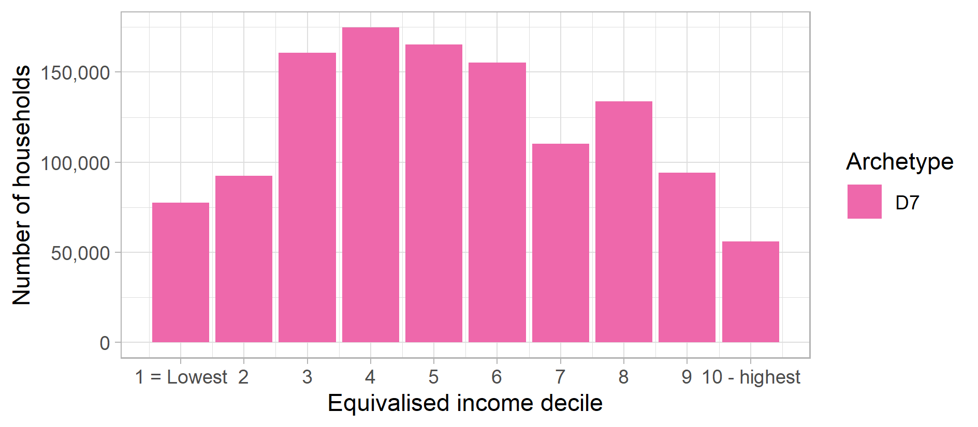
Figure 26: Archetype D7 – Gas consumption distribution (Mains gas kWh decile)
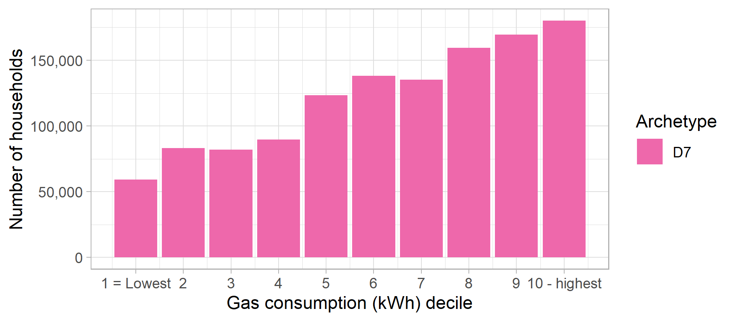
Figure 27: Archetype D7 – Electricity consumption distribution (Electricity kWh decile)
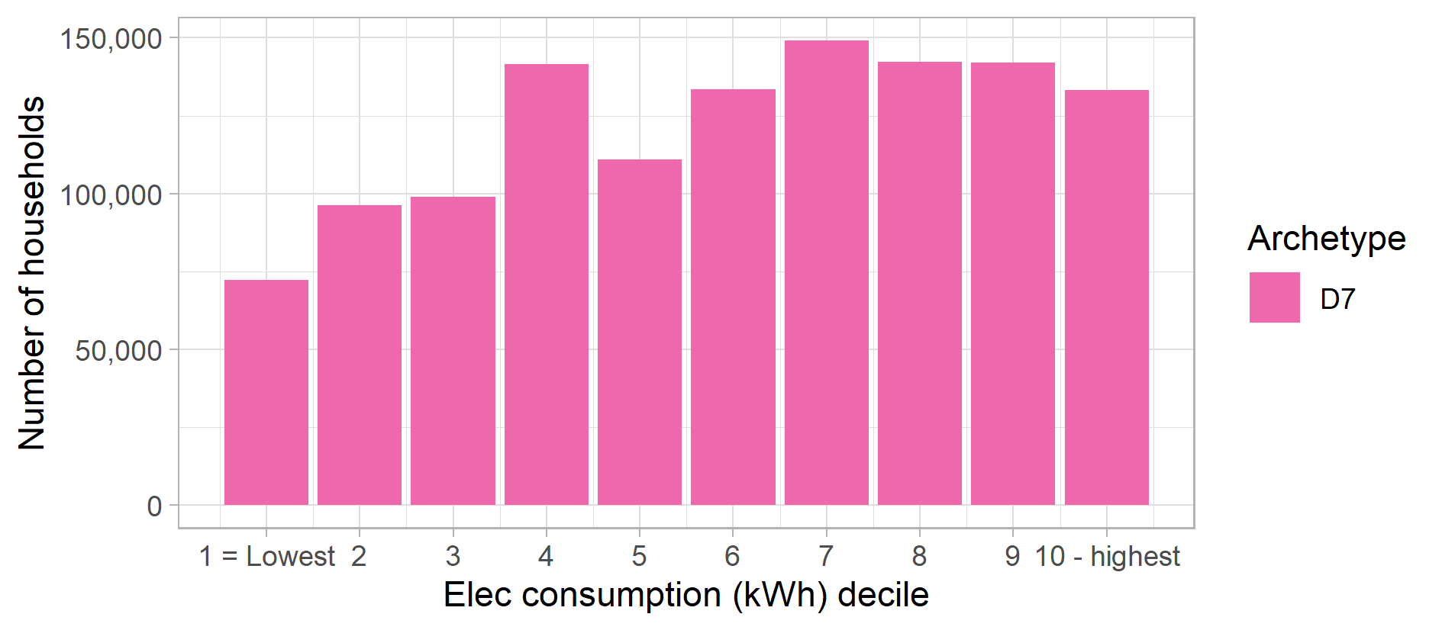

Figure 28: Archetype D7 – Proportion of population in each English region and devolved nation of Great Britain
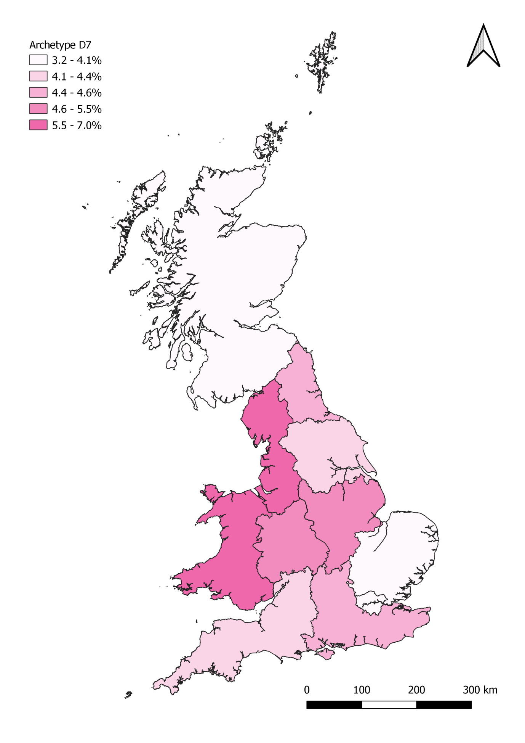

Archetype E8

Headline statistics
Archetype E8: Key statistics |  | GB-wide statistics
Number of households: | 2,356,000 | 26,390,000
Average net household income (BHC) | £23,400 | £34,100
Average net household income (AHC) | £16,200 | £29,400
Average electricity consumption (kWh) | 3,620 | 3,980
Average mains gas consumption (kWh) | 11,950 | 13,630

Key words: Low income, younger households, part-time work or unemployed, private or social renters, disengaged non-switchers.

Summary Description
These are younger, low income renters, mostly below the age of 45, who are either out of work or work part-time. Half are living below the poverty line.
Around 50% of households are families with children and this group has the highest proportion of single parents (18%). A fifth of households are from a black or minority ethnic (BME) background.
This group lives in either terraced houses or flats in predominantly urban areas, with most privately renting. Many are on short-term lets, with a quarter of households living in their current home for less than a year, and half for less than 2 years.
They have good access to the internet at home and many are smart phone users. However, this group has very low levels of engagement with the energy market. More households pay their energy bills either quarterly or using prepayment meters rather than Direct Debit and they are around three times as likely to have had difficulties paying their energy bills compared to the national average.

Summary profile
Archetype E8: Profile
 | Archetype | GB profile
Age profile  (head of household) | 16-24: 10%  25-34: 25%  35-44: 23%  45-54: 17% | 16-24: 3%  25-34: 14%  35-44: 17%  45-54: 20%  55-64: 17%  65-74: 15%  75+: 14%
Main tenure(s) | Housing association: 20%  Local authority: 24%  Private rented: 50% | Housing association: 8%  Local authority: 8%  Owner occupied: 65%  Private rented: 18%
Household composition | Couple: 20%  Couple with children: 25%  Single adult: 22%  Single parent: 18% | Couple: 34%  Couple with children: 20%  Single adult: 28%  Single parent: 5%  Other: 11%
Households with children | 48% | 29%
Economic status (head of household) | Part-time employee at work: 35%  Not working below pension age: 17%  Self-employed: 19%  Unemployed: 11%
Main heating fuel of dwelling | Mains gas
 | Archetype | GB average
Internet in the home | 96% | 88%
Use smart phones to access the internet | 53% | 46%
Any engagement with energy market in last 12mths | 19% | 41%
Have a degree qualification (or higher) | 20% | 26%
Long term health conditions that affect daily activities a lot (HoH) | 8% | 12%
Households on disability benefits | 1% | 13%
Households in poverty (income below 60% of national median) | 48% | 20%
Been in arrears on electricity or gas bills | 7.7% | 2.3%
Electric or hybrid vehicle ownership | 0.2% | 0.8%
Rural population | 11% | 22%
Figure 29: Archetype E8 – Equivalised income distribution (OECD equivalised income decile)
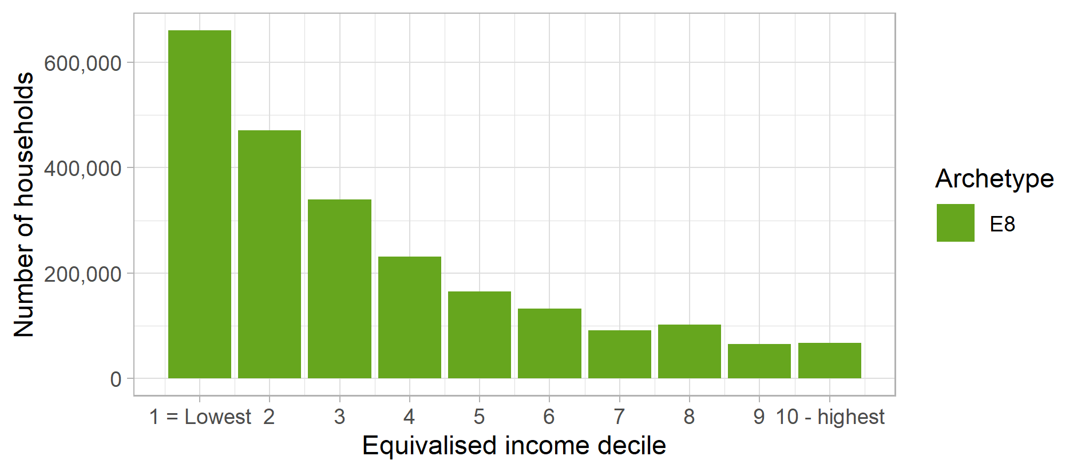
Figure 30: Archetype E8 – Gas consumption distribution (Mains gas kWh decile)
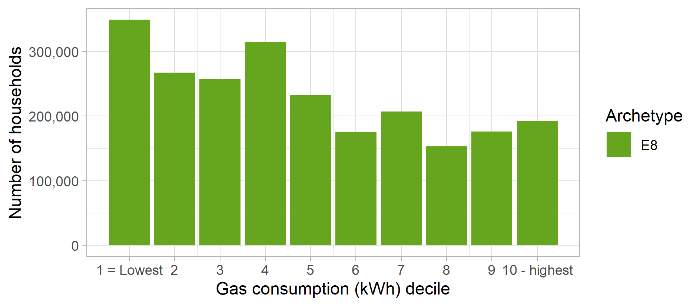
Figure 31: Archetype E8 – Electricity consumption distribution (Electricity kWh decile)
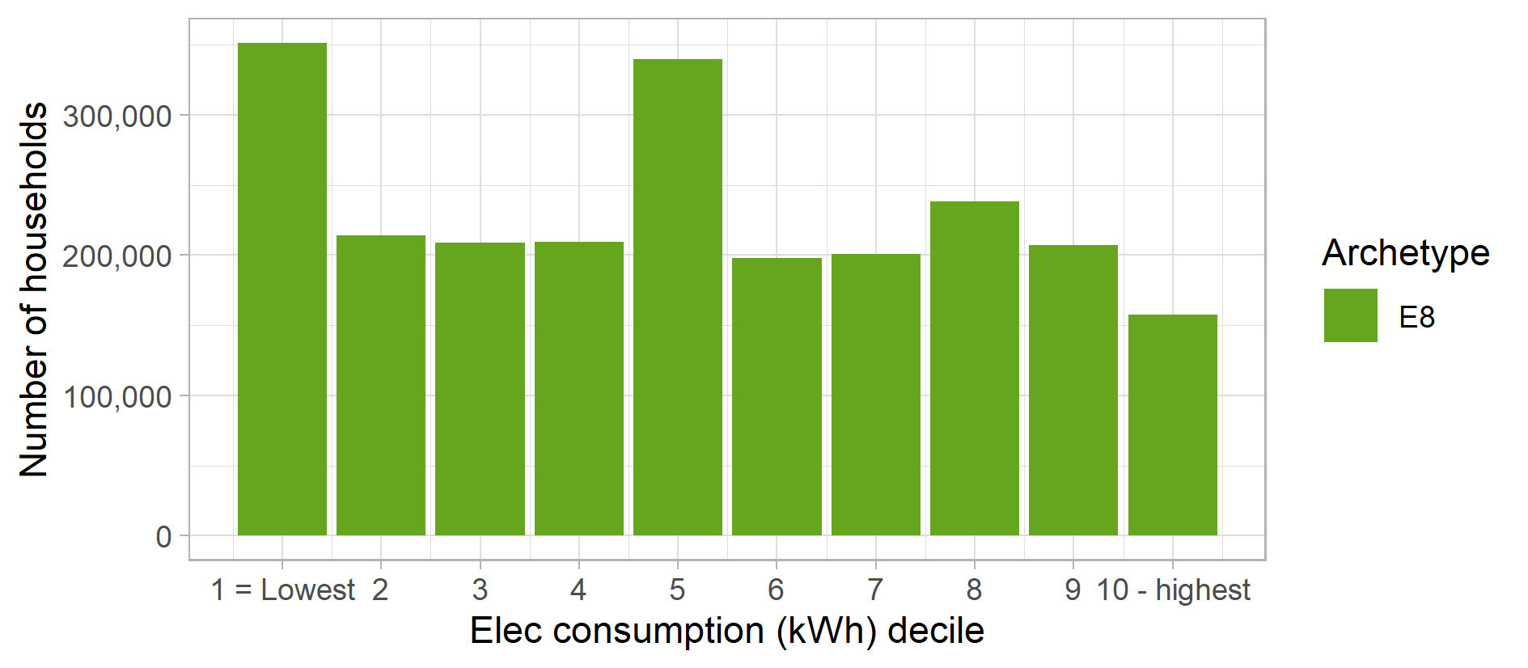

Figure 32: Archetype E8 – Proportion of population in each English region and devolved nation of Great Britain
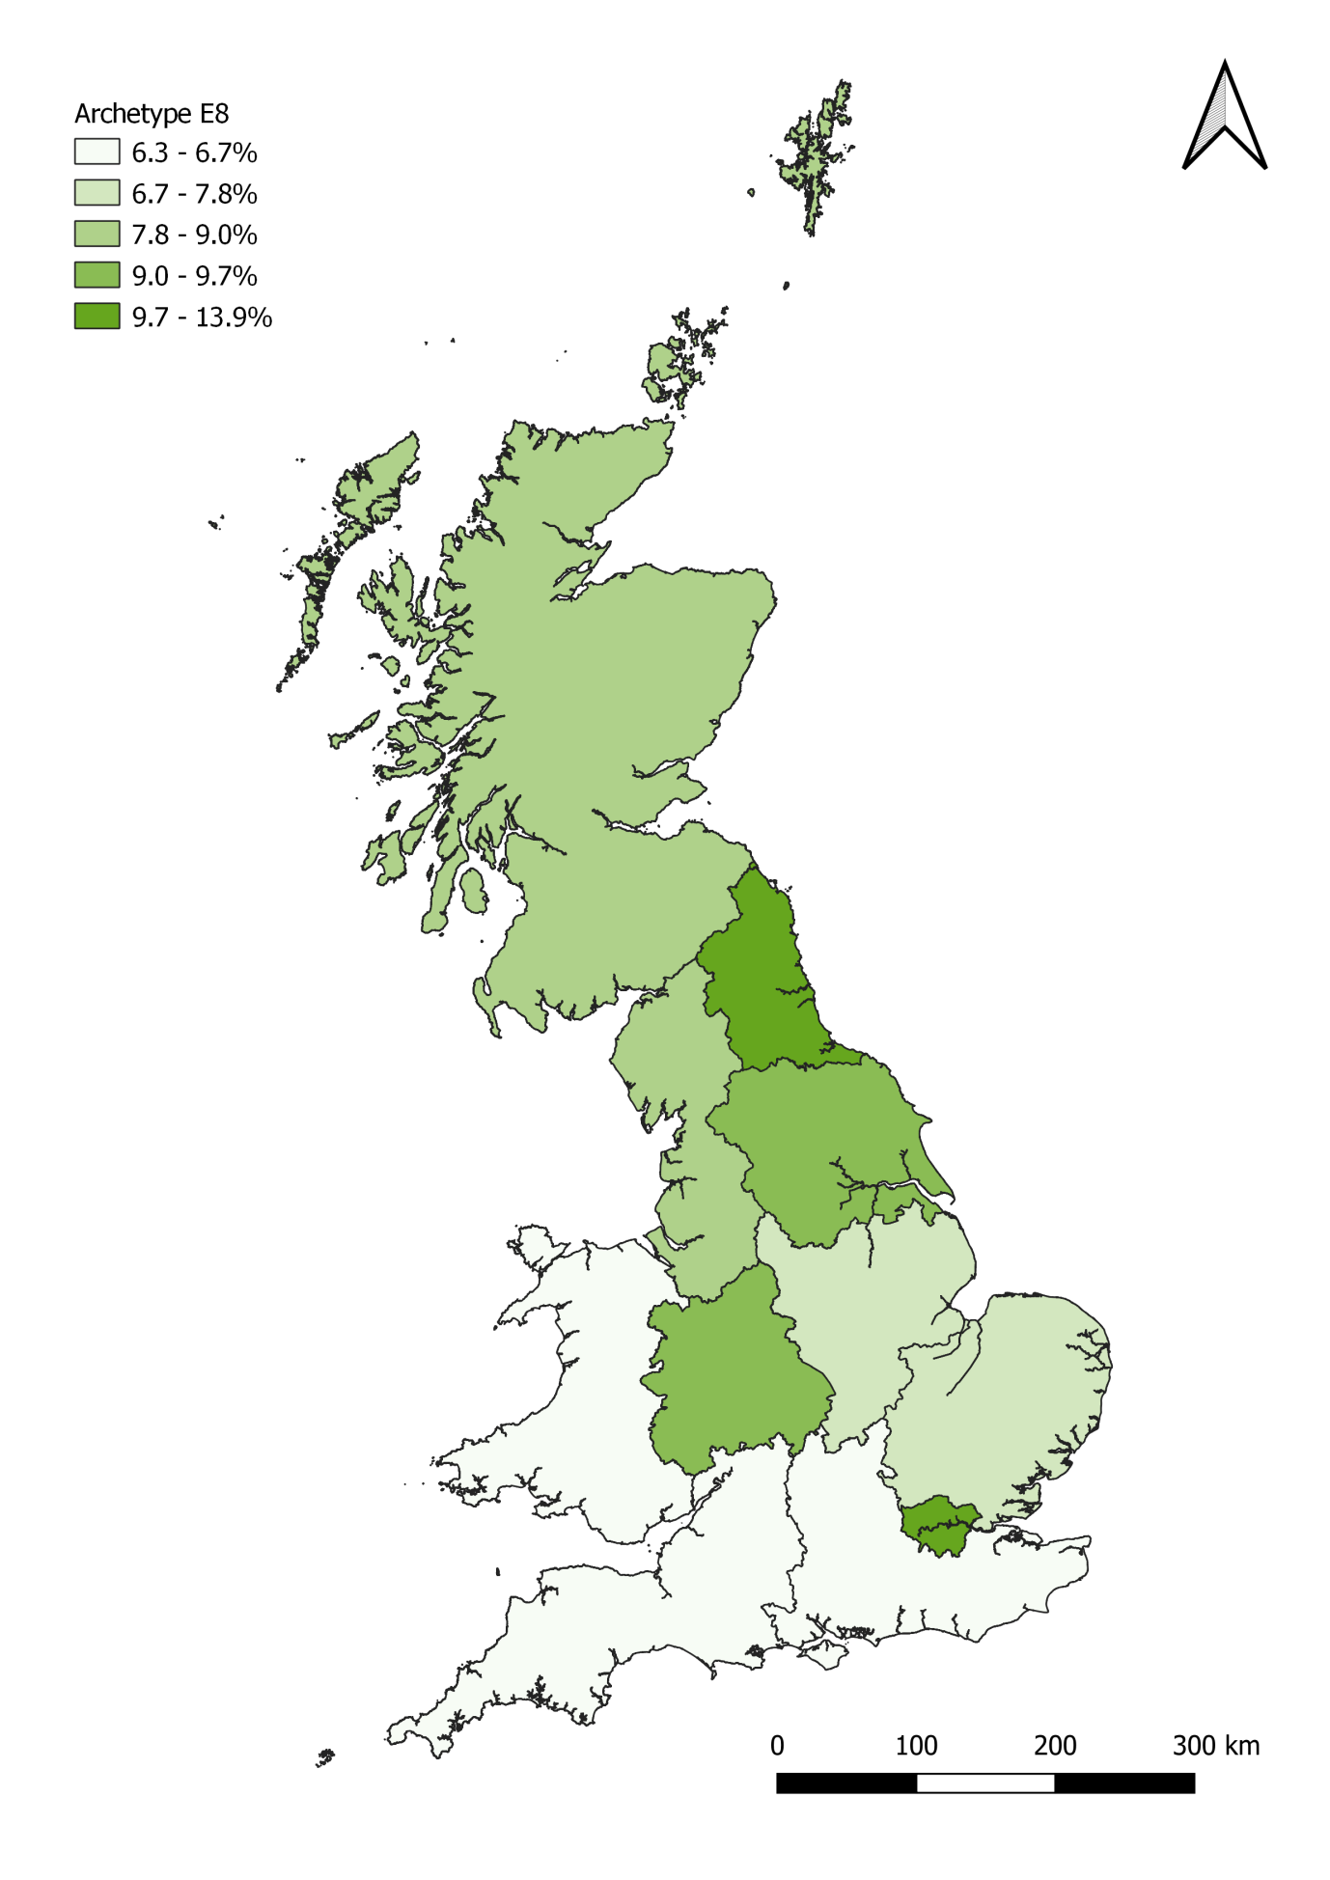

Archetype E9

Headline statistics
Archetype E9: Key statistics |  | GB-wide statistics
Number of households: | 3,093,000 | 26,390,000
Average net household income (BHC) | £37,000 | £34,100
Average net household income (AHC) | £29,700 | £29,400
Average electricity consumption (kWh) | 3,200 | 3,980
Average mains gas consumption (kWh) | 10,440 | 13,630

Key words: High income, young renters, full time employments, private renters, early adopters, smart phones.

Summary Description
This is a group of higher income renters. They are relatively younger households in early stages of their careers in full time employment and on above average salaries, and the third most educated archetype (in terms of those with a degree qualification or higher).
The households are typically couples or couples with children. They mostly live in private rented properties, although some are on the housing ladder, in urban areas in 1-3 bedroom terraces or flats. Many are on short term lets, and move frequently – over 50% have lived in their current home for less than 2 years.
They all have an internet connection in the home and most are smart phone users. They are one of the groups most likely to buy new products when they appear on the market. However, few have engaged with the energy market in the last year, and they are low rates of switching overall. Although most pay their energy bills by Direct Debit, a significant number also use prepayment meters (20%) or standard credit (15%).

Summary profile
Archetype E9: Profile
 | Archetype | GB profile
Age profile  (head of household) | 25-34: 33%  35-44: 22%  45-54: 22%  55-64: 15% | 16-24: 3%  25-34: 14%  35-44: 17%  45-54: 20%  55-64: 17%  65-74: 15%  75+: 14%
Main tenure(s) | Housing association: 8%  Local authority: 11%  Owner occupied: 22%  Private rented: 60% | Housing association: 8%  Local authority: 8%  Owner occupied: 65%  Private rented: 18%
Household composition | Couple: 36%  Couple with children: 25%  Single adult: 22% | Couple: 34%  Couple with children: 20%  Single adult: 28%  Single parent: 5%  Other: 11%
Households with children | 32% | 29%
Economic status (head of household) | Full-time employee at work: 100%
Main heating fuel of dwelling | Mains gas
 | Archetype | GB average
Internet in the home | 99% | 88%
Use smart phones to access the internet | 57% | 46%
Any engagement with energy market in last 12mths | 9% | 41%
Have a degree qualification (or higher) | 36% | 26%
Long term health conditions that affect daily activities a lot (HoH) | 2% | 12%
Households on disability benefits | 0% | 13%
Households in poverty (income below 60% of national median) | 6% | 20%
Been in arrears on electricity or gas bills | 2.1% | 2.3%
Electric or hybrid vehicle ownership | 0.4% | 0.8%
Rural population | 14% | 22%

Figure 33: Archetype E9 – Equivalised income distribution (OECD equivalised income decile)
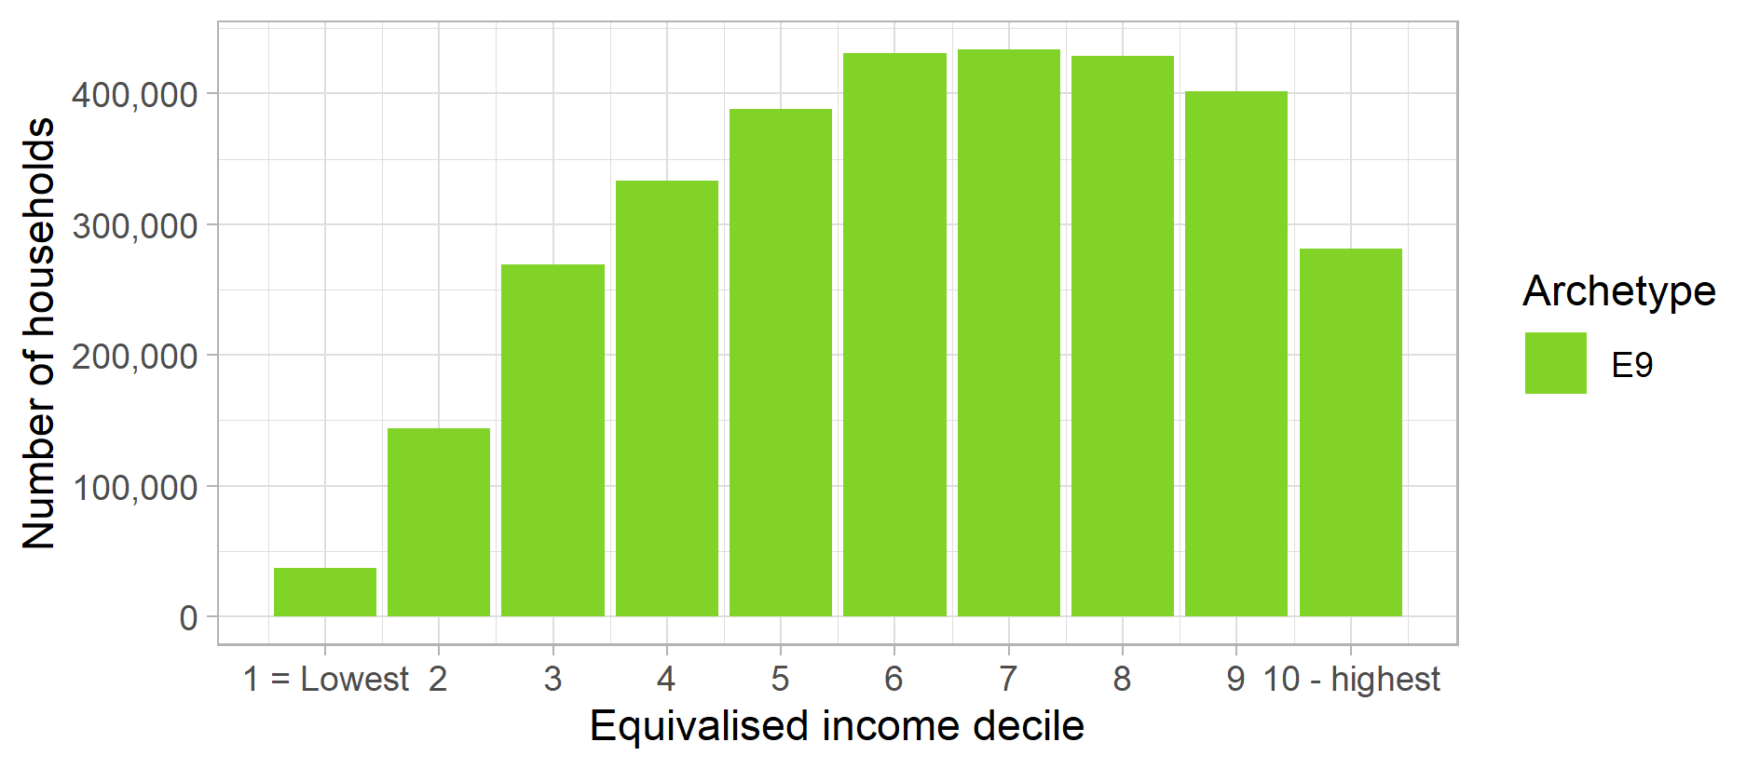
Figure 34: Archetype E9 – Gas consumption distribution (Mains gas kWh decile)
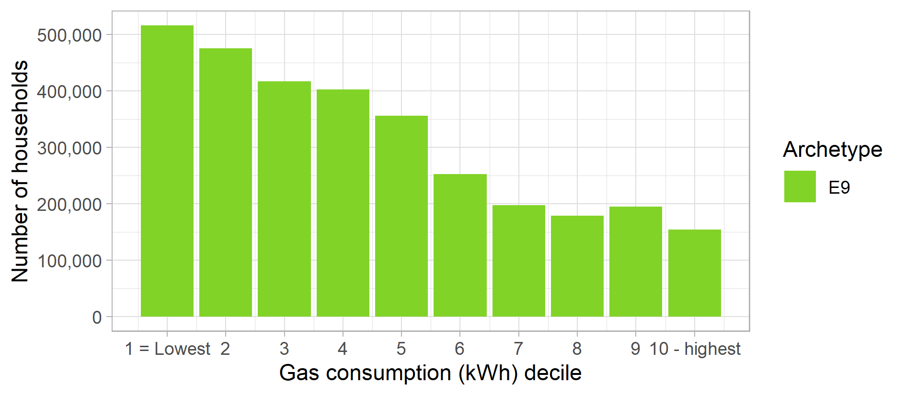
Figure 35: Archetype E9 – Electricity consumption distribution (Electricity kWh decile)
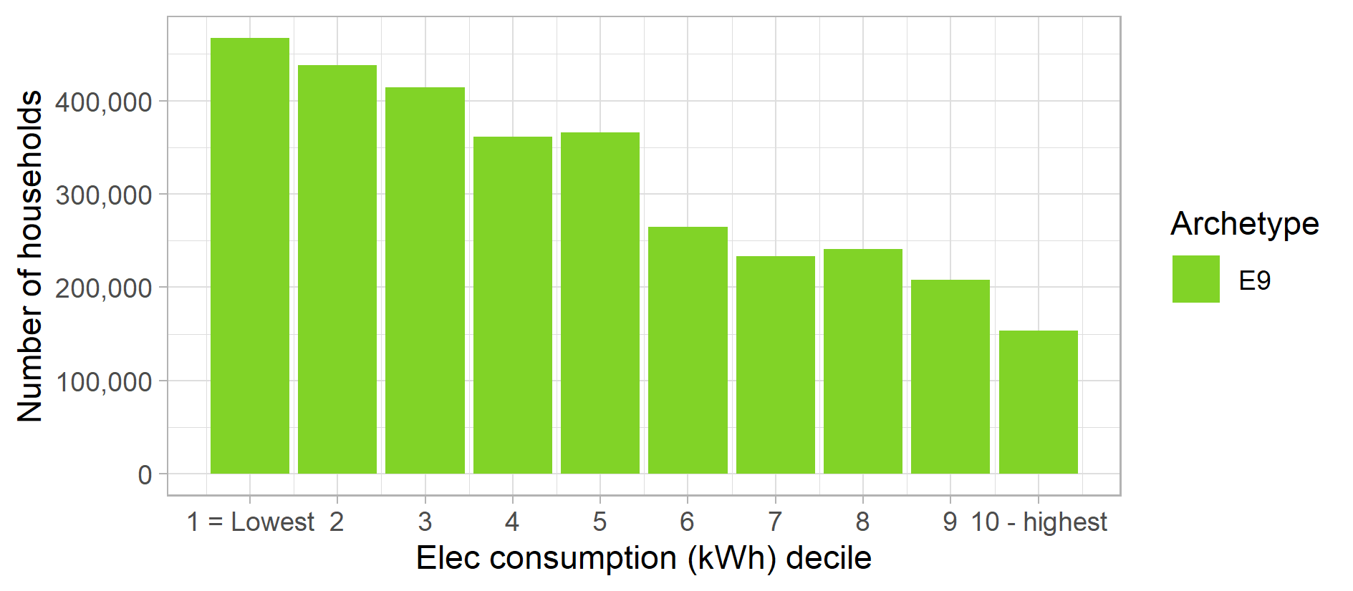

Figure 36: Archetype E9 – Proportion of population in each English region and devolved nation of Great Britain
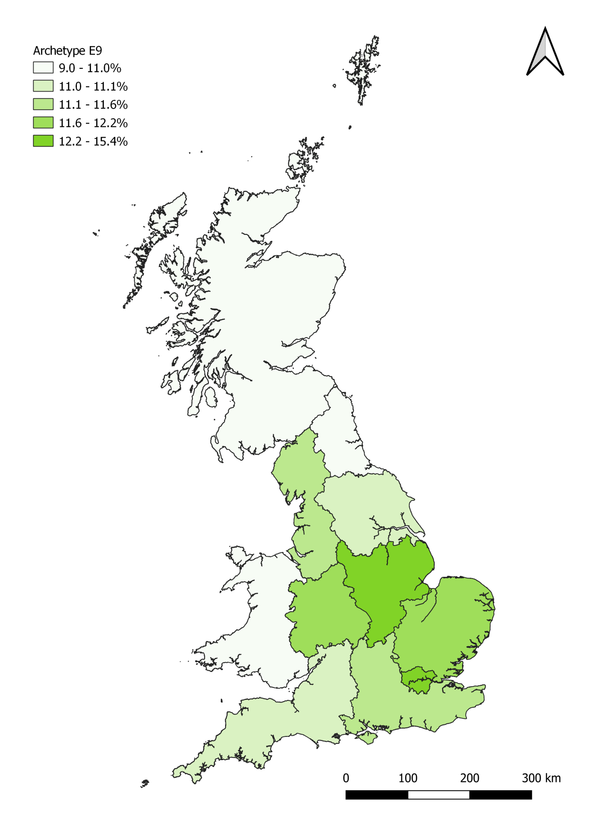

OFF-GAS ARCHETYPES
The following set of four archetypes are distinct from the previous nine as these all use fuels other than mains gas to heat their homes.
Each archetype profile for the mains gas archetypes includes the following:
- Headline statistics
- Summary description of the archetype highlighting key features
- Statistical profile
- Graphs showing the income and electricity consumption distribution of each archetype in deciles (e.g. income decile)
- Map showing the proportion of the population in each English region and devolved nation that the archetype represents

Archetype F10

Headline statistics
Archetype F10: Key statistics |  | GB-wide statistics
Number of households: | 1,912,000 | 26,390,000
Average net household income (BHC) | £38,900 | £34,100
Average net household income (AHC) | £35,400 | £29,400
Average electricity consumption (kWh) | 5,750 | 3,980

Key words: Middle aged to pensioners, full time work or retired, owner occupied, higher incomes, oil heating, rural, RHI installers, late adopters.

Summary Description
Archetype F10 is a set of middle-aged or retired households on higher incomes - mostly married couples or single adult households although a few have some older (teenage) children. They own their own dwellings and use oil (some electricity) as the main heating fuel. Half are in full time employment or self-employed while another third are retired.
These households live in rural areas in 3-5 bedroom detached or semi-detached houses. Most are well settled and have lived in their current homes for at least 10 years.
They pay for their electricity by Direct Debit and are well engaged, regular switchers – more than half have compared or switched tariff in the last 12 months. However, they are late adopters to new market products and have a lower that average smart phone usage.
They are likely to have good awareness of environmental issues and take steps to reduce their carbon footprint. For example, this archetype includes the consumers who are most likely to have installed heat pumps, biomass boilers and solar thermal systems in their homes through the RHI.

Summary profile
Archetype F10: Profile
 | Archetype | GB profile
Age profile  (head of household) | 35-44: 12%  45-54: 21%  55-64: 20%  65-74: 23% | 16-24: 3%  25-34: 14%  35-44: 17%  45-54: 20%  55-64: 17%  65-74: 15%  75+: 14%
Main tenure(s) | Owner occupied: 94% | Housing association: 8%  Local authority: 8%  Owner occupied: 65%  Private rented: 18%
Household composition | Couple: 44%  Couple with children: 18%  Single adult: 24% | Couple: 34%  Couple with children: 20%  Single adult: 28%  Single parent: 5%  Other: 11%
Households with children | 24% | 29%
Economic status (head of household) | Full-time employee at work: 35%  Retired: 34%  Self-employed: 15%
Main heating fuel of dwelling | Oil, electricity
 | Archetype | GB average
Internet in the home | 98% | 88%
Use smart phones to access the internet | 41% | 46%
Any engagement with energy market in last 12mths | 56% | 41%
Have a degree qualification (or higher) | 29% | 26%
Long term health conditions that affect daily activities a lot (HoH) | 6% | 12%
Households on disability benefits | 1% | 13%
Households in poverty (income below 60% of national median) | 12% | 20%
Been in arrears on electricity or gas bills | 0.9% | 2.3%
Electric or hybrid vehicle ownership | 1.3% | 0.8%
Rural population | 63% | 22%
Figure 37: Archetype F10 – Equivalised income distribution (OECD equivalised income decile)
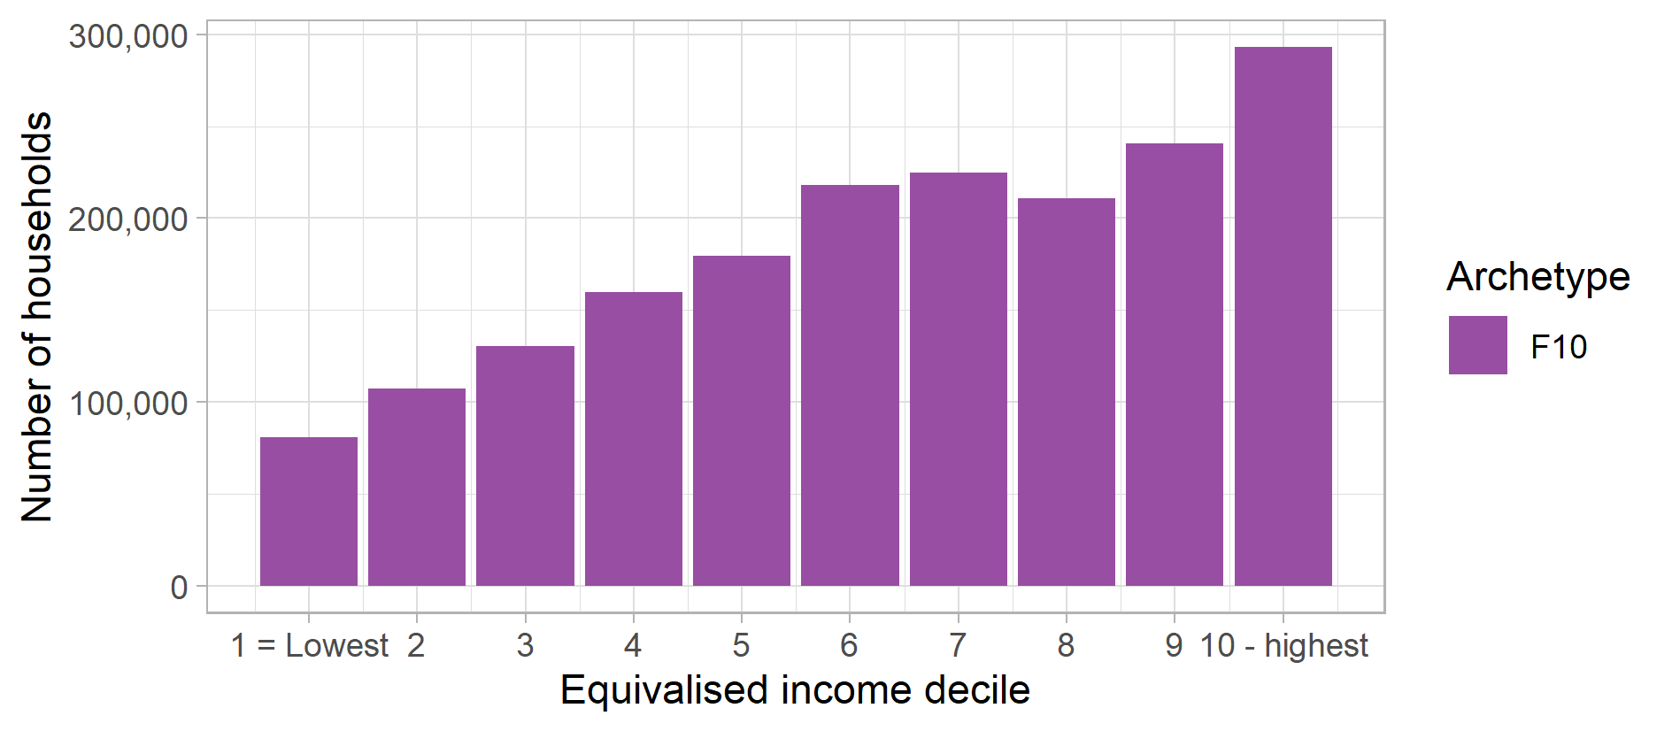
Figure 38: Archetype F10 – Electricity consumption distribution (Electricity kWh decile)
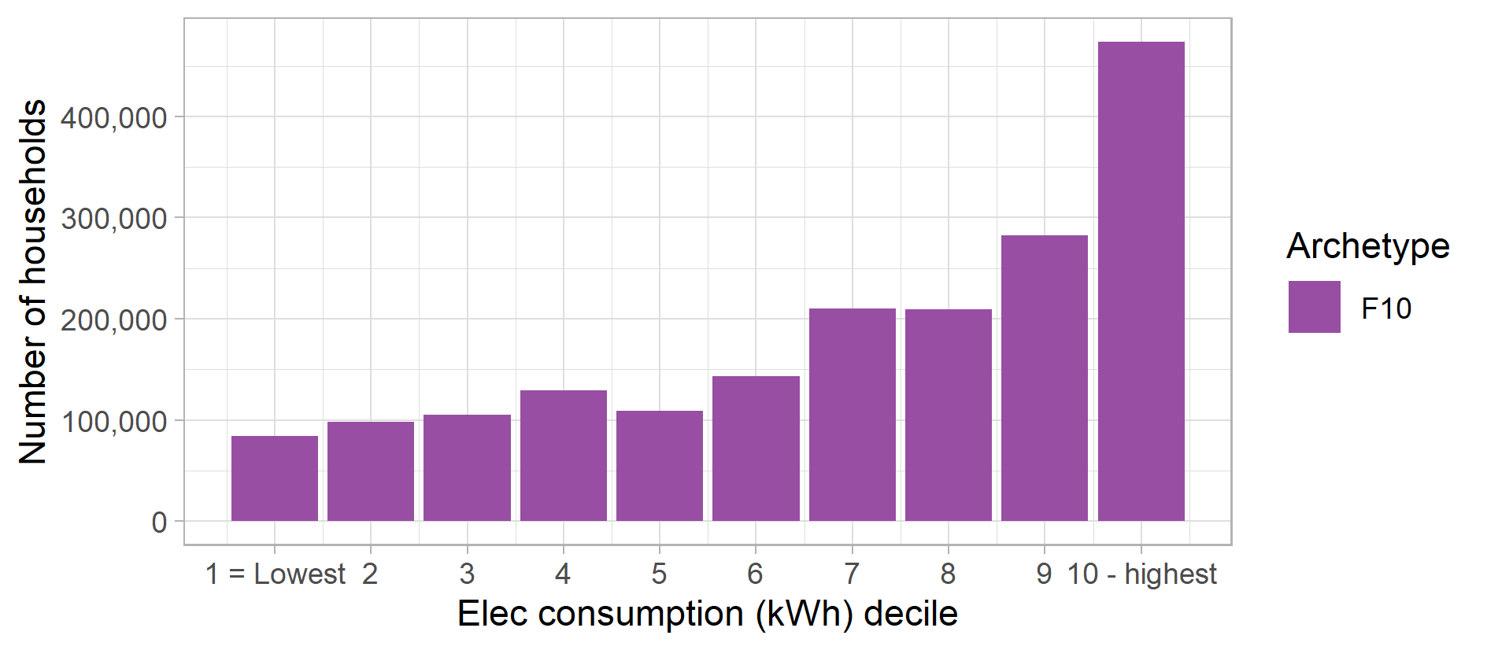

Figure 39: Archetype F10 – Proportion of population in each English region and devolved nation of Great Britain
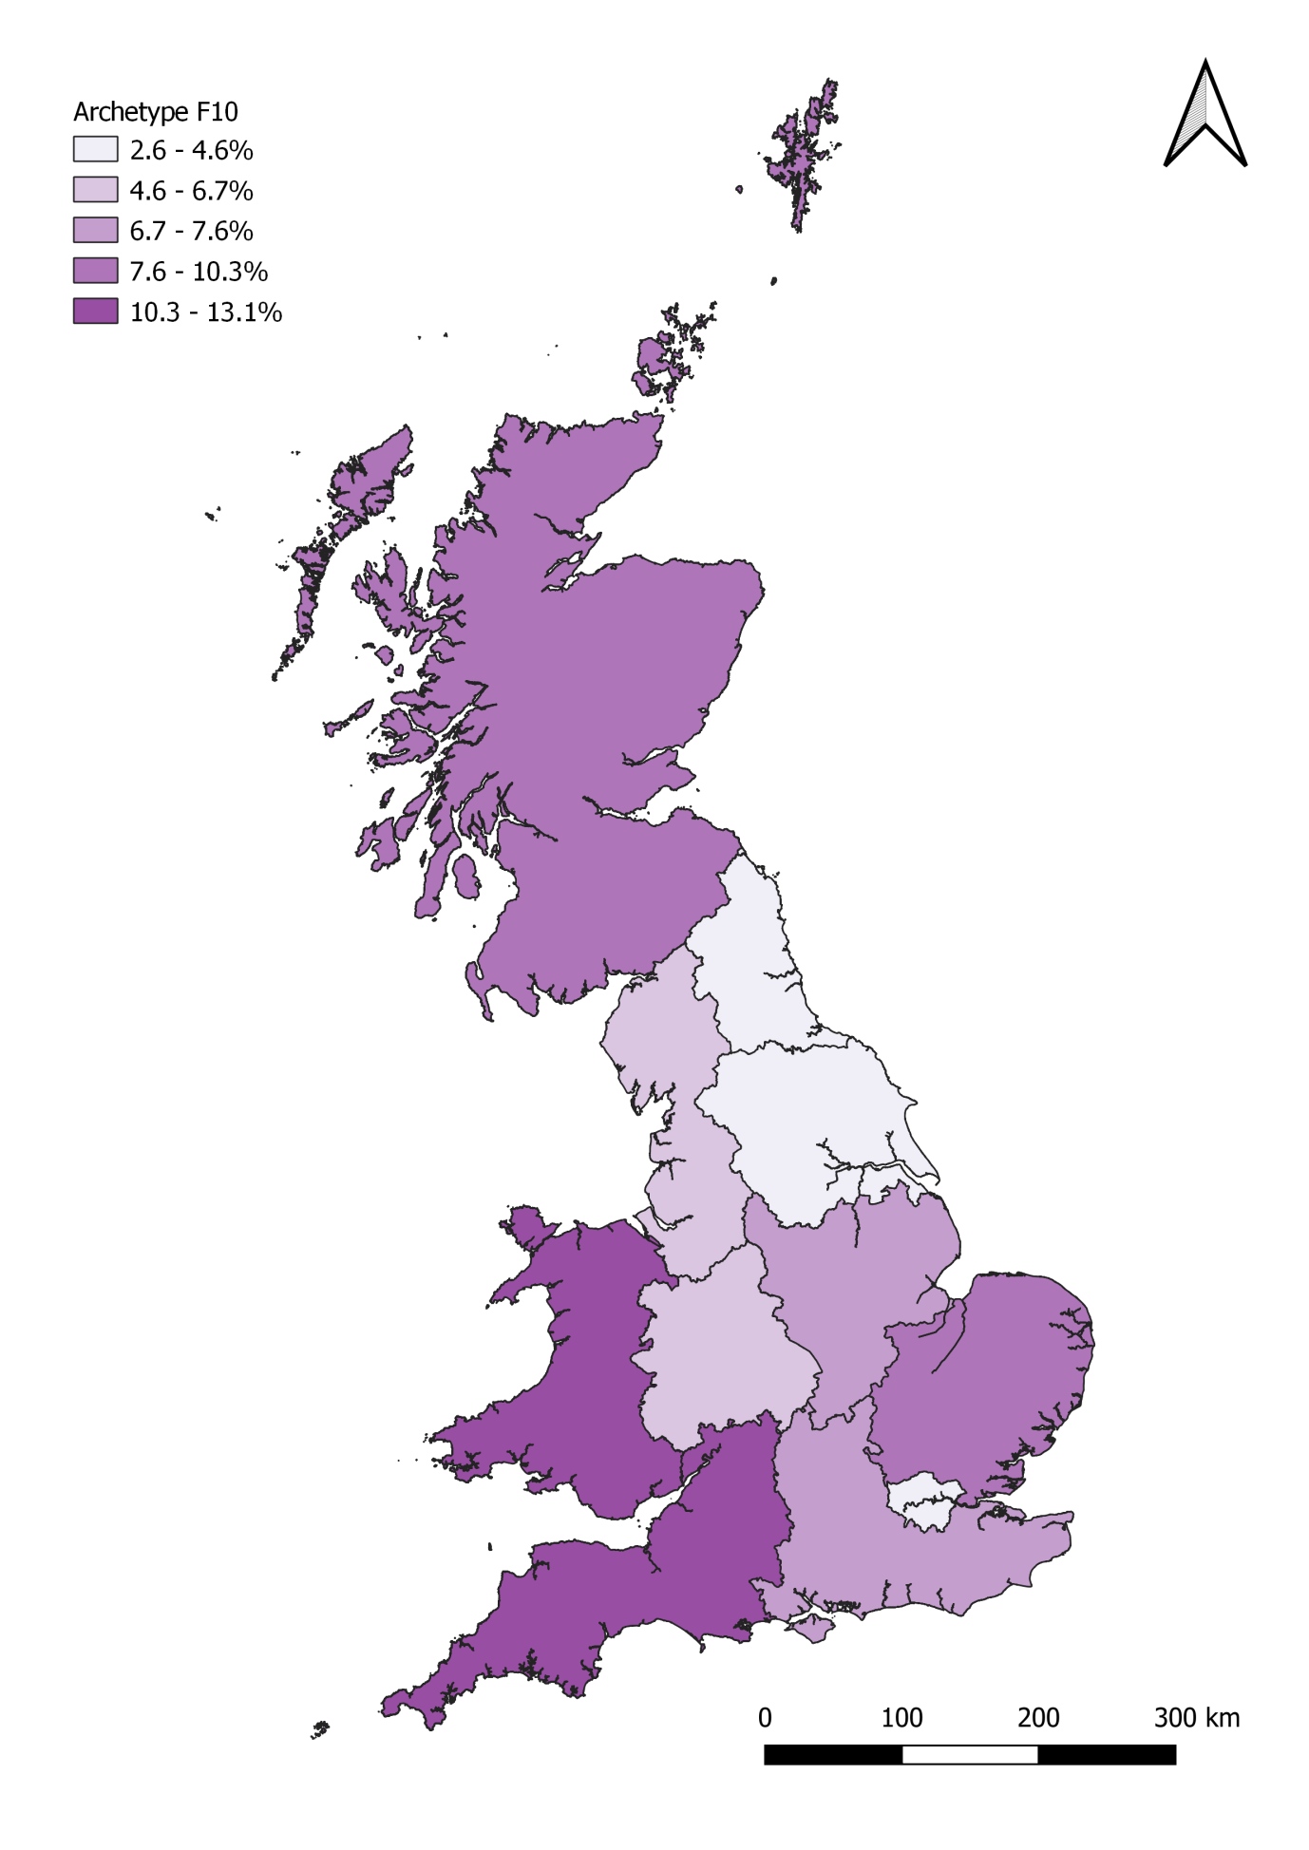

Archetype G11

Headline statistics
Archetype G11: Key statistics |  | GB-wide statistics
Number of households: | 1,510,000 | 26,390,000
Average net household income (BHC) | £30,200 | £34,100
Average net household income (AHC) | £23,200 | £29,400
Average electricity consumption (kWh) | 5,250 | 3,980

Key words: Younger couples or single adults, private renters, electric heating, employed, average incomes, early adopters, BME backgrounds, low levels of engagement.

Summary Description
Archetype G11 is a group of younger couples or single adults, most of who are under the age of 44. The majority of this group is in full-time employment, although some work part-time or are self-employed. However, being in the early stages of their careers they are typically on lower salaries and household incomes are below the national average (however, as Figure 40 demonstrates, the income distribution in this archetype is reasonably broad).
While most are single adult households or couples, some households have started families and have children. 18% of are from a black or minority ethnic (BME) background – the second highest rate among all the archetypes. This is also the group with has the highest proportion of early adopters of new technologies or market products.
The households mostly privately rent electrically-heated flats, although some are in social housing and a small proportion own their homes. Some also inhabit terraces or semi-detached houses. Being younger renters, this is also a relatively transient group with approximately three quarters having lived in their homes for less than 5 years, and a significant proportion for less than a year.
As a result of using electrical heating systems, this group has high electricity consumption. The majority of households pay by direct debit, but a significant number use either prepayment meters or pay quarterly for their electricity. And while there are low rates of fuel debt, there are also low levels of engagement in the energy market with less than 20% having considered switching tariff in the last 12 months (compared to a national average of over 40%).

Summary profile
Archetype G11: Profile
 | Archetype | GB profile
Age profile  (head of household) | 16-24: 11%  25-34: 30%  35-44: 23%  45-54: 17% | 16-24: 3%  25-34: 14%  35-44: 17%  45-54: 20%  55-64: 17%  65-74: 15%  75+: 14%
Main tenure(s) | Housing association: 14%  Owner occupied: 16%  Private rented: 64% | Housing association: 8%  Local authority: 8%  Owner occupied: 65%  Private rented: 18%
Household composition | Couple: 30%  Couple with children: 19%  Single adult: 37% | Couple: 34%  Couple with children: 20%  Single adult: 28%  Single parent: 5%  Other: 11%
Households with children | 28% | 29%
Economic status (head of household) | Full-time employee at work: 60%  Part-time employee at work: 12%  Self-employed: 9%
Main heating fuel of dwelling | Electricity, Oil
 | Archetype | GB average
Internet in the home | 97% | 88%
Use smart phones to access the internet | 53% | 46%
Any engagement with energy market in last 12mths | 19% | 41%
Have a degree qualification (or higher) | 35% | 26%
Long term health conditions that affect daily activities a lot (HoH) | 6% | 12%
Households on disability benefits | 4% | 13%
Households in poverty (income below 60% of national median) | 21% | 20%
Been in arrears on electricity or gas bills | 1.2% | 2.3%
Electric or hybrid vehicle ownership | 0.3% | 0.8%
Rural population | 29% | 22%
Figure 40: Archetype G11 – Equivalised income distribution (OECD equivalised income decile)
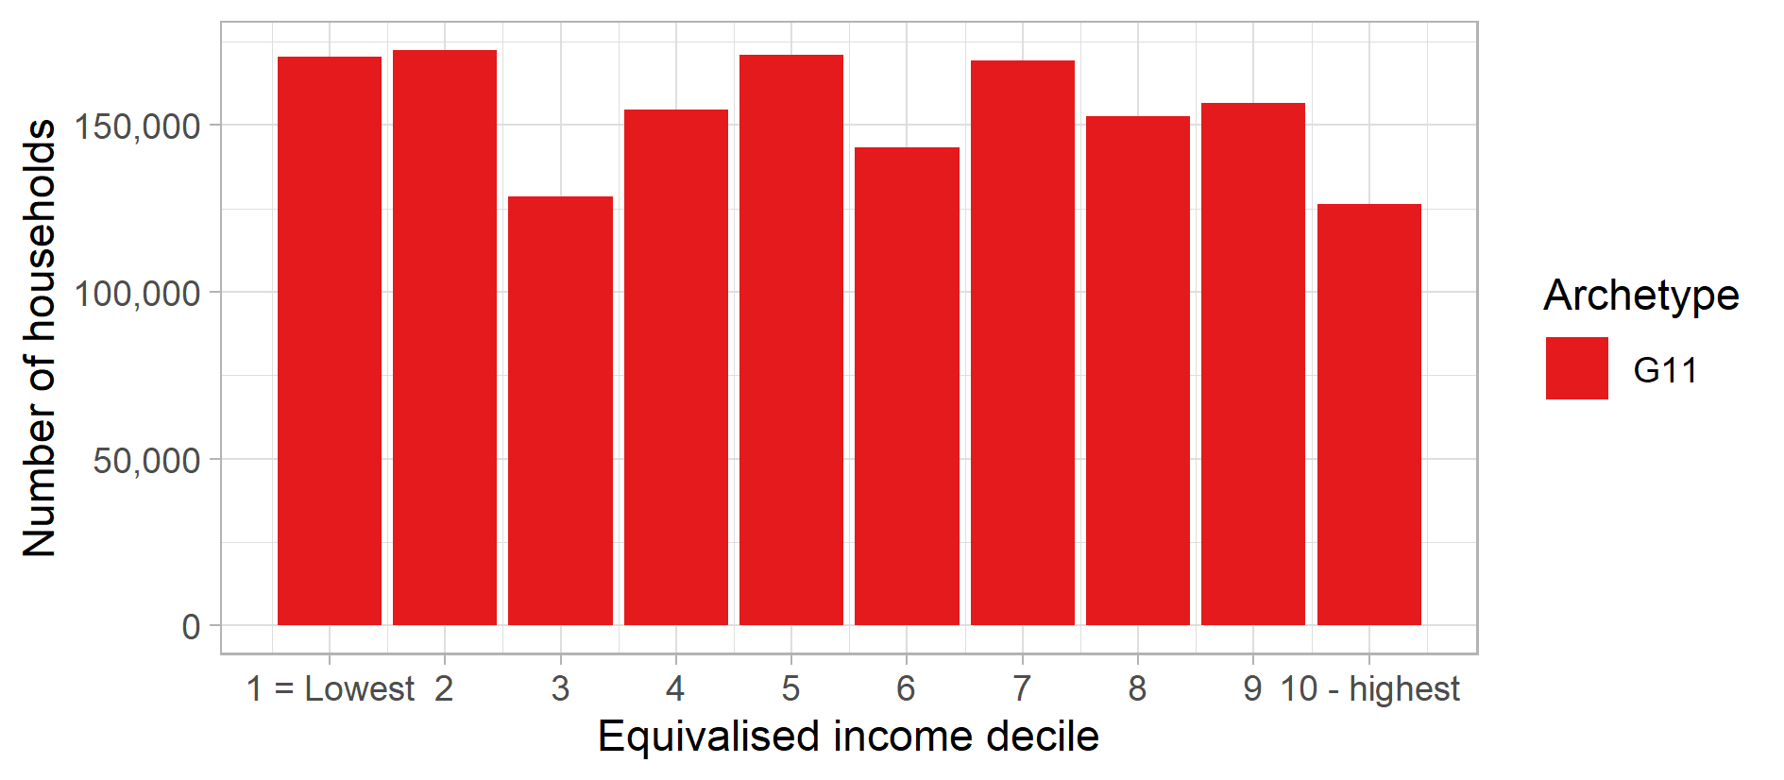
Figure 41: Archetype G11 – Electricity consumption distribution (Electricity kWh decile)
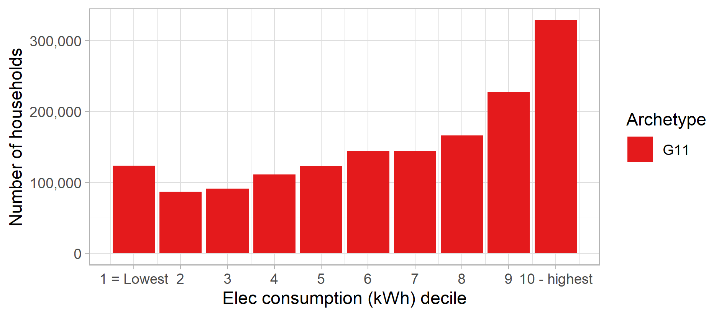

Figure 42: Archetype G11 – Proportion of population in each English region and devolved nation of Great Britain
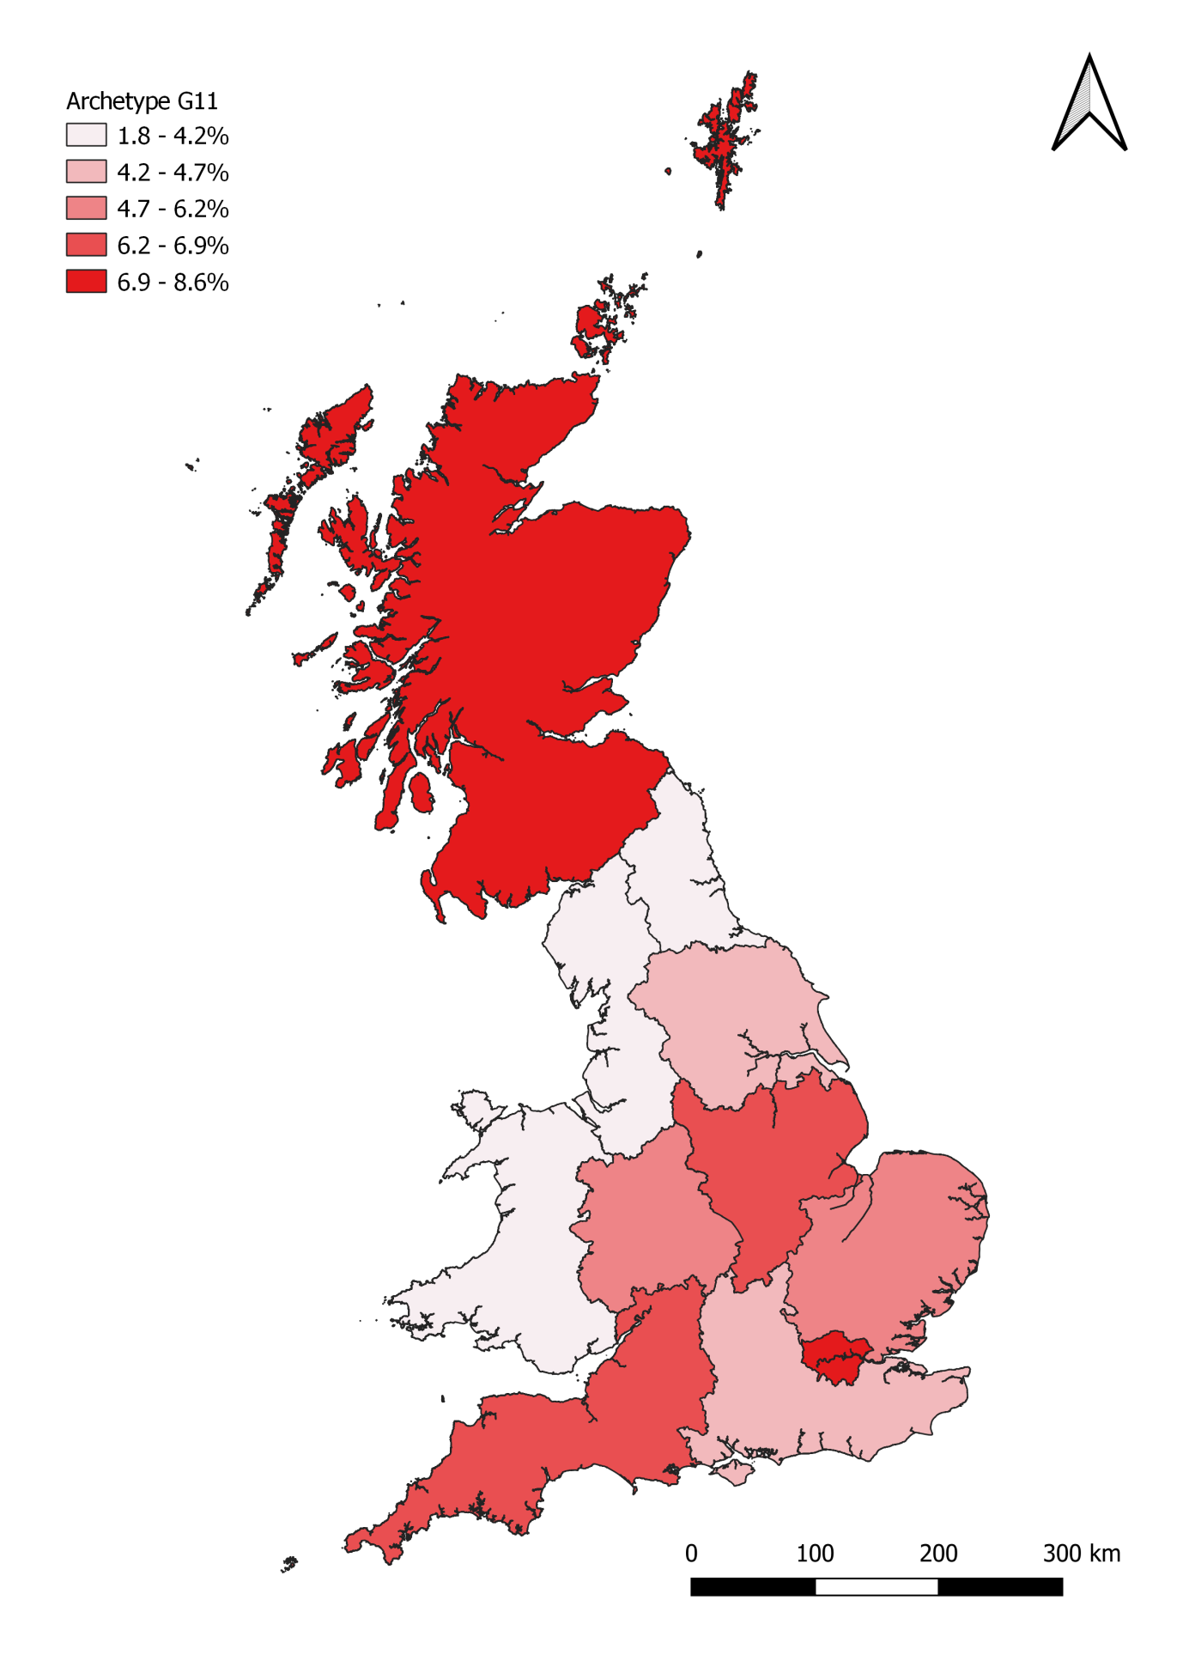

Archetype H12

Headline statistics
Archetype H12: Key statistics |  | GB-wide statistics
Number of households: | 644,000 | 26,390,000
Average net household income (BHC) | £14,500 | £34,100
Average net household income (AHC) | £12,000 | £29,400
Average electricity consumption (kWh) | 4,030 | 3,980

Key words: Elderly, single adults, very low income, medium electricity consumers, never-switched, disconnected, fuel debt.

Summary Description
This is a group of elderly, very low income single adult households, 55% of which are over 75 years of age. While few are in receipt of specific disability benefits, a significant proportion have longer term health conditions related to their age. Almost a quarter report having a health condition which limits day-to-day activities significantly, with a further 23% having a less severe long term health condition. In addition, around half are below the poverty line.
Around 50% live in their own homes, with the rest renting homes from either social or private landlords. Most of this group live in flats, while a smaller proportion live in terraces or semi-detached houses. Many have lived in these homes for a significant period of time, with 30% having lived in their home for more than 30 years.
None of these household have access to the internet at home and they do not own smart phones. They do not engage with the energy market at all, most having never switched supplier. They are very late adopters, one of the least likely archetypes to buy new market products.
This archetype is an ‘off-gas’ and more rural counterpart to Archetype C5. However, as most use electricity as a heating fuel they have a slightly higher than average electricity consumption. While some use Direct Debit to pay for bills, a significant proportion pay quarterly or use prepayment meters and they have twice as likely to have been in arrears on their utility bills than the average consumer.

Summary profile
Archetype H12: Profile
 | Archetype | GB profile
Age profile  (head of household) | 65-74: 21%  75+: 55% | 16-24: 3%  25-34: 14%  35-44: 17%  45-54: 20%  55-64: 17%  65-74: 15%  75+: 14%
Main tenure(s) | Housing association: 14%  Local authority: 19%  Owner occupied: 52%  Private rented: 14% | Housing association: 8%  Local authority: 8%  Owner occupied: 65%  Private rented: 18%
Household composition | Single adult: 79%  Couple: 17% | Couple: 34%  Couple with children: 20%  Single adult: 28%  Single parent: 5%  Other: 11%
Households with children | 3% | 29%
Economic status (head of household) | Retired: 79%  Full-time employee at work: 8%  Part-time employee at work: 6%
Main heating fuel of dwelling | Electricity, Oil
 | Archetype | GB average
Internet in the home | 6% | 88%
Use smart phones to access the internet | 2% | 46%
Any engagement with energy market in last 12mths | 0% | 41%
Have a degree qualification (or higher) | 4% | 26%
Long term health conditions that affect daily activities a lot (HoH) | 23% | 12%
Households on disability benefits | 0% | 13%
Households in poverty (income below 60% of national median) | 47% | 20%
Been in arrears on electricity or gas bills | 5.0% | 2.3%
Electric or hybrid vehicle ownership | 0.0% | 0.8%
Rural population | 35% | 22%
Figure 43: Archetype H12 – Equivalised income distribution (OECD equivalised income decile)
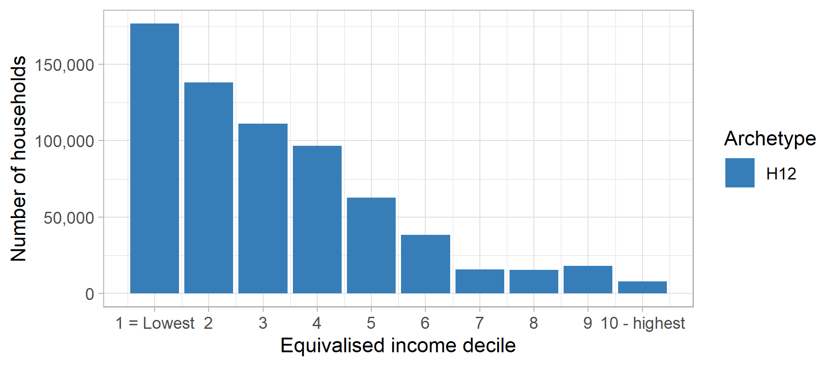
Figure 44: Archetype H12 – Electricity consumption distribution (Electricity kWh decile)
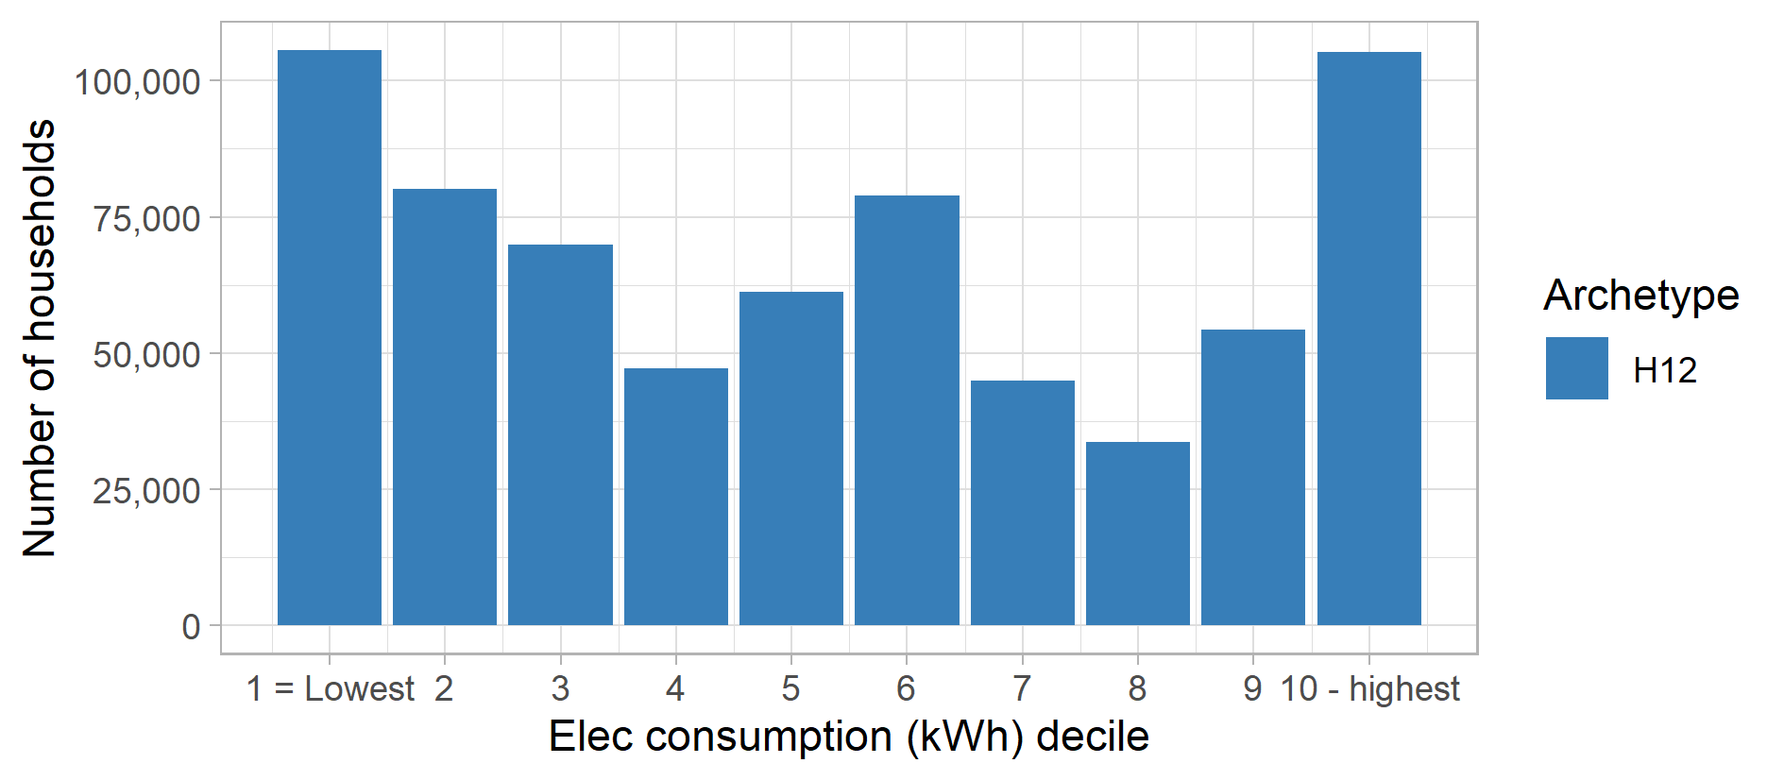

Figure 45: Archetype H12 – Proportion of population in each English region and devolved nation of Great Britain
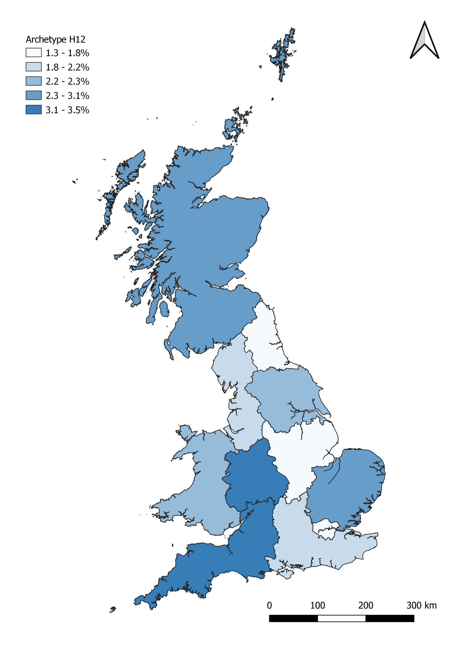

Archetype H13

Headline statistics
Archetype H13: Key statistics |  | GB-wide statistics
Number of households: | 526,000 | 26,390,000
Average net household income (BHC) | £22,000 | £34,100
Average net household income (AHC) | £18,200 | £29,400
Average electricity consumption (kWh) | 5,360 | 3,980

Key words: Off gas, low income, high electricity consumption, disability benefits, over 45s, low energy market engagement, late adopters.

Summary Description
Consumers in Archetype H13 are a group of low income, high electricity consumers, on disability benefits. They are mostly older single adult or couples who are out of work due to disabilities or are retired pensioners with long term health problems. Over 40% have long term health condition which significantly affects their daily lives (four times the national average). However, a small proportion (13%) are also in full time employment in lower paid jobs. Most are over 45 and two-fifths are below the poverty line.
Less than half own their homes, with 40% living in social housing and 16% privately renting. Many live in rural areas and most have lived in their home for at least 10 years.
Around a third of households do not have internet in the home or a personal computer and less than a quarter have a smart phone. They are generally late adopters, and show little interest in new technologies or market products. They are the least likely group to own an electric or hybrid vehicle.
They also have low engagement in the energy market, and around two thirds have never switched energy supplier. Around a quarter of the group pay for electricity by prepayment meter.

Summary profile
Archetype H13: Profile
 | Archetype | GB profile
Age profile  (head of household) | 45-54: 22%  55-64: 22%  65-74: 14%  75+: 22% | 16-24: 3%  25-34: 14%  35-44: 17%  45-54: 20%  55-64: 17%  65-74: 15%  75+: 14%
Main tenure(s) | Housing association: 19%  Local authority: 19%  Owner occupied: 46%  Private rented: 16% | Housing association: 8%  Local authority: 8%  Owner occupied: 65%  Private rented: 18%
Household composition | Single adult: 41%  Couple: 37%  Multiple adults: 10% | Couple: 34%  Couple with children: 20%  Single adult: 28%  Single parent: 5%  Other: 11%
Households with children | 12% | 29%
Economic status (head of household) | Retired & under pension age: 41%  Retired & above pension age: 35%  Full-time employee at work: 13%
Main heating fuel of dwelling | Electricity, Oil
 | Archetype | GB average
Internet in the home | 69% | 88%
Use smart phones to access the internet | 24% | 46%
Any engagement with energy market in last 12mths | 28% | 41%
Have a degree qualification (or higher) | 10% | 26%
Long term health conditions that affect daily activities a lot (HoH) | 43% | 12%
Households on disability benefits | 99% | 13%
Households in poverty (income below 60% of national median) | 40% | 20%
Been in arrears on electricity or gas bills | 5.4% | 2.3%
Electric or hybrid vehicle ownership | 0.0% | 0.8%
Rural population | 41% | 22%

Figure 46: Archetype H13 – Equivalised income distribution (OECD equivalised income decile)
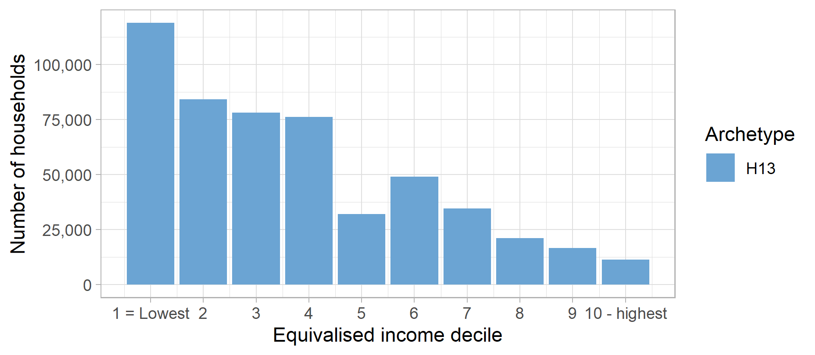
Figure 47: Archetype H13 – Electricity consumption distribution (Electricity kWh decile)
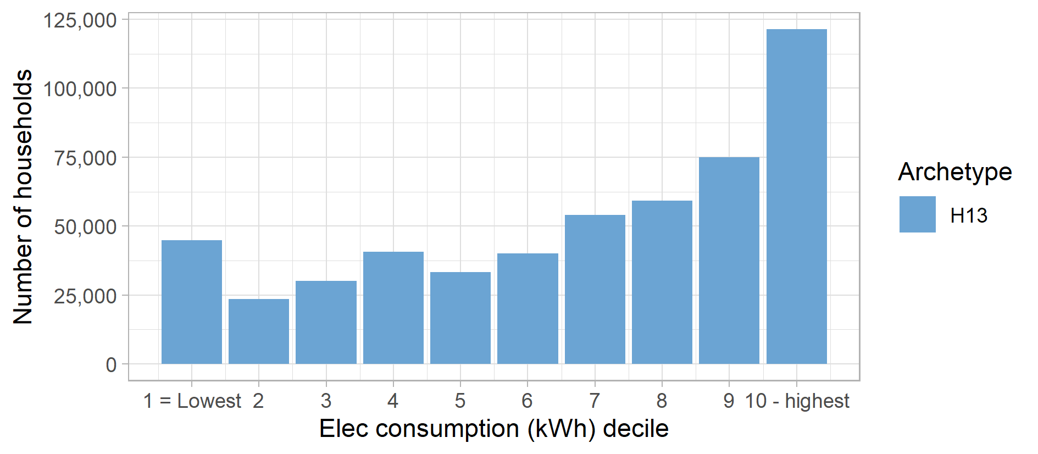

Figure 48: Archetype H13 – Proportion of population in each English region and devolved nation of Great Britain
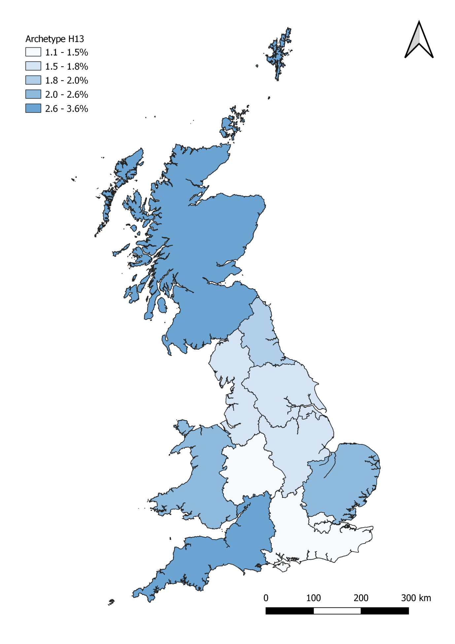

Appendix A –Methodology
The approach used to develop the 13 energy consumer archetypes from national survey data sets involved four main stages:
- Compiling an energy consumer data set
- Calculating energy consumption data
- Generating energy consumer archetypes
- Analysis, profiling and reporting on the archetypes
Each of these stages is described in more detailed below. The first three stages are also summarised in the methodology process diagram shown below in Figure 49.

Compiling an energy consumer dataset
The initial stage of the work involved developing a data set representing of all households across the country and some key socio-demographic and consumer information. At the core of this was data derived from the Living Costs and Food Survey (LCF), which provides detailed information on spending habits of the population, including energy (e.g. how much is spent, on which fuels and via which methods of payment or meters). It also includes a variety of socio-demographic information. In order to ensure a robust analysis, four years of LCF survey data were combined covering the surveys conducted in 2014, 2015-16, 2016-17 and 2017-18. A new unique ID was assigned to each record in the combined data set and the cases were reweighted to represent the total number of households in Great Britain.
This core data set was supplemented by additional information regarding energy market attitudes and behaviour derived from Ofgem Consumer Segmentation Survey data and housing characteristics from the English Housing Survey (EHS) data. The Ofgem Consumer Segmentation Survey was used to develop an energy market engagement model that reflected whether households have engaged in the energy market in the last 12 months (either by comparing tariffs, switching tariffs or switching energy supplier), a historical supplier switching model (identifying which households had never switched energy supplier) and a model predicting consumer attitudes to new market products. These models were run on the core LCF data set using common characteristics present in both data set to impute this information in the survey. The EHS was similarly used to estimate the energy efficiency characteristics of each household’s dwelling.
A set of complete fields from this derived dataset was then selected to create a resulting energy consumer dataset that is representative of the GB household population and includes socio-demographic information on households, dwelling characteristics and energy behaviour. This included total annual expenditure by a range of different fuels and the method used to pay for those fuels.

Calculating energy consumption data
The second stage involved estimated total annual energy consumption for each household based on their reported expenditure. In order to conduct this calculation, the latest available fuel price statistics and datasets were accessed. These included BEIS Quarterly Energy Prices for electricity and mains gas broken down by standing charge and method of payment (Direct Debit, standard credit and prepayment meter), and Sutherland tables for unmetered fuels (including coal, LPG, oil and biomass fuels). This allowed the conversion of fuel expenditure into annual energy consumption totals for electricity, mains gas, oil, LPG, solid fuels and biomass, based on the reported expenditure of each household. The fuel price statistics included tariff and standing charge variation by different regions and devolved nations across Great Britain which were mapped to different households based on geographical information in the energy consumer data set.
Once these initial fuel consumption values were estimated, a final verification process of the derived numbers was conducted using national statistics sources on total domestic energy consumption by fuel types. The verification process ensured that the total energy consumption for each separate fuel in the data set matched national statistics.
This second stage completed the production of an energy consumer data set.

Generating energy consumer archetypes
The energy consumer data set was then segmented into distinct groups or energy consumer archetypes. The process used a hierarchical clustering method resulted in each household in the data set being assigned to a distinct set of ‘clusters’ or archetypes. The analysis was performed using R software and the hclust package using a variety of fields in the data set to segment the population, including socio-economic and demographic information, dwelling characteristics (e.g. energy efficiency details), energy consumption data and energy engagement behaviour.
A specific segmentation approach used was Ward’s hierarchical clustering method. This approach was selected because it allows for both categorical and numerical fields to be included in the segmentation and is a method that produces dense clusters of similar sizes (i.e. similar number of households), with fewer outliers. It also allows for different predictive fields to be allocated different weightings to enhance or diminish how significant these are in the clustering.
A guiding principle of the segmentation was to develop a discrete number of archetypes (e.g. 12 as before but subject to discussion and final agreement with Ofgem). An iterative process was be used to derive the provisional and final set of consumer types, which including adding in or removing different fields in the underlying data set and applying different weightings to these fields in clustering function.
The process also included input from Ofgem with an initial workshop held with a range of key members of staff at Ofgem to identify key factors to be considered when deriving the archetypes. Discussions held during this meeting were taken into consideration when developing an initial set of archetypes. A second follow-up workshop was then held to present a set of provision archetypes and provide Ofgem staff a chance to review the process and provide some further input into the provisional archetypes. Feedback from this second workshop was used to derive the final set of archetypes presented in this report.
The different fields included in the segmentation and their weightings used to derive this final set of archetypes are provided below in Table 3.

Table 3: Segmentation characteristics and weighting applied to produce archetypes
Characteristics | Segmentation weighting (mains gas archetypes) | Segmentation weighting (off gas archetypes)
Gas (kWh) | High | (not included)
Disabilities | High | High
Economic status of head of household | High | High
Tenure | High | High
Income | High | High
Number of children | Medium | Medium
Computer ownership | Medium | Medium
Internet connection | Medium | Medium
Access internet via smart phone | Medium | Medium
Total expenditure | Medium | Medium
Tariff switching history | Medium | Medium
Recent energy market engagement | Medium | Medium
Rurality | Low | Low
Dwelling type | Low | Low
Age of head of household | Low | Low
Gas MOP | Low | (not included)
Elec MOP | Low | Low
Elec kWh | Low | Low
Main heating fuel | (not included) | High

Analysis, profiling and reporting
The clustering process assigned each household in the energy consumer data set to a particular energy consumer archetype. A statistical analysis and archetype profiling was then conducted by disaggregating key consumer characteristics by archetype and producing a statistical profile across all the archetypes.
This analysis was used to understand the key defining characteristics and most common and distinct attributes of each archetype. These were presented as headline statistics, and statistical profiles, and were used as a basis for a summary description of each archetype. In addition, the distributions of income and energy consumption levels (electricity and gas) were produced to illustrate the variation from the national averages across each archetype.
Some external analysis was also reviewed that assessed low carbon technology ownership, and energy activities and consumption profiles by different socio demographic groups. Where possible this information has been linked to relevant archetypes through inference using certain attributes in order to add some further details to their descriptions.
For example, characteristics of households with positive attitudes and values towards environment issues were profiled using Experian Mosaic data to identify the types of households who most strongly showed concern for the environment and green issues. These cross referenced with existing studies (BEIS Public Attitudes Tracker (2019), Eurobarometer (2008)).

References
Smart Energy GB (2019). Smart energy outlook https://www.smartenergygb.org/en/-/media/SmartEnergy/essential-documents/press-resources/Documents/Smart-energy-outlook-March-2019.ashx
DECC (2016). Renewable Heat Incentive quarterly statistical release, deployment to December 2015. https://assets.publishing.service.gov.uk/government/uploads/system/uploads/attachment_data/file/493977/Updated_RHI_quarterly_release__Dec_2015_data__publication.pdf
Experian Mosaic Segmentation Portal, Experian Information Solutions, Inc., © 2020 Experian. https://www.experian.co.uk/assets/marketing-services/brochures/mosaic-ps-brochure.pdf
Eurobarometer (2008). Attitudes of European citizens towards the environment. European Commission, 295. https://ec.europa.eu/commfrontoffice/publicopinion/archives/ebs/ebs_295_en.pdf
BEIS Public Attitudes Tracker: Wave 31, Published 7 November 2019. https://www.gov.uk/government/statistics/beis-public-attitudes-tracker-wave-31
Torriti, J and Yunusov, T. (2020). It’s only a matter of time: Flexibility, activities and Time of Use tariffs. Energy Research & Social Science (submitted).
Yunusov, T. and Torriti J. (2020). Distributional effects of Time of Use tariffs based on smart meter electricity demand and time use activities. Energy Policy (submitted).

Figure 49: Methodology process diagram (* - archetypes shown are illustrative and do not relate to the final set of archetypes)
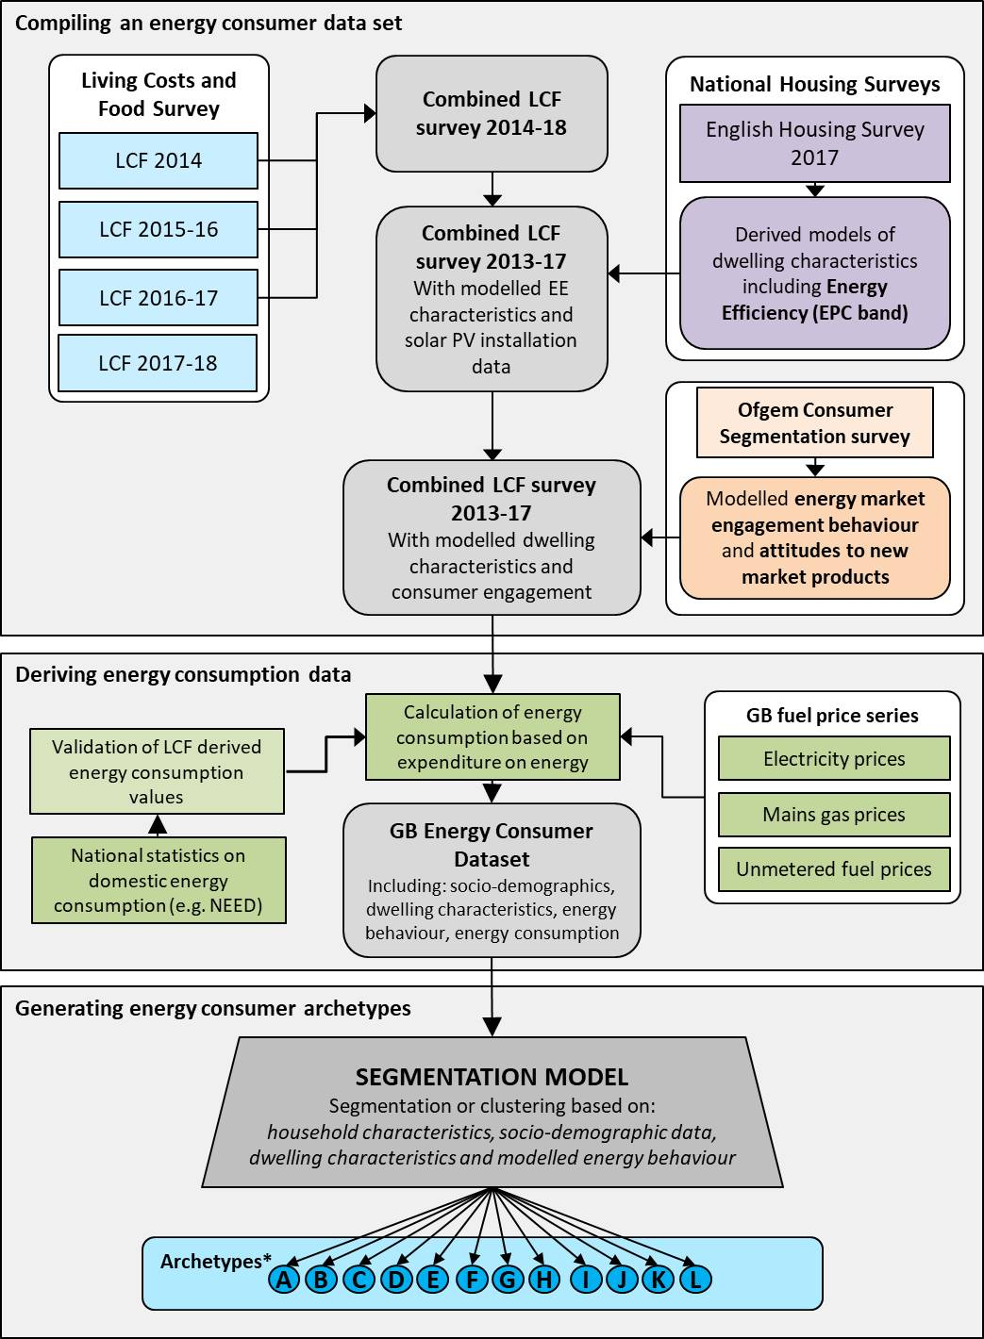

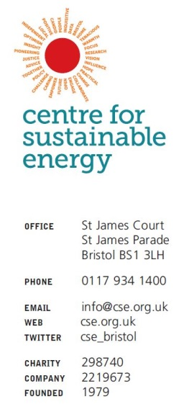

This is referenced in the report as ‘based on cross-referenced profiling of Experian Mosaic household types’.
Based on cross-referenced profiling of Experian Mosaic household types.
Based on cross-referenced profiling of Experian Mosaic household types.
based on cross-referenced profiling of Experian Mosaic household types
Based on cross-referenced profiling of Experian Mosaic household types.
https://www.ofgem.gov.uk/publications-and-updates/consumer-engagement-survey-2018
https://www.gov.uk/government/collections/english-housing-survey
https://www.gov.uk/government/collections/digest-of-uk-energy-statistics-dukes
https://arxiv.org/pdf/1111.6285.pdf
BEIS Public Attitudes Tracker: Wave 31, Published 7 November 2019. https://www.gov.uk/government/statistics/beis-public-attitudes-tracker-wave-31
Eurobarometer (2008). Attitudes of European citizens towards the environment. European Commission, 295. https://ec.europa.eu/commfrontoffice/publicopinion/archives/ebs/ebs_295_en.pdf

