Energy Use Quiz

Teacher instructions:

This is an optional activity that could be run with all ages together with the people they live with.

The aim is to get the pupils to complete the Energy Use Quiz at the start of the Energy Matters programme, with the help of the people they live with, and again at the end of the programme to see if their “energy rating” score has improved.

For pupils who are unable to do this at home, an alternative option is provided to do something similar with the school.

The following pages should be printed and handed to the pupils to take home at the start of the programme. The same printout should be handed to the pupils to take home at the end of the programme. Ask the pupils to bring back their completed quizzes to class.

You could collate the star ratings of all the pupils at the start and the end of the programme and then give out prizes for whoever ends up with the highest stars.

You could also plot the results on a bar chart to show the pupils (and use this as an example of charting data in Maths!).

Energy Use Quiz (at home)

In my home, we try to… | Yes | No
1. Close all the curtains at dusk to keep the heat in
2. Switch off the lights when you leave the room
3. Turn the heating down when you are too hot instead of taking off your jumper
4. Put your jumper on when you are too cold instead of turning the heating up
5. Keep the doors and windows shut when the heating is on
6. Switch off the television and video completely when not in use, instead of leaving it on standby

8. Keep the plug in the sink when running water
9. Keep lights turned off when there is sunlight through the windows
10. Mostly take showers rather than baths
11. Defrost the freezer regularly
12. Only open the fridge/freezer door for as short a time as possible
13. Wait to make a full load if using the dishwasher or washing machine
14. Use low temperature washes for clothes
15. Dry washing on a line or clothes-horse if possible
16. Spin clothes well before using a tumble dryer

17. Boil as little water as you need in a kettle

Calculate your energy star rating

Add up the ticks in the left-hand column (“Yes” column) Number of ticks:___

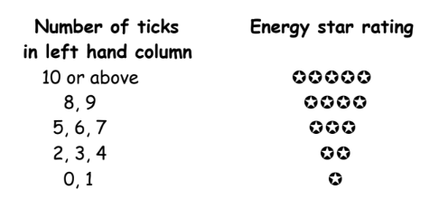

My energy star rating:

Energy Use Quiz (school version)

 | Yes | No
1. Do you switch off the lights when you’re the last to leave a class room (or other room at school)?
2. Do you tell the teacher when the heating is too high?
3. Do you put a jumper on when you are too cold instead of asking to turn the heating up?
4. Do you switch the water tap off when you are not using it?
5. Do you encourage the teacher/other pupils to keep the doors and windows shut when the heating is on?
6. Do you switch off the computer when you are not using it?

Calculate your energy star rating

Add up the ticks in the left-hand column (“Yes” column) Number of ticks:___

Number of ticks
in left hand column
6
4,5
3
1,2
0

My energy star rating:

