Energy Matters background and context document

Welcome to Energy Matters. Before you use the materials, we recommend reading through this background and context document. This document has two purposes:
- To provide some useful context for why these materials have been created and how to use them.
- To serve as an energy and climate change encyclopaedia, designed to provide you with in-depth background knowledge when teaching these complex topics. Navigate the document using the links below to help you answer tricky questions and avoid common misconceptions.
Overall context
Our reliance on fossil fuels and heavy energy use in our daily lives is worsening the impacts of climate change – and it’s costing us a lot of money. Climate change is already affecting our communities and our wildlife, and we are in a critical decade for action to avoid the worst consequences.
Children in the UK are rightfully worried. A survey by environmental charity Global Action Plan revealed 3/4 of students say that thinking about climate change makes them anxious. However, 1/2 of teachers feel ill-equipped to deal with student anxiety around climate change.
We all want our community and our children to have affordable energy and secure futures.
The Energy Matters materials are aimed at helping educators and children alike become true champions for climate action and energy conservation - to protect both people and the planet at a global and local scale. With the help of interactive activities, games, and cool experiments, educators and children will discover how to save energy, protect our planet and make a positive impact in school, at home, and in the community.

Climate change
What is causing climate change?
The greenhouse effect
Impacts of climate change
Climate change and young people
Energy
The UK’s energy system
Where does the UK get its energy?
Fossil fuels
Renewable Energy
Saving Energy
What is the energy crisis?
Heating
Hot water
Lights
TV
Washing
Fridge and freezer
Cooking
Glossary

Climate change
Climate change is affecting people and wildlife across the world and more locally in our communities. Because our climate is changing, we are seeing more extreme weather such as floods, heat waves and droughts. This is directly impacting the health of our communities, causing biodiversity loss and affecting our key infrastructure and economy.

What is causing climate change?
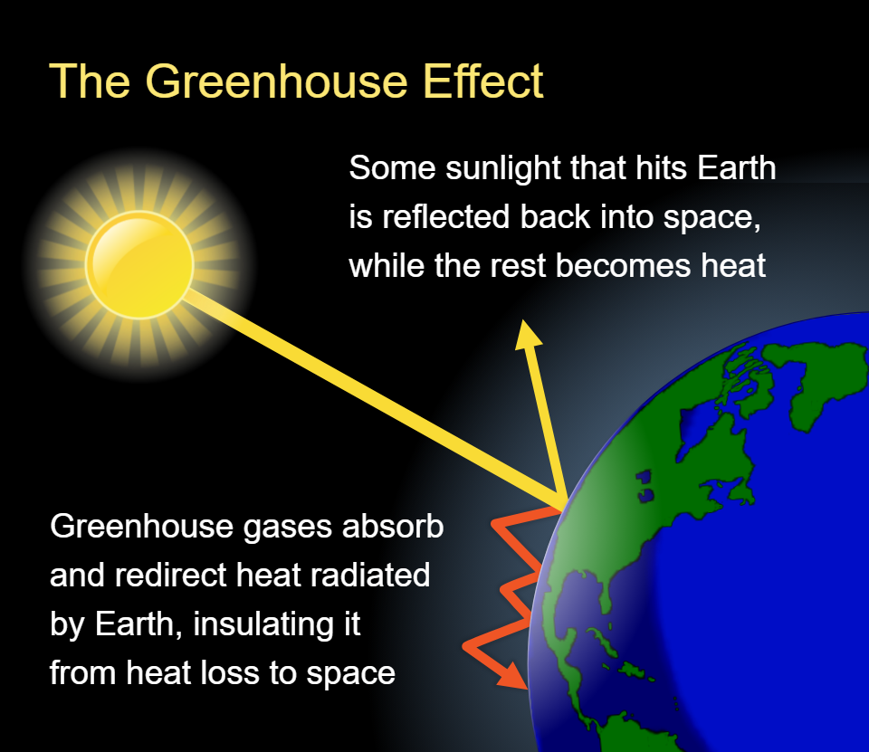
Our climate is changing due to the Earth’s surface getting warmer - this is what we call global warming. The main cause of global warming is the release of greenhouse gases through human activities such as burning fossil fuels to make energy. Burning fossil fuels releases greenhouse gases that get trapped in our atmosphere, creating a big blanket around our planet and trapping the heat from the sun, stopping it from reflecting back into space - this is what we call the greenhouse effect.
What are fossil fuels?

The greenhouse effect
Radiation from the Sun covers a wide range of wavelengths, but most of it is in the visible band. Planets such as the Earth reflect some radiation back into space with no change of wavelength. The pictures of the Earth from space illustrate this because the Earth is seen with reflected visible light.
However, a greater amount of the radiation from the Sun is absorbed by the Earth and re-emitted as infrared radiation at a longer wavelength. The greenhouse gases in the atmosphere absorb this infrared radiation and radiate it back towards the Earth, which warms it. This natural greenhouse effect has kept the Earth roughly 33⁰C warmer over time than it would have been without an atmosphere.
Because some of the infrared radiation does escape into space, until now the Earth has not become too hot. The problem now is that the amount of greenhouse gases in the atmosphere is increasing. This causes more heat to be trapped in the atmosphere, and the temperature of the Earth to increase.
Since about 1900, average world temperatures have risen by up to 1.1⁰C and, perhaps more significantly, ten of the hottest years on record have occurred since 2002.

Impacts of climate change
Because the Earth is getting warmer, the seas are also seeing an increase in temperatures, which is causing key glaciers and ice caps in the polar regions to melt. This is adding a large amount of water into our seas, increasing their volume and causing sea levels to rise around the world. It is certain that overall increases in world temperatures lead to rises in sea levels. There has been a rise in sea levels of 10 to 25 cm since the late 19th century. In the UK, sea level is expected to rise by 5cm per decade, threatening low-lying coastal land and cities, especially in the east of the country. Around the world, millions of people will be affected by sea level rises over the next century.
There are likely to be large changes in weather patterns and climate instability. For example, the ocean currents are likely to change, and in the UK this could mean we lose the warming influence of the Gulf Stream. Another problem is that it only requires a small temperature increase for pests associated with hotter climates to arrive in the temperate areas of the world. The effects on agriculture could be devastating.

Climate change and young people
The recent increase in young people’s participation in climate activism such as the Youth Climate Strikes have further heightened the importance of ensuring young people feel supported to understand the effects of the climate crisis and take action. Climate anxiety is being experienced more and more by young people and many young people are concerned about their future in light of climate change. Unlike generalised anxiety, climate, or eco-anxiety is not a mental illness, but a response to uncertainty and fear of the consequences of climate change. It is becoming more common in adults as well as children.
Dealing with climate anxiety can be challenging, we recommend looking at Transform Our World's resource here. In general, it is recommended that encouraging children to take part in smaller actions can help alleviate climate anxiety. Those smaller actions can be things like being part of a school eco-action team or spending time tending to a garden or green space within the school. It is important to help children see what changes have been made for the better, for example, that more renewable sources of energy are now being used.
As with most aspects of anxiety, it is important to talk about the feelings associated with climate anxiety, making sure children know that it is okay to speak about our feelings. Giving them the opportunity to do so will be key to supporting them.

Energy

The UK’s energy system
The UK uses energy in two ways: as a primary source (like gas burned in an oven or petrol pumped into a car); and to generate electricity (like coal burned to turn a turbine to produce electricity).
Most of the UK’s primary energy comes from fossil fuels, including gas boilers for central heating. Some buildings are heated directly through renewables or low carbon sources: solar thermal, heat pumps and biomass boilers.
Most of the UK’s electricity is produced by burning fossil fuels, primarily natural gas. Although coal has been used heavily in the past, this is now being phased out. Other sources include nuclear, wind, tidal, and solar. You can see the UK’s current ‘live’ electricity mix by going to the Energy Dashboard. On certain days, renewables are our main energy source. In 2019, renewable sources generated more than a third of our electricity. We also import electricity from other countries including France, the Netherlands and Ireland.
Electricity is 'clean energy' at the point of use. What is often not appreciated (unless you live near a power station) is that much of our electrical energy is generated in coal, oil and gas-fired plants, and from nuclear sources. It’s worth noting that even when we use battery-powered appliances there is still a contribution to global warming. This is because the energy needed in the manufacturing process often comes from burning fossil fuels. Furthermore, some of the materials used in battery production are very harmful to the environment.
How does electricity get to us?
In industrialised countries like the UK, energy systems have tended to be centralised. This means electricity is provided by a smaller number of large generation plants that are connected to users by country-wide networks. The UK electricity system is run by a high voltage transmission network. The transmission system is run by one system operator - The National Grid. Below the transmission level, there are 14 distribution networks that move electricity and reduce the voltage down to suit different end users.
How does gas get to us?
Gas is distributed by a high pressure transmission network and lower pressure local distribution networks. In the UK, this transmission system is owned and operated by National Grid. Local distribution zones are run by eight Gas Distribution Networks, which step down the pressure and deliver gas in pipelines of different sizes to end users.
Who decides how the UK’s energy networks work?
Electricity and gas networks are regulated by the Office of Gas and Electricity Markets (Ofgem). Ofgem sets how networks can operate, the amount of money network operators can make, and decides on changes to market rules. Energy systems are also influenced by national policy decisions that are largely made in the Department for Energy Security and Net Zero but also other departments relating to transport, building standards and planning.

Where does the UK get its energy?

Fossil fuels
We burn fossil fuels (such as coal, gas and oil) to produce energy which is used to power our lights, heat our buildings, help us move around and produce things such as clothes and food. Fossil fuels were made millions of years ago and they formed from the decomposition of organisms. This is why they are called fossil fuels. They are dug up from the ground and there is only a finite amount of them – which means they will run out.
Coal began as trees and plants. About 300 million years ago, much of the land was covered in vast swamps. When the plants died they sank into the swamps and gradually rotted to form layers of peat. After millions of years of heat and pressure, the soft peat was transformed into coal.
Oil and gas were formed from millions of tiny sea creatures which died and sank to the ocean floor. The layers of mud and sand on the ocean floor eventually changed to rock and the rotting biological material turned to oil and gas. This oil and gas accumulated in pockets when it became trapped in the rock, with the lighter gas rising to the top. Some gas is also found with coal deposits.
Fossil fuels took millions of years to produce and are non-renewable.
What are the problems with using fossil fuels?
Because living things contain a lot of carbon, fossil fuels also contain carbon. Burning fossil fuels to release energy produces carbon dioxide (CO2), a greenhouse gas, as the carbon reacts with oxygen in the air.
Coal, gas and oil contain many substances as well as carbon. Two of these are sulphur and nitrogen. The oxides of sulphur and nitrogen are poisonous, and when dissolved in water they form acid rain, which damages plants and animals. One of the oxides of nitrogen is also a greenhouse gas, but less of it is being produced than carbon dioxide.
Sulphur and nitrogen oxides are released when fossil fuels are burned in power stations to make electricity. Methane (CH4) is another greenhouse gas that is emitted during the production of fossil fuels and during agricultural processes.
The increasing levels of greenhouse gases in the atmosphere are causing the greenhouse effect. The greenhouse effect is leading to climate change.

Renewable Energy
All forms of energy have some advantages and some drawbacks. However, if they are used together, they can be very helpful, and if we find that one of them does not work so well, there are others to take their place.
The alternatives to fossil fuels are nuclear power and renewable energy resources. A very convenient form of energy is electrical energy and electricity generation is much of our energy consumption. Electrical energy does not occur naturally in a useful form, and has to be produced by converting another type of energy such as heat or motion.
Nuclear power plants can produce a lot of electricity but there are many concerns about safety, and about the disposal of the radioactive waste produced. Like fossil fuels, nuclear fuels such as Uranium, are finite resources which must be dug up from the ground, which also damages the environment.
Renewable energy sources include:
- Water;
- Wind;
- Solar;
- Geothermal;
- Biomass;
- Waste.
Water
Hydro-electric power is a well-established form of renewable energy. Power stations make use of the energy in water at the top of a waterfall or stored behind a dam. The water flows through turbines, which turn generators to produce electricity. The flow of water can be controlled so that more electricity can be produced when demand is high, which is an advantage. An environmental disadvantage occurs if rivers have to be diverted, or land has to be flooded, to produce the lake of water needed behind the dam.
Wave and Tidal
Wave power is still being developed. Wave motion can be used to pump liquid or air, which drives turbines to turn generators. The cost of building these machines so that they can stand the force of the waves is high.
Tidal power uses the rise and fall of the tide to drive turbines. There are a few operating tidal barrages in Europe and North America but they have to be situated in areas with a high rise and fall of the tide. The cost of these projects is also high.

Wind
The energy in the wind can be converted to electrical energy by machines called wind turbines. Wind turbines are made by companies in Europe and North America, and many thousands of them are in use around the world. In some areas wind farms, with lots of turbines, have been constructed.
Wind turbines can be situated in places where there is a lot of wind, usually on the tops of hills, in open countryside or near to the sea. These are known as ‘on-shore’. They can also be placed in the sea where the winds are strong and steady. This 'off-shore' wind energy produces a lot of energy in a windy country like Britain. Wind power currently produces the largest share of the UK’s renewable electricity.
Geothermal
In some volcanic areas, steam can be tapped from boreholes and used directly for space heating and in power stations to produce electricity. Iceland is famous for this geothermal power which heats the capital, Reykjavik. There are also areas where rocks near the surface are hot because of geological conditions. Pumping water down into the rocks, and converting it to steam to drive turbines, generates electricity. Only a small amount of electricity is currently produced from geothermal sources.
Solar
The centre of the Sun reaches temperatures of up to 20 million°C and the energy that radiates from the Sun takes about ten minutes to reach us. Only one in 2000 million parts of the Sun's energy reaches us, but that is enough to provide all the heat and light required for life.
Solar energy can be used in three ways:
- Passive solar design uses the Sun's energy to heat houses during the day and retain the heat during the night. By using materials thoughtfully this can work very well, even in cold climates.
- Solar water heaters use the Sun's energy to directly heat water, often in coils of tubing. The hot water can then be stored in well-insulated tanks for use. This can make a significant contribution to the hot water supply in a house, even in a country like Britain, which we do not think of as very sunny.
- Solar cells (photovoltaic cells or solar PV) use light energy from the Sun to produce electrical energy from hundreds of small electronic devices made from silicon. You may have a calculator or a watch which is powered by a small solar cell. Photovoltaic cells can be used to provide electrical energy for a house or office.

Biomass
There are a number of possibilities around the world where 'energy crops' (fast growing trees and other plants) can be burned or broken down by bacteria. There is also some waste material available for use in this way. In the UK, coppiced willow is often used. It is thought that this will become a more important renewable energy source in the future.
Waste
This includes using the methane gas produced when organic material decomposes. Examples are landfill gas, sewage gas and slurry gas. Alternatively, waste can be burnt under carefully controlled conditions, and the heat produced extracted.

Saving Energy

What is the energy crisis?
The 2021-22 energy crisis and increase in fuel bills pushed more families into fuel poverty. The rapid increase in energy prices was caused by a combination of factors and cannot be attributed to one single event, but rather a mixture of demand and supply fluctuations in the energy markets. Other factors include that during the pandemic, countries in the northern hemisphere experienced a long and cold winter and this depleted much of our gas storage. As we then came out of the pandemic and economies started to recover, the demand for energy grew and as a result, so did the cost. To add to this, Russia’s invasion of Ukraine in February 2022 and their subsequent cut of natural gas connections to many countries in the EU meant that the price of natural gas soared significantly. This has left the UK and many other European countries having to deal with record-high energy prices and much of the brunt of this has been taken on by householders with an estimated 6.3 million now expected to be experiencing fuel poverty.
The Energy Matters module and accompanying training aims to support educators to be able to signpost those who are experiencing fuel poverty to get the right support and advice. It will also support older children to become aware of the link between fuel poverty, climate change and the energy system.
Here are some general tips that can reduce energy bills:

Heating
- Turn the thermostat down by just 1ºC to save up to 10%.
- Use a timer on your heating programmer to only heat the house at certain times of the day.
- Close the curtains at dusk to keep the heat in.

Hot water
- Take showers instead of baths. A shower uses about a fifth of the amount of hot water of a bath.
- Put the plug in the sink when washing.
- Set the hot water thermostat at 60ºC. This is adequate for washing and bathing.
- Make sure the hot water tank is properly insulated with a minimum 80mm (about 3") jacket.

Lights
- Remember to turn the lights off when you leave a room!
- Fit energy-efficient bulbs for the lights you use regularly. They use a fifth of the energy and last ten times longer than ordinary bulbs.

TV
- If you are not using the television, turn it off completely (at the plug). Leaving it on standby can use as much energy as a low-power light bulb.

Washing
- Wait until you have a full load for the washing machine or dishwasher. If necessary, use the half load or economy cycles.
- Use low-temperature programmes. Modern washing powders work well at 40ºC, and this costs a quarter of the amount of the hot cycle.
- Hang washing on a line or clothes airer when possible. Dryers use a lot of energy.
- Don't put very wet clothes in the dryer. Spin them well, or at least wring them out first.

Fridge and freezer
- Don't leave the door open for longer than necessary as the cold air is replaced by warm air from the room and the appliance has to use more energy to cool itself down again.
- Chest freezers are more efficient than upright freezers because the cold air does not easily escape when the lid is lifted.
- Check that door seals are working properly.
- Defrost the freezer regularly. This helps it run more efficiently and keeps down costs.
- Try to put the fridge or freezer in a cool place, especially away from the cooker.

Cooking
- Keep lids on pans when you are cooking.
- Make sure the base of the pan just covers the electric ring. With gas, the flames should heat only the bottom of the pan.
- Don't boil more water than you need in a pan or kettle. However, make sure that the element in an electric kettle is entirely covered with water.
- Microwave ovens use four times less energy to heat food than conventional ovens.
- Air fryers and slow cookers also use less energy than ovens.
- A fan-assisted oven uses 25% less energy than a conventional oven.
Our most popular resource is our What uses Watt Factsheet, How much electricity am I using? - Centre for Sustainable Energy (cse.org.uk) which shows how much energy is being used in the home and how you can reduce this.
For more information on how to save energy please see the CSE website here: https://www.cse.org.uk/my-home/advice/

Glossary
Carbon: In the context of climate change, ‘carbon’ is used as shorthand for ‘carbon dioxide’ in terms such as carbon emissions, carbon footprint and carbon capture.
Carbon Dioxide (CO₂): Carbon Dioxide (CO₂) occurs naturally and is vital for many ecosystems. For example, plants and trees take in carbon dioxide to create energy via photosynthesis, releasing the oxygen that we breathe in the process. However, carbon dioxide is also released by burning fossil fuels.
Carbon emissions: Carbon dioxide released by burning fossil fuels and other industrial processes.
Fossil fuels: Coal, oil and gas. Formed from the remains of plants and animals that lived and died hundreds of millions of years ago. Burning them releases the carbon that those organisms absorbed while alive and that has been stored since that time. The increased concentration of carbon dioxide in our atmosphere is causing global heating.
Climate change: Climate change is long-term change in the average weather patterns that define Earth's local, regional and global climates.
Climate Crisis: Serious problems that are being caused or likely to be caused by changes in the world's long-term weather patterns due to an increase in the level of carbon dioxide in the atmosphere, created by human activity.
Climate Justice: Climate justice is a concept that addresses the just division, fair sharing, and equitable distribution of the benefits and burdens of climate change and the responsibilities to deal with climate change.
Greenhouse gases: Gases (including carbon dioxide and methane) in the Earth’s atmosphere that prevent some heat energy from escaping, causing it to warm – this is known as the greenhouse effect.
Renewable energy: Energy sources that are naturally replenished, rather than getting depleted when used. Solar, wind, hydro, tidal and bioenergy are classed as renewable.
Non-renewable energy: Energy sources that cannot be replaced after they have been used. Fossil fuels are a type of non-renewable energy.
Fuel Poverty: Fuel poverty relates to households that must spend a high proportion of their household income to keep their home at a reasonable temperature. Fuel poverty is affected by three key factors: a household’s income, fuel costs, and energy consumption (which in turn is affected by the energy efficiency of the dwelling).

https://www.globalactionplan.org.uk/files/climate_anxiety_press_release_for_release_.pdf
https://www.goodenergy.co.uk/climate-change-glossary/
https://commonslibrary.parliament.uk/research-briefings/cbp-8730/
Image: https://en.wikipedia.org/wiki/Greenhouse_effect#/media/File:Climate_Change_Schematic.svg
Top ten UK’s hottest years all since 2002 - Met Office
National Energy Action (NEA) | Energy Crisis

