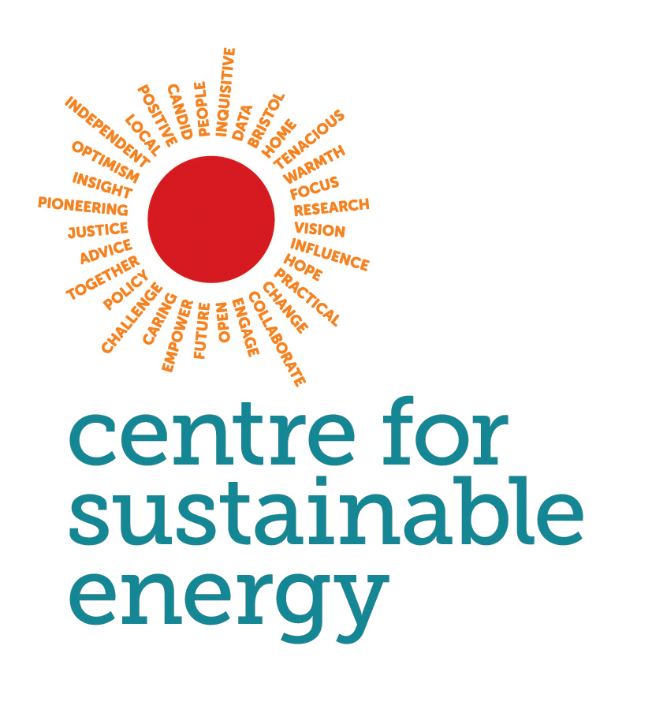
Running an energy cafe event

An energy cafe is a great way to bring the school community together around energy and fuel poverty. Energy cafes offer an opportunity for parents, guardians, staff, and pupils to get together around the topic of energy. You can celebrate what the pupils have learnt about energy and parents have an opportunity to get access to local support on their energy bills.

Below are some ideas of how you could run your energy cafe at your school.

Timing

We suggest running the energy cafe over school pick up time (between 2:30 and 4:30pm) this way parents have an opportunity to speak to an energy provider about their energy bills and receive support before the pupils leave class.

Promotion

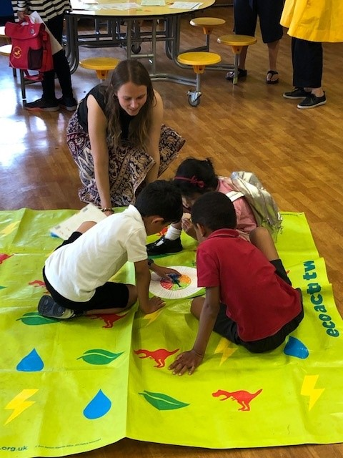
We would suggest promoting the event well ahead of time. Use school newsletters, posters and if possible, send pupils home with an information leaflet about the event. We would also suggest running a raffle at the event, the prizes could be energy saving appliances such as a slow cooker, electric blanket or radiator reflectors. Advertise that there will be a raffle in your promotional materials to entice people to come along.
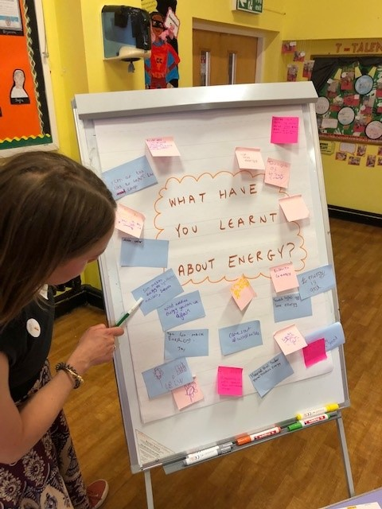

Activities

We suggest having some games that children can play or an activity that they can be a part of, so that parents are free to receive energy advice. If you have been learning about energy in class, you could ask pupils to contribute to a flipchart or display about what they have learnt.

Partnering with a local energy advice service

We would suggest getting in touch with local organisations that can offer free energy advice to attendees. Ask if they can bring along any relevant forms or sign-up sheets for local support. Most local councils will either have an energy support team in-house, or they will know of local organisations that can help. Let them know that you are educating the pupils on energy and fuel poverty and that you are running an event to support parents and families with their energy bills.

Further advice on running events

CSE have a guidance document on running an energy day, this guidance has more ideas, tips and tricks for how you can make the most of your community event. You can access this document here.

