Solar PV checklist: Questions to ask installers

When it comes to choosing a solar photovoltaic (PV) installation, there are a lot of variations – which can make it difficult to compare quotes and to be sure what your investment will buy you. These guidelines are designed to help you ask installers the right questions and understand the answers, and ensure you get the best system. Areas covered in this checklist are: Finding a good installer (page 1) │ Design of the product and system (page 2) │ System components (page 6) │ Structure and installation (page 8) │ Connection (page 10) │ Monitoring and display (page 12) │ What could go wrong? (page 13) │ Further information about solar PV (page 14)

Finding a good installer

- MCS accreditation
Question: Is your company registered with the Microgeneration Certification Scheme (MCS)?
The MCS is set up to protect consumers by ensuring good standards of performance and that installers are technically safe and competent. Information about the scheme and a list of installers accredited under MCS, is available online at: www.mcscertified.com/
To be eligible for the Smart Export Guarantee (SEG) (this is the payment generators receive for any electricity they export to the grid) both the solar PV system and the installer must be accredited under the MCS or equivalent scheme. DIY installations and systems installed by non-MCS accredited companies are therefore not eligible for the SEG.

Company reputation

Question: What is your experience in solar PV installation (how many years have you been in business, what previous projects have you worked on etc)?
You may also want to check how long the company has been installing solar PV systems, where they are based, what previous customers say about them, and so on. Important issues that need to be reviewed before choosing an installer include: size of the company, number of years they have been in business, number of previous projects they have completed etc. You might want to ask how many people will carry out the work, how they are qualified to do it and how long they have been with the company.
You may also want to look for independent reviews on www.checkatrade.com.

Design of the product and system

Embodied carbon

Question: How much energy is used in the construction of the panels? What is the embodied carbon?
You may be interested in how much energy is used in the construction of the PV panels, and therefore what the embodied carbon is and how long it will take to ‘pay back’. You can ask this from the installer for the specific product they install.
The good news is that the embodied carbon of solar has fallen rapidly, and is expected to continue to fall in the future. Solar offers very low carbon electricity.
The estimates will continue to change as a result of declining grid intensity factors. The embodied emissions per kWh are currently about five to eight times lower than the average grid carbon intensity and eleven to eighteen times lower than electricity generated by a combined cycle gas turbine.

- Orientation and tilt
Question: Have both the orientation and tilt of the roof, or wherever the panels are located, been taken into consideration in their positioning and in calculating the generating potential of the system?
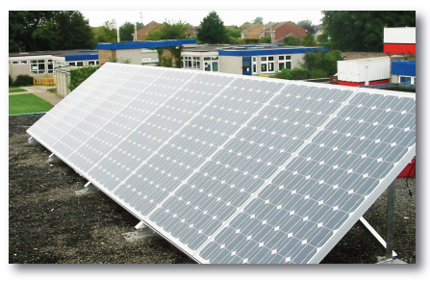
When buildings have flat or unsuitable roofs, PV panels can be fitted on frames and attached to the roof or even placed on the ground.

Solar PV panels work best when they face south, which maximises the capture of energy. Panels will still work if they face south east or south west, but just not as effectively. Outside of this range, though, and they are even less likely to be cost effective.
To catch the most sun, panels need to be tilted at an angle of 30 to 35° from horizontal – about the same as the average pitched roof. If the panels are installed on a flat roof, or even standing on the ground, they can be placed on frames which tilt them at the optimum angle.
The table below shows how the percentage of effectiveness of the system is affected by the tilt and orientation. For example, panels facing southwest on a 30° roof pitch will capture around 96% of the energy that would result if they were facing due south at the same tilt angle.

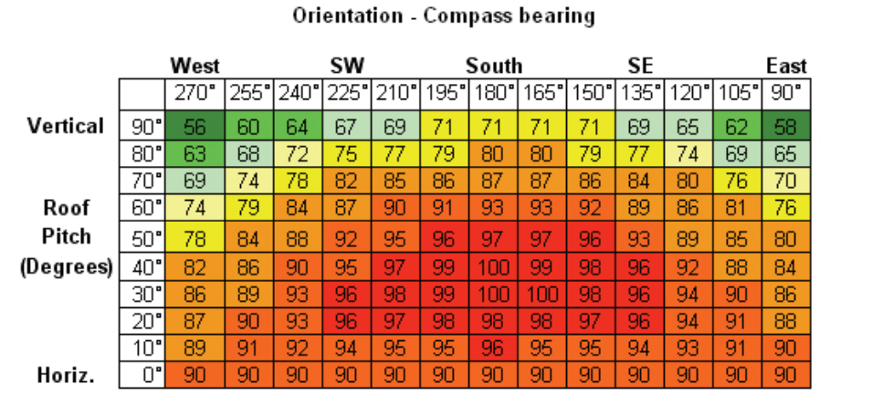
This table shows that the percentage of sun that a solar PV panel will receive is dependent upon its tilt and orientation, with the red areas demonstrating the optimum angles.

It’s worth noting that MCS has a standard calculation procedure that takes into account orientation, tilt and shading so if you are using an installer that is MCS certified then it is likely that this would have been considered.

- Asset shading
Question: Has the company accurately assessed shading and how has this been done?
All panels are adversely affected by shading. Even the slightest of shadows cast by nearby buildings, trees or even lamp-posts can significantly reduce the system’s output.
So it’s important to know whether the site will be shaded at all throughout the year, and to what extent, before going ahead with an installation.
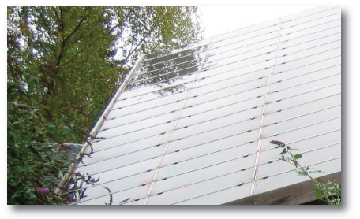
Shading of the panels, such as with these trees, can have a detrimental effect to the output of the system.

There are various methods to assess whether there will be shading on the site, which include:
- Using maps such as Google Earth as a starting point – these can provide a rough indication of whether there will be shading from nearby buildings, trees or other street features.
- Taking on-site observations, photographs or records of year-round shading on the site.
- Using tools like the ‘Solar Site Selector’ (from the Solar Design Company), which fit to a camera and help identify the shading risks – you need to be at the level of the array to do this, however.
- Computer modelling, which can be used in conjunction with the ‘Solar Site Selector’ described above, to predict the impact of shading on energy yields

Mitigating shading

Question: If there’s a risk of shading, have they considered ways to minimise the impact in the design of the system?
When part of a panel is shaded, the shaded cells won’t be able to generate the same amount of electricity as the cells in full sun; they will tend to ‘block’ the flow of current through the whole panel. In some cases this may result in damage to the cells as the blockages may cause overheating.
However, where individual panels or ‘strings’ (a number of panels connected together in series) are shaded, there are techniques that can be factored into the design to lessen the impact on the whole system – ask your installer about:
- Using ‘bypass diodes’ – these are integrated into the panels to allow the current to pass around a shaded, weak, or damaged cell.
- Connecting the panels in parallel, rather than in series in each single string – this allows shaded panels to be bypassed by the output from the other unshaded panels (this solution could require more than one inverter in the system).
- Using a micro-inverter integrated with each individual panel – these can be used as an alternative to larger stand-alone inverters.

System components

Overall effectiveness

Question: What type of panels are available?
There are three main types of panel, but there are also various hybrids that are becoming more widely available.
Each type of solar PV panel uses different materials which collect and capture energy from different wavelengths of light. This means that different types of panels may be more or less effective in different conditions; for example, when it’s cloudy.
Different types of panels also offer different cost and efficiency ratios, as well as different performance levels. The three main types are:
- Monocrystalline panels: made of cells of wafer-thin slices of silicon crystal, these are characterised by their distinctive pattern of small bevel-edge squares that look black or dark blue. They’re the most efficient panels available in terms of energy generated per m², but also the most expensive – and they’re also quite fragile.
- Polycrystalline panels: these are made of cells that are cut from an ingot of melted and re-crystallised silicon – this gives them a very distinctive crackled ‘shimmer’. They’re a bit less efficient than monocrystalline, but also a bit cheaper.
- Amorphous or thin-film panels: these can be bent to fit the architecture on which they are mounted, and are more robust than other panels (so they may be a good choice if vandalism is a potential issue). They’re much cheaper than crystalline panels, but they take up to three times as much space to generate the same amount of energy. However, they do perform better in cloudier conditions or if partly shaded.

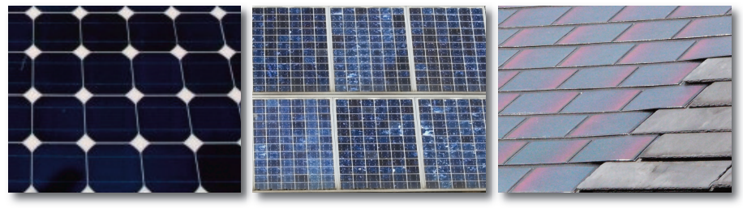
From left to right, examples of: monocrystalline panels (identifiable by its bevel-edge squares and dark black colour), polycrystalline panels (with their distinctive ‘shimmery’ effect) and amorphous or thin-film panels (which can be incorporated onto a roof alongside normal roof tiles).

Energy and power output

Question: What’s the annual energy output per kWp (kilowatt peak) for the system?
You’ll need to know the generating capactity of the system and the annual energy output in order to realistically compare quotes from different installers.
The generating capacity is measured in kilowatt peak, or kWp. This is a measure of the maximum electrical power generated by a system under optimum conditions (i.e. on a clear sunny day). Think of it as the ‘engine capacity’ of the system.
The annual energy output, measured in kilowatt hours (kWh) is the amount of energy a solar PV system actually generates in one year. As a general rule of thumb, a 1kWp system will generate approximately 800kWh per year.
This will, of course, vary depending on the orientation, tilt, and shading, but the type of panel has an even greater effect on annual energy output. The size of the array needed to generate the same amount of energy can vary significantly. Just as two cars with the same engine size (kWp) will go different distances on a litre of petrol, different systems with the same kWp will produce different energy yields over the same period of time given the same amount of sunlight. The table below compares the relative efficiency and space requirements for the three main types of panel:
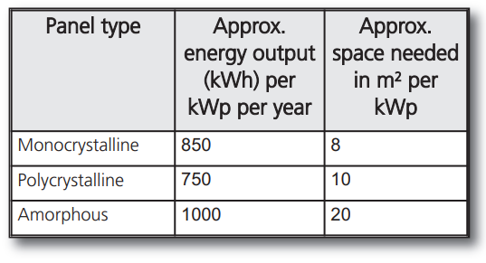

Inverter

Question: What type of inverter will be installed? How durable is it? How big is it?
The inverter is the device that converts the direct current (DC) being generated by the panels into alternating current (AC) which can be used for domestic appliances. It is usually a fairly small component (a bit bigger than a shoe box) and is installed inside the building.
There are different models which mean, of course, different costs, so you may want to explore options.
Sometimes the inverter can make a small ‘humming’ noise while working so make sure it’s not installed next to where you sleep. Also, the lifespan of inverters can be short, so they may need replacing during the lifetime of the system.

Structure and installation

Installing the system

Question: What is the roof made of and how will the panels be attached?
Panels are normally attached to the roof using support brackets and the structural characteristics of the roof will need to be considered prior to the installation. For example, is it strong enough to bear the weight of the panels, as well as the upward force of wind getting under the panels. Here are some questions to bear in mind:
- Does the roof structure need to be strengthened to bear the load? Are there any leaks or gaps that need to be sealed or repaired? Does the roof contain asbestos?
- Has the installation team received training from the system manufacturer? Are procedures specified by the manufacturer strictly adhered to?
- Is there easy access to all areas of the system for maintenance and cleaning? Do you know how wiring will be concealed and accessed?
- Because solar panels are expensive, they could be a target for theft, so will theft-proof hardware (such as bolts that require special wrenches to undo) be an option?

Installation costs

Question: Does the quote include all installation costs?
This is very important, as additional installation costs (e.g. labour, fixings, hire of equipment) could greatly increase the price of the installed system.
Ask for a breakdown of material costs, labour costs and any other costs such as grid connection (see below).
- Do you know exactly what you are going to be paying for? Are there any ‘hidden’ costs that will be added to the quote (for example, scaffolding costs?).
- If during the installation damage is caused to a person or property, will the installer pay for repairs and compensation? Is the installer fully insured?
- What are the cost implications if work is begun, but not completed (e.g. if asbestos is found)

Timescales and work

Question: How soon can the work be carried out and when will you be eligible for the smart export guarantee (SEG)?
You’re probably keen to start generating electricity as soon as possible, but there may be a waiting list of customers, or long lead times between ordering and receiving equipment. Check expected timescales for installation dates and ask how long the work will actually take.
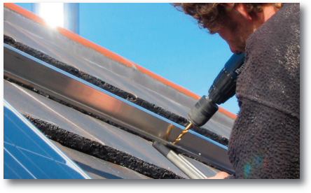
To start receiving SEG payments, you will need to submit an application for a SEG export tariff to a SEG licensee (this does not need to be the same company that supplies you with electricity). You will be asked to demonstrate that the installation and installer are suitably certified, you may have an installation certificate to demonstrate this.
It can take some time to process the application and then you will receive your SEG contract. After this SEG licensees are not required to make payments under the SEG until they have received or been provided with your actual export meter reading.
Please note that you cannot receive a SEG tariff if you are receiving export payments under the Feed-in Tariff scheme.

Connection

Connecting to the grid

Question: How do I connect to the grid and will there be any extra costs?
In order to be connected to the grid, you’ll need to have agreement with the people who run the National Grid in your area – this is the Distribution Network Operator (DNO). A list of each DNO, as well as a postcode checker: www.energynetworks.org/customers/find-my-network-operator
For smaller scale arrays, usually less than 3.68kWp, you need to let them know within 28 days of the installation. For larger arrays you will need to get permission in advance. We recommend you contact your DNO to confirm there are no additional costs or conditions associated with your installation – and your installer may help guide you through all the arrangements.
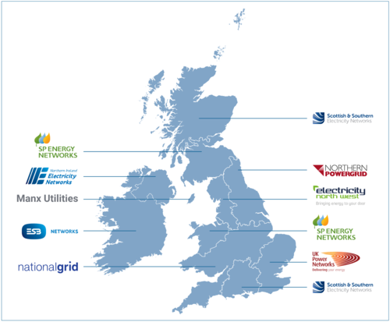
A map showing which Distribution Network Operator (DNO) covers which area across the UK (Energy Networks Association).

Metering

Question: What’s the metering arrangement?
Metering is important for measuring your electricity use and generation, and to get the smart export guarantee (SEG). To claim SEG payments, you must have a meter capable of providing half-hourly export readings and have an export MPAN.

An export meter must be located at the point where the installation connects to the distribution network/the grid. Your existing meter may be capable of measuring exported electricity; speak to your SEG licensee about whether your existing meter can be used to receive SEG payments.
More information on eligibility requirements can be found here: www.ofgem.gov.uk/publications/smart-export-guarantee-guidance-generators.

Monitoring and display

Monitoring energy generation

Question: Will there be a display unit? What does it show? Will it cost extra?
Many systems are installed with a display unit that shows how much electricity is being produced at any given time, or over a set time period. Sophisticated displays will show additional measurements such as the outside temperature.
You may need a separate control unit to log information about the amount of energy you are generating, by linking separate meters via a data cable. This might also enable you to download your generating history onto a computer.
Some systems allow you to log data on energy generation via the export meter or generation meter, or even via the inverter. This can be particularly useful if the array is on a school or public building.
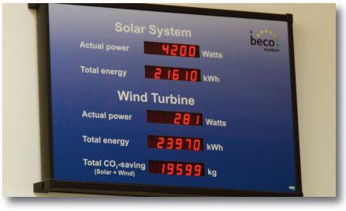
Some solar PV systems are installed with a display unit which shows how much electricity has been produced alongside a variety of other information.

What could go wrong?

Warranties

Question: Does the system come with a warranty? What does it cover? And over what time period?
The installer may provide performance guarantees or warranties for the system. These can include product warranties (covering defects in manufacture), system warranties (covering proper operation of equipment for a specific time period), and, less frequently, energy performance warranties guaranteeing a minimum energy output of the PV panels over time.
We’d also recommend that you check to see if the installer is a member of the Renewable Energy Consumer Code: www.recc.org.uk/.
It’s worth bearing in mind that other components in the system may have a shorter life expectancy than the PV panels. Inverters may have ten, five or even one-year warranties.
However, entire system warranties should be for a minimum of five years. This gives an indication that the manufacturer has taken other operational issues into account.

Maintenance

Question: What should I expect in terms of on-going maintenance?
Some panels are self-cleaning but some may require occasional cleaning as a result of snow, bird mess etc, especially if the panels are relatively flat. Dirt on the panels can have a similar effect to shading so this is an important issue.
As explained above, some parts of the system have shorter life expectancies than others and parts might need repairing, replacing or servicing.
MCS certified installers are required to provide information about the maintenance of the system.

Further information about solar PV

Centre for Sustainable Energy (CSE) www.cse.org.uk
Microgeneration Certification Scheme (MCS): www.mcscertified.com
Renewable Energy Consumer Code (RECC): www.recc.org.uk
Centre for Alternative Technology (CAT) www.cat.org.uk
Energy Saving Trust (EST) www.est.org.uk
Carbon Trust (look up the best practice guides in their publications section): www.carbontrust.co.uk
Department of Energy Security and Net Zero (DESNZ): www.gov.uk/government/organisations/department-for-energy-security-and-net-zero
Smart Export Guarantee (SEG) (Ofgem page): https://www.ofgem.gov.uk/environmental-programmes/smart-export-guarantee-seg/generators

https://etude.co.uk/how-we-work/low-embodied-carbon-of-pv/

