Running a slow-cooker workshop
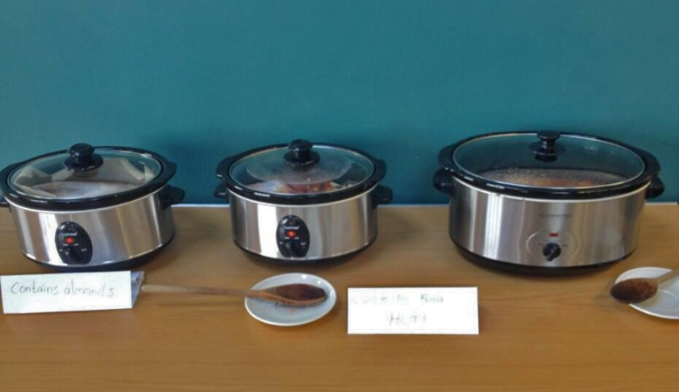

What is it?

Slow cookers are cheaper than an electric oven and you can leave them cooking on a low heat overnight. They are both efficient in terms of energy use, but also in terms of time as you can put everything in a pot and leave it to cook as you get on with the rest of your day.

A slow cooker workshop serves as a social opportunity to get people together to have a chat and share some food. By getting people involved in the cooking of a slow cooker meal, you can show members of your community the benefits of slow cooking as a way to save energy in the home (especially if they have an electric oven). And while people wait for their free hot meal, there is plenty of time to talk about energy more broadly – we’ve experienced local residents talking to each other about smart meters, tips for thrifty energy use and their gripes about single glazing.

Event organisation

You’ll need a community space to set up the event. The space will need to be appropriate for cooking so having a kitchen would be handy (but not vital).

You should plan to run this event for 4-5 hours (as it takes time to cook the meal). If you want to prepare a lunch time meal, you will need to start the event in the morning, if you want to prepare a dinner you will need to start in the early afternoon.

How you run the event is up to you – you can either get people involved in the cooking from the beginning or have people come and go as they wish throughout the cooking process. You will want to invite people to join to eat the meal at the end of the event!

Whilst the meal cooks, here are a few options of what you can do:
- You can plan some energy-related activities, like making your own draught proofing snake, or doing some energy quizzes!
- You can run a competition to win some freebies – a slow cooker for example! Running a competition that people have to enter in is a good way of gathering some contact details for people who may be interested in getting involved in an energy project in the future.
- You can use prompts to start group conversations about energy topics such as switching, draught proofing, using smart meters, etc.

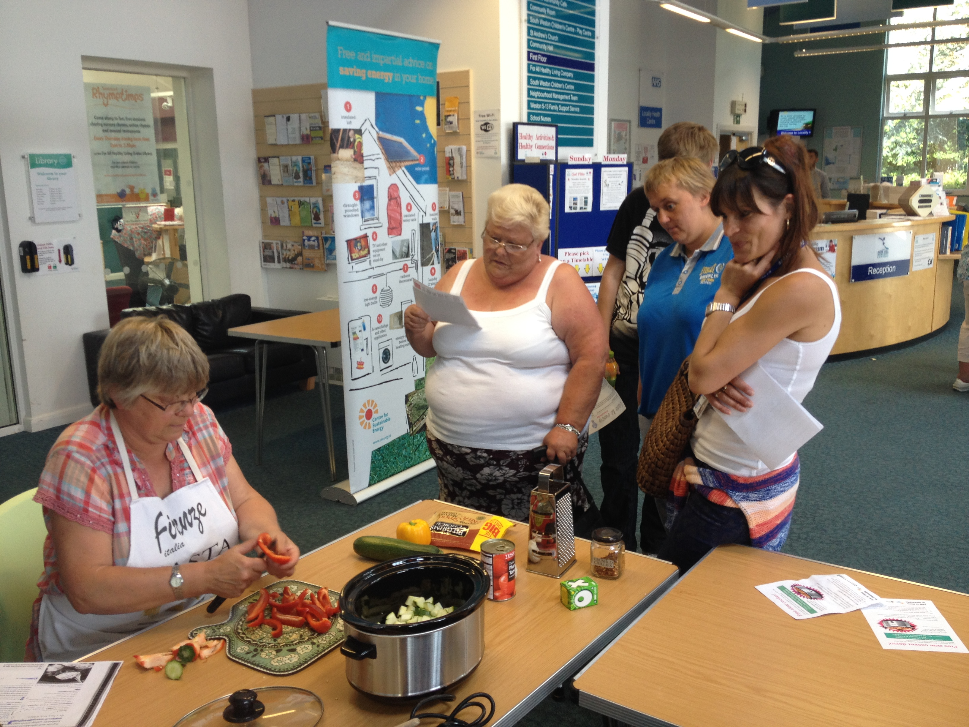

Slow cooking brings energy efficiency into the context of domestic life. There are a number of other examples of this – visit our factsheet on energy saving tips for some conversation ideas.

What you’ll need

- A few slow cookers – depending on the amount of people attending your event, and what meal you plan to cook, you will need to bring in a few slow cookers to cook the meal.
- Your ingredients – don’t forget to plan in advance what you need to get, and plan for several options for food (veggie option? vegan?)
- Cooking utensils – check with the venue what utensils they may already have.
- Freebies – freebies are always good to encourage people to come to an event. You could have slow cookers, LED lightbulbs, or energy monitors to give away.
- Information materials
- Slow cooker recipe book there are lots of recipes here: https://www.bbcgoodfood.com/recipes/collection/slow-cooker-recipes
- We have a suite of information sheets covering topics from home improvements to dealing with energy bills. See the full range available here www.cse.org.uk/advice-leaflets

Marketing

Start as far ahead as you can and advertise the event as widely as possible in your community through flyers, posters and local papers or magazines. When making your posters or leaflets, consider what message to put across – a free meal and some giveaways is likely to be more attractive than free information! Use social media to promote the event further and distribute news via your email lists and networks. Telling influential people in the community will help spread the message via word of mouth.

Feedback and next steps

It’s a good idea to collect feedback from people who attended your event so you can understand what people enjoyed/didn’t enjoy, and to start developing an understanding of their motivations for attending and getting involved in the project. It’s also a great opportunity to collect basic contact details so you can be in touch with people in the future.

