Running a community energy advice service

Getting started

Deciding on your approach

The main thing that will shape how your advice service will operate is how much time you/your group has, and if there are any resources that can be put towards running your service.
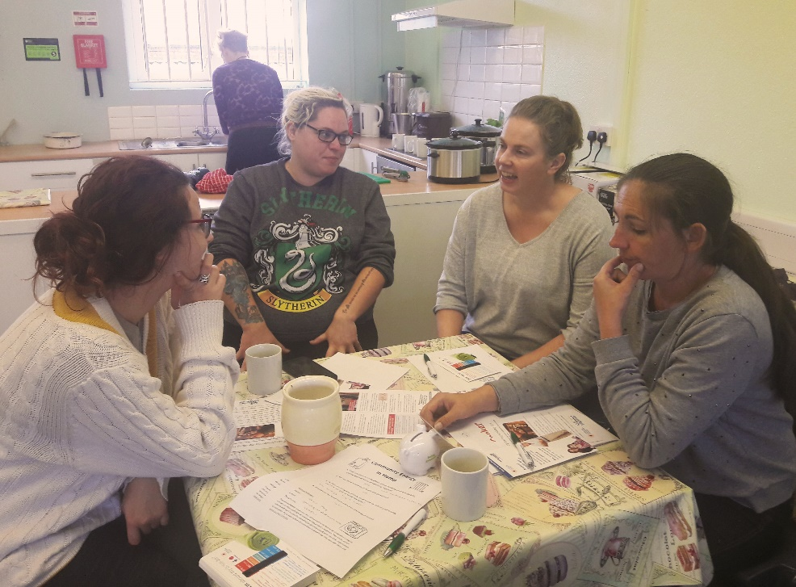
There are different approaches you can take. You could: plan a one off ‘pop-up shop’; have a regular stand at a local event (e.g. a farmers market ); have a stand in a shop or community venue (e.g. a community centre, village hall or church); or have a stand at different local events and gatherings. You can also run events on specific topics, such as draught proofing, understanding your bill, or heating controls.
The approach you take is entirely up to you. Different approaches may be more effective in different communities, and you will know what will work best in your area. Think about the people you want to engage with and the best way to reach them. Do some research on suitable venues and upcoming or regular events. Of course, you could start small and build up to a more ambitious service as time goes on or try a few different approaches.

People

You’ll need to find people to staff your advice service. You might be able to use existing members of your group, but you’ll probably want to recruit more volunteers to act as energy champions in your area and to lighten the load.
Once you know who’s going to be involved, agree who will be doing what. For an ongoing advice service, you may need a rota. For all events everyone needs to know exactly what their role is and what the timings are.

Training

Of course, providing energy advice assumes a basic level of knowledge and understanding. A meet up or an informal training session to run through the basics and accompanying resources including the CSE factsheets and signposting contacts will help to make sure everyone feels confident when it comes to providing information to members of the public.
If you want to take things a bit further you could arrange more formal training (for example the City and Guilds Energy Awareness course or a bespoke training session for your group run by an expert).

Organise and book

When you have decided on your approach, you know who will be involved in running your advice service, and you’ve organised some training, get some dates in the diary whilst the training is fresh in your minds! Check what resources are available at your chosen venue (e.g. tables and chairs; tea and coffee making facilities) and ask about practical things like requirements for setting up and clearing away, facilities for storage, drop off, parking. If there are venue costs, ask if you qualify for a discounted rate as a local community group/organisation.

Insurance & managing risk

If you’re delivering something as part of a larger event, or in a public building, these should have their own insurance which would cover you as well – have a chat with the relevant people to double check. As your advice-giving will likely involve a lot of signposting to organisations/agencies for further support and advice, then having your own insurance is less relevant but you may want to do a risk assessment to think through some of the risks that could arise from your activities and what you could do to mitigate them.

Working with partners

We really recommend speaking with other local stakeholders about your plans to deliver local energy advice – and do this early on in your planning! There may be opportunities to develop a formal partnership or piggyback existing work; but even just letting them know it’s happening ensures efforts aren’t duplicated, can lend legitimacy to your activities, and they may be able to support you in your efforts. Residents may also not have much direct contact with local stakeholders, or have a tricky relationship with them – there could be an opportunity for your project to facilitate a more meaningful relationship.
Local authority: It’s a good idea (especially if you choose to do something big right from the start) to contact your local authority at the beginning to discuss your plans. They may well have an energy saving scheme that they would like you to promote, and in return they can help to promote your advice service. Having the backing of the local authority can be a valuable tool to gain people’s trust and to raise the awareness in the area of what you’re doing. They also may be able to help provide support and resources (possibly even a venue) or to signpost you to other sources of funding and support in your area.
When your local authority is the local housing provider, it is useful to engage with their housing team because of their existing links to residents. They may even have a dedicated energy advisor. Knowing what the local housing providers are doing, and who the best contacts are will be critical when giving advice to social housing tenants.
Also find out if your local authority has neighbourhood wardens, and any of the following specialist officers: community development/empowerment; energy/climate changes officers; and fuel poverty/affordable warmth.
Local organisations: Working in partnership with other advice-giving organisations is a great way to raise your profile and extend the range of support on offer. Consider contacting charities, support organisations that support vulnerable people, community development organisations, and other environmental charities in your area. Offer to disseminate information for them or to signpost to their services. They may be able to provide some training for your volunteers in their particular area of expertise.
Local businesses: They might be willing to provide sponsorship and support, sometimes in return for your endorsement of their services/products. But bear in mind that one of the main things people like and trust about local organisations offering advice is their impartiality.

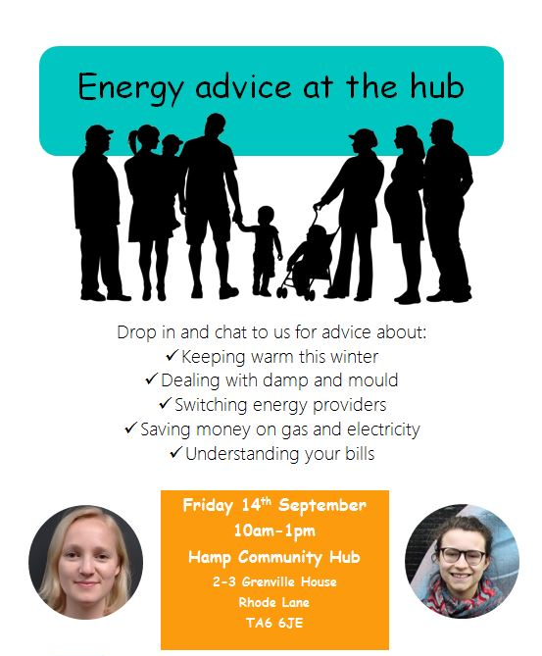
Publicity
An example poster

Once you’ve got a plan for how your advice service will operate you’ll need to get the word out.
Local media: Use as many forms of local media as you can – newspapers, free newsletters and radio can all be really effective.
Social media: Social media can be a great way to advertise your service as well as post advice information. If you don’t already have a Facebook page create one!
Posters and flyers: Plaster your area with posters – on noticeboards, in local shops and public buildings. If you have capacity hand out fliers on your local high street or do a door-to-door leaflet drop.
Using the right message: Before advertising think carefully about your messaging. Who is the advice service aimed at and what will get their interest? Whilst money saving can definitely be a good messaging ‘hook’, for many low-income households there is little extra they can do to save money given that they are already amongst the lowest energy users. We recommend stressing opportunities to improve comfort and reduce damp in the home. For some who grew up in post-war Britain where people valued frugal behaviours, messaging around reducing energy wastage can work well.
The more the better: It may take some time for the word to spread about your advice service so do not be disheartened if you only have one person turn up to begin with – projects like this often take a bit of time to get off the ground. Keep going with the leaflets, posters and promotion, taking advantage of any opportunities you get to let people know about the service.

Giving energy advice

Speaking to people

Some people will feel able to raise issues that they are concerned about directly with you; others may need some prompting; and some may want some general help but won’t have a specific question. Think about how to break down barriers to put people at their ease – with introductions, materials to look, or displays which highlight potential issues.

Learnings
- When CSE gives householders advice the topics that come up the most often are high energy bills, funding for insulation and heating improvements – so be prepared for these topics to emerge as people talk with you.
- People will have a variety of housing situations, and this will shape how able they are, and how empowered they feel, to make changes to their energy behaviours.
- If someone has a question which you don’t know the answer to, be honest and don’t feel obliged to answer every question. Refer them to an organisation who may know more.
- And remember, don’t promise more than you can offer – manage people’s expectations and deliver what you promise.

Drop-in for those needing help

You may decide to structure your service as an advice surgery offering people one to one support with various issues, such as switching energy suppliers or managing energy debt. This may appeal if you’re in an area with high levels of fuel poverty and you feel this may be a valuable service to local people. If you do this, 20-30 minute slots are probably about the right length of time. Use CSE’s information sheets to talk through issues and for people to take away with them.

Display materials

It’s easier to get information across to someone when there’s something visual that can be a talking point which will stick in their memory. Displays also help to attract people to your stand and mean there is something to do if there is a queue of people waiting to talk to you.

CSE factsheets

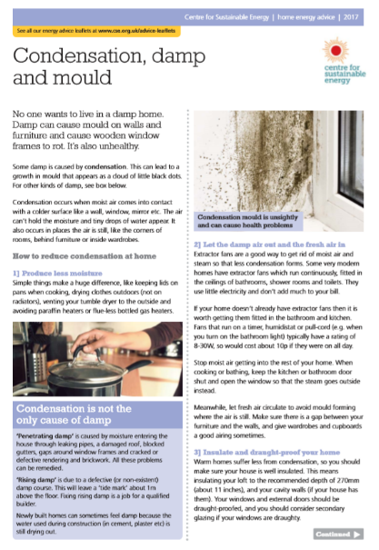
CSE have developed a whopping 70 factsheets covering almost anything that you might get an enquiry about! Factsheets cover different insulation types, help with managing bills, renewable technologies, advice for those living in older homes, setting heating controls, switching energy supplier and much more. You can find them on https://www.cse.org.uk/resource/home-energy-fact-sheets/ and they are free to download and print.

Subsidies and support
Many enquirers will want to know what funding is available to make home improvements. Are there any local funding pots or national subsidies (e.g. the Energy Company Obligation) which households can tap into, or schemes or support you can signpost to? Make sure you are up to speed on these to ensure that you’re giving the best service possible.

Record keeping

Think about what you as an organisation are hoping to achieve, how you give information out to people, and how you will record what you’ve done. Do you have any targets you’re hoping to meet? Will you collect people’s details and add them to a mailing list? Further down the road you might want to apply for funding to support your service, and having information about how many people you’ve already supported will be important.

Engaging people with giveaways & activities

To make things a bit more fun you might consider giveaways (e.g. free lightbulbs or something tangible which will attract attention), or you could run a competition or a prize draw with an attractive prize.
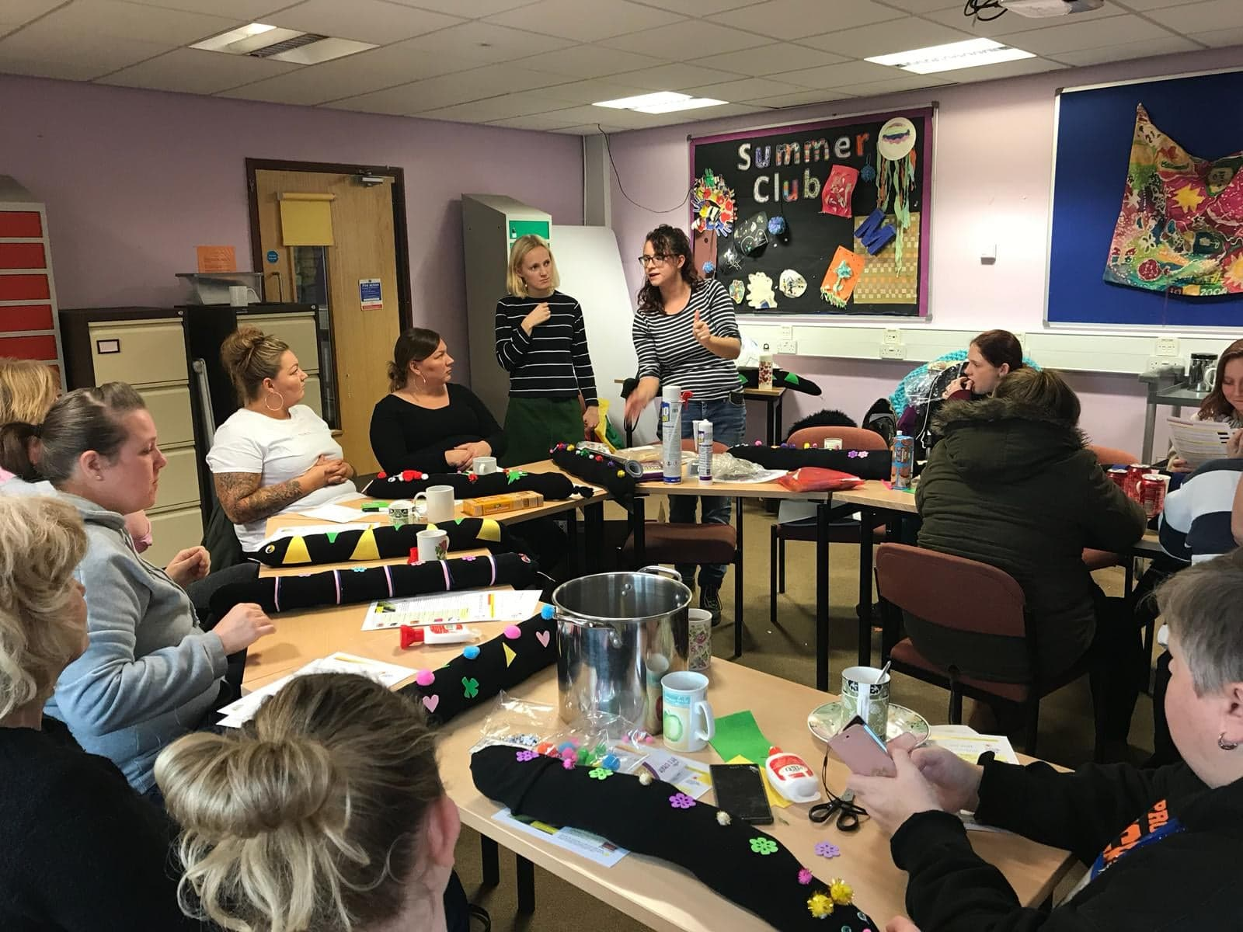
Another way to make your energy advice fun is to run crafty or practical workshops. For example, you could have a workshop getting people to make their own draught proofing snakes and use the opportunity to advise people on practical draught proofing measures. Another example is running a slow cooker workshop as a chance to get people together to share a meal and talk about domestic energy use and energy saving tips!

Tea, coffee and cake

It’s a fact of life that free food and drink gets people interested! Why not give away slices of cake, or arrange a coffee morning with bacon butties where people can come along for a chat about energy saving? You might have volunteers who aren’t too confident at giving advice but would love to help out by providing food.

Ongoing publicity

You will have made some noise about your project right at the start. But it’s important to keep spreading the word throughout your project rather than thinking that you have ‘done’ the publicity. You could carry on using flyers, and getting out press releases and written information, or you could try some different approaches like putting up a banner, getting a key person in the community to talk about it (e.g. the vicar or mayor). Word of mouth is really important so encourage people you meet with to let their friends, families and neighbours know about what you are doing.

Feedback and next steps

Whether you end up doing one or more individual events or running an ongoing advice service, it’s important to get feedback and think about any areas for improvement. It’s also a great opportunity to collect basic contact details so you can be in touch with people in the future.

Feedback

Gather feedback from people who have used the advice service (e.g. a survey, a telephone follow up, a postcard or an online form) and from your volunteers and any partners.
Gather quantitative data (e.g. the number of people who have received advice, the number of sessions you have delivered, the number of information sheets you have given out) and qualitative data (e.g. why did people seek energy advice? what did people do with the advice they received? have any partners changed their practices?).
Use all of this information to review your project’s success. It’s really useful if you can get together and reflect on what you have done within your group. Try to answer the following questions: What have you achieved? Who did you reach? How did they find out about the service? What could you improve? What are your strengths? What are the gaps? Can you recruit more volunteers or raise more funding to expand the service? Do you need to try a different approach?

Next steps

Based on the information and your review, make an action plan for your next steps. That might be to continue the service with a few tweaks, make drastic changes to grow or shrink what you’re doing, or to build on your experience and start a new project.

