Running a draught proofing workshop

What is it?

Draught proofing is an easy and low cost way to make your home warmer and more comfortable whilst saving energy and money on your bills. Holding a draught proofing event is a great opportunity to demonstrate and discuss draught proofing measures with the people in your local community and give out information about other home energy improvements. Offering some freebies like letterbox covers and door brush strips will encourage people to install measures when they get home.
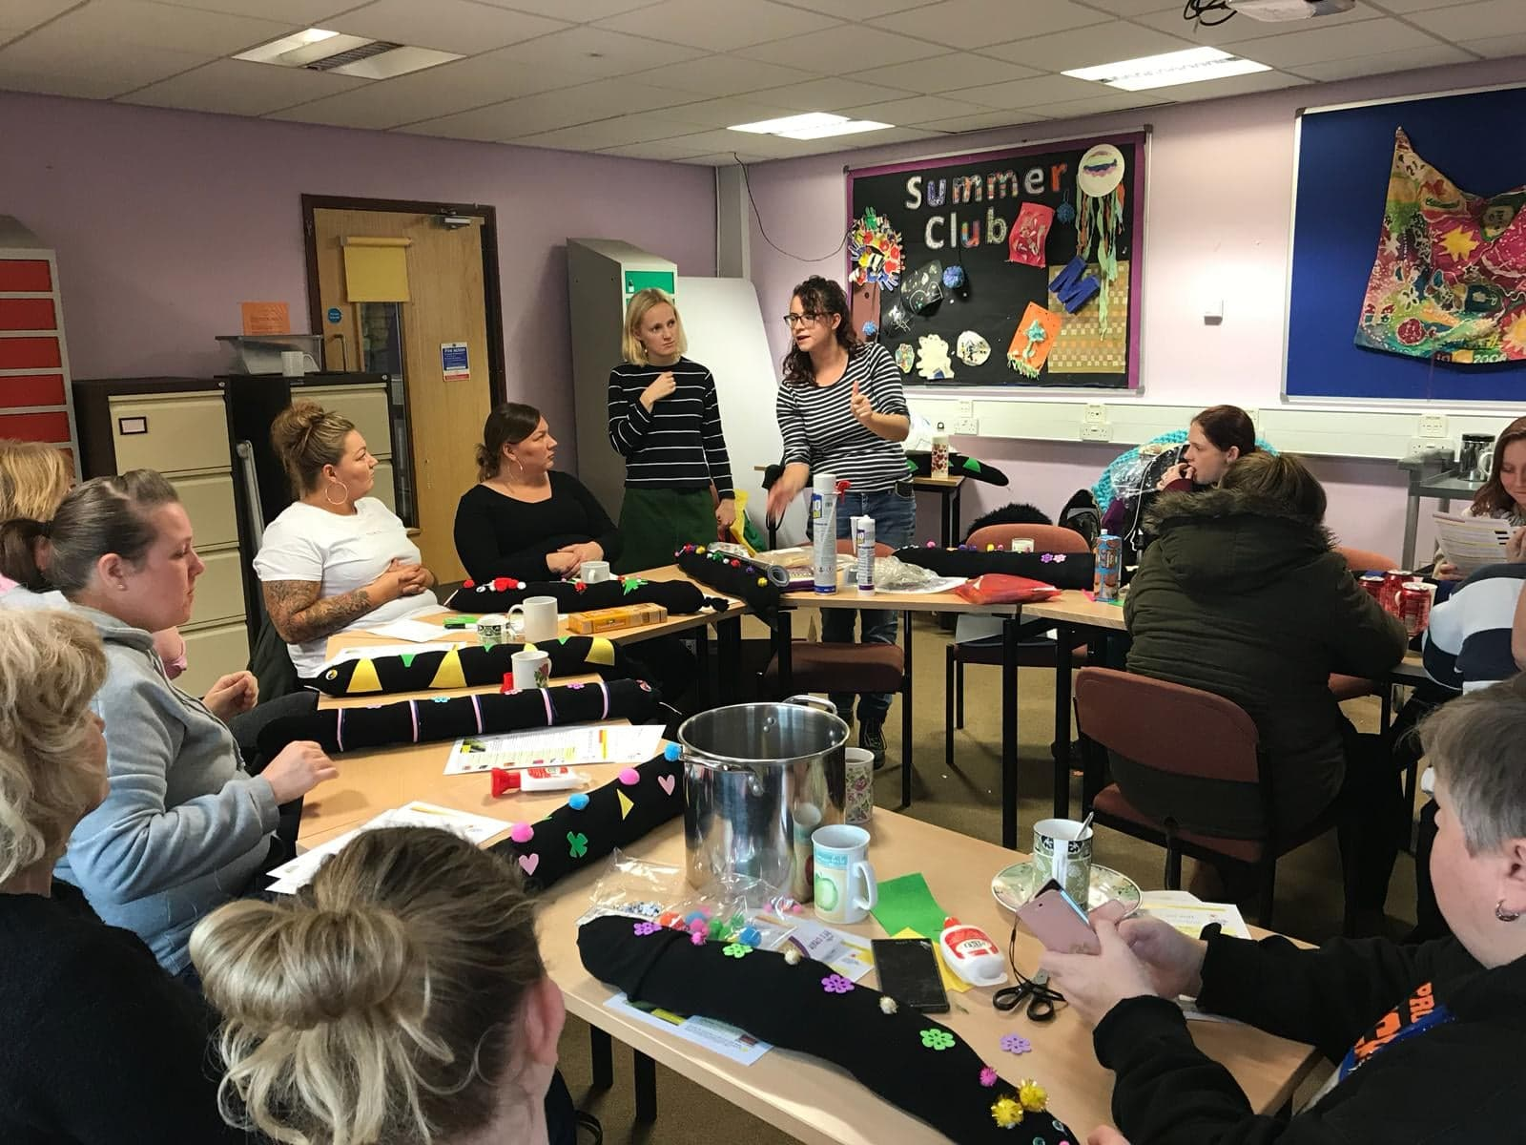

As part of your event, you could hold a draught proofing snake-making workshop – it’s a fun way to engage people in energy & gives people an immediate, very low-cost way to make their home warmer and more comfortable. Whilst people are making snakes you can give them broader energy saving and DIY draught proofing tips.

Event organisation

You’ll need a community space to set up a stand – a community hall, a church hall or outside a busy shop. Or why not do it as part of a bigger community event like a summer fayre, street party or school fun day? It will take some of the organisational pressure off and hopefully catch more people. This event will only take a day or half day to run, but remember to give yourselves a few weeks beforehand to organise, plan and promote it.

Marketing

Start as far ahead as you can and advertise the event as widely as possible in your community through flyers, posters and local papers or magazines. When making your posters or leaflets, consider what message to put across – a free draught proofing kit is likely to be more attractive than free information! Use social media to promote the event further and distribute news via your email lists and networks. Telling influential people in the community will help spread the message via word of mouth.

What you’ll need

- Posters and information sheets
- Extra information sheets on other energy-related topics (e.g. damp & condensation, heating) – CSE has a suite of free information sheets, available here: www.cse.org.uk/advice-leaflets
- A demonstration kit – to include a range of draught proofing measures, which you could also offer as free giveaways: (totals to £110-150) – if your budget is tight you can choose to just buy some of the items.
- Letterbox cover: https://bit.ly/33K3pJ2
- Keyhole cover: https://amzn.to/32GTq5R
- Secondary glazing film: https://amzn.to/2QcU2xp
- Expanding foam: https://bit.ly/33FxQQu
- Filler/Sealant: https://bit.ly/2KjSnT3
- Stop gap: https://amzn.to/2ryohEL
- Draught-proofing strips:
Weather strips: https://bit.ly/374sEYr
Weather strips (extra thick): https://bit.ly/2XkwoRr
P strips: https://bit.ly/2KiCa0u
- Door draught excluder: https://amzn.to/2KihC8u
- Door brush: https://bit.ly/2NIdSim
- Chimney sheep: https://amzn.to/2CH2nl0

- Additional event equipment may be needed such as a trestle table, chairs, any leaflets and promotional material you have for other activities you’re carrying out, and a sign-up sheet for people who want to be kept informed of your activities.

Feedback and next steps

It’s a good idea to collect feedback from people who attended your event so you can understand what people enjoyed/didn’t enjoy, and to start developing an understanding of their motivations for attending and getting involved in the project. It’s also a great opportunity to collect basic contact details so you can be in touch with people in the future.

