

A picklist of questions for your Neighbourhood Plan Questionnaire, embedding climate change, sustainability and resilience issues
We’ve put together a pick-list of questions you might choose to use or adapt in your neighbourhood plan questionnaire. It’s unlikely that all the questions we’ve drafted will be relevant to your community, so pick and choose those which address particular local concerns. (Also remember that the more questions you ask, the more you have to analyse afterwards!)
Try to treat issues holistically and to build links with other issues and objectives that people care about (even people who don’t believe in climate change) e.g. economic development, town centre renewal, low energy costs; and to underlying values that might be shared: e.g. quality of life, good health, community development, choice (e.g. of not always having to drive).
Also bear in mind that questionnaires are not the only way to engage your community.

Your thoughts about the area (freeform questions)
- What do you like about the town / area?

- What do you dislike about the town / area?

- How would you like the area to change over the next 15 to 20 years? / How does it need to change?

- How would the area need to change in order to be more environmentally sustainable, given the need to cut carbon emissions to nothing in the coming decades? What are the 3 key sustainability challenges here?

Resilience to climate change and Extreme Weather
- Do you feel at risk to any climate change issues locally - flooding, heat, storms? etc. Is the area likely to be vulnerable to the impacts of climate change within the next 15 years (the plan period)?

Very much so | Somewhat | Not at all | Comments

Please read the following statements and indicate the strength of your agreement by placing a cross in the relevant box. Comments explaining your response are welcome.
- Flood waters have or have the potential to impact on my property and my way of life, particularly if they were to worsen in severity or frequency.

Very much so | Somewhat | Not at all | Comments

- Floodwaters should be directed to green spaces within the town during flood events to prevent flooding of homes and businesses.

Very much so | Somewhat | Not at all | Comments

- Heat waves have or have the potential to impact my quality of life and health, particularly if they were to worsen in severity or frequency.

Very much so | Somewhat | Not at all | Comments

- Should the town be addressing climate change issues better? If so what could it do better?

Very much so | Somewhat | Not at all | Comments

- How should new development do more to minimise climate change and adapt to its effects?

New buildings should have renewable energy built in, providing as much of the building’s energy needs as possible from renewable energy on-site. | Strongly agree | Agree | Disagree | Strongly disagree
New buildings should be designed to be highly energy efficient / carbon neutral, in order minimise the need for heating and cooling (e.g. thicker walls, south-facing glazing with integral shading etc, designed for natural ventilation and to be resilient to extreme weather). | Strongly agree | Agree | Disagree | Strongly disagree
New buildings should be designed to be highly sustainable in design and construction, using sustainable materials with low embodied energy. | Strongly agree | Agree | Disagree | Strongly disagree
Through their design, layout and landscaping, new buildings should be designed to be resilient to overheating during heat waves | Strongly agree | Agree | Disagree | Strongly disagree
New buildings should have facilities for drying laundry outside | Strongly agree | Agree | Disagree | Strongly disagree
New buildings should have secure, weatherproof weather bike storage, usable by all. | Strongly agree | Agree | Disagree | Strongly disagree
New developments should have charging infrastructure for electric cars | Strongly agree | Agree | Disagree | Strongly disagree
New buildings should incorporate green roofs and walls to help reduce flooding (by slowing down rainwater runoff), to reduce heat extremes and provide wildlife habitat. | Strongly agree | Agree | Disagree | Strongly disagree
New development should utilise natural drainage systems such as soakaways, ponds and ditches to help reduce flooding (by slowing down rainwater runoff) and provide wildlife habitat. | Strongly agree | Agree | Disagree | Strongly disagree
Please provide further comments if you wish:

Our Existing Building Stock and fuel poverty
- Do you struggle to heat your home in the winter?

Very much so | Somewhat | Not at all | Comments

- Do you struggle to keep your home comfortable during heatwaves? Would your home be resilient if heatwaves increased in frequency or severity?

Very much so | Somewhat | Not at all | Comments

- The neighbourhood plan should support appropriate measures to increase energy efficiency of traditional and historic buildings (including listed buildings) where their historic interest can be conserved.

Very much so | Somewhat | Not at all | Comments

- What measures should be supported?

Secondary glazing for listed buildings | Strongly agree | Agree | Disagree | Strongly disagree
Slimline double glazing for listed buildings | Strongly agree | Agree | Disagree | Strongly disagree
The installation of solar panels on unobtrusive roofslopes | Strongly agree | Agree | Disagree | Strongly disagree
Solid wall insulation measures on buildings without historic or decorative stonework or brickwork, where it doesn’t detract from the historic character of the building.  (This is insulation fixed to the outside of the building, typically finished with render.) | Strongly agree | Agree | Disagree | Strongly disagree
Internal wall insulation fitted within historic and listed buildings to improve energy efficiency, where it doesn’t detract from the historic character of the building.  (This is insulation lining the inside of the building.) | Strongly agree | Agree | Disagree | Strongly disagree
Other (please specify) | Strongly agree | Agree | Disagree | Strongly disagree
Other (please specify) | Strongly agree | Agree | Disagree | Strongly disagree
Other (please specify) | Strongly agree | Agree | Disagree | Strongly disagree

- Future developments should be designed to have high energy efficiency and low energy running costs, to ‘design out’ fuel poverty.

Very much so | Somewhat | Not at all | Comments

Renewable Energy

- The Neighbourhood Plan should give support to the production of renewable energy, to make our town more self-sufficient and capture energy spending in our local economy.

Strongly agree | Agree | Disagree | Strongly disagree | Comments

- As far as possible, the parish should aim to become self-sufficient in energy generation, generating all of our electricity demand from renewable energy (eg. solar panels, micro-hydro, onshore wind).

Strongly agree | Agree | Neither agree nor disagree | Disagree | Strongly disagree

- Please tick all the forms of renewable energy you would support in principle. I support renewable energy in the form of:

 | Strongly agree | Agree | Neither agree nor disagree | Disagree | Strongly disagree
Roof based solar panels
commercial scale solar farms
Micro-hydro projects,
Onshore wind
Anaerobic digestion
Energy from Waste
Geo-thermal energy generation
District heating
Ground source heat pumps

- Support should be given to:

 | Strongly agree | Agree | Neither agree nor disagree | Disagree | Strongly disagree
Wholly community owned renewable energy schemes, returning all profits to the community
Partially community owned projects (jointly owned with commercial developers) returning a share of the benefits to the community.
Commercial renewable energy developments, wholly privately owned, but returning some benefits to the community.
All renewable energy schemes, regardless of ownership and benefit structures.

Renewable energy developments should not be encouraged at all, regardless of ownership and benefit structures

Wholly community owned projects return all of the profits to the community, but the community carries all of the risk and cost of developing them. Jointly owned and private sector projects return progressively smaller returns to the community, but require less of an investment (of time and money) from the community to develop.

Transport and Travel
General
- What forms of transport do you use most? Vote for your top three:

 | Most commonly used | 2nd most common | 3rd most common

Car

Bus

Train

Taxi

Motorbike

Walking

Cycling

Other

- Are there forms of sustainable transport that you would you like to use more? Please tick all that apply. For each option you tick, briefly state what it is that prevents you doing so.

 | I’d like to use this the most | I’d like to use this 2nd most | I don’t do this because….

Bus

Train

Shared bike scheme

Car Club

Walking

Cycling

Other

- We need more segregated cycle lanes (Dutch style cycle lanes, separated from road traffic)

Very much so | Somewhat | Not at all | Comments - where specifically are these needed?

- Cycle routes need to have better links with neighbouring communities.

Very much so | Somewhat | Not at all | Comments - where do links need improving?

If out-commuting from your neighbourhood is a concern

- Where do you work?

postcode

- Is there a choice of transport options to get there? Tick all those options available / feasible.

Car

Bus

Train

Walking

Cycling

Other

- How does your commute influence your health and /or quality of life?

It benefits my health and/or quality of life | It harms It has no impact on my health and/or quality of life | It harms my health and/or quality of life | I have no opinion

Comments:

The school run
- If you have children, is it possible for them to get to school or nursery safely and conveniently on foot, scooter, by bike or on public transport?

Very much so | Somewhat | Not at all | Comments

- Are you concerned that your children are exposed to air pollution whilst getting to school, or at school?

Very much so | Somewhat | Not at all | Comments

- Are there specific danger points, barriers or pieces of missing infrastructure that discourage you or your children from walking, cycling and using public transport? Where are they and what? (Free write/text) (This would work best if people could annotate a physical or digital map)

- What improvements could be made to the public transport infrastructure in the area?

Sustainable transport to and from key destinations

- How could cycling and walking routes to and from the train station / school / town centre / other key transport generators be improved?

Location of housing

- What are your views on the location of new houses that are built in the town – should the plan reinforce the need for housing to be built in locations that are accessible on foot, by bike and public transport

Very much so | Somewhat | Not at all | Comments

Community Facilities

- Which services/facilities do you use in your neighbourhood? (Here you could populate the community facilities that exist, e.g. schools, community halls, shops, pubs, banks etc...)

- Which services/facilities do you have to go elsewhere for?

- Are there any community facilities or services which are missing, and which would make the community more self-sufficient?

- What sports, leisure and entertainment facilities would you like to see more of in the town / area?

The High Street / Town Centre
- Describe the high street / town centre in three key words. What’s it like as a place to spend time in?

- Describe the shopping provision in your town centre in three words

- What would encourage you to spend more time in the town centre?

- What would make the town centre a more interesting place to spend time in, for visitors and local residents alike?

- What activities would you like to have more or less of in your town centre?

(One option here would be to make this visual and include relevant photographs of shopping, employment uses, cafes, public space, cultural activities etc.… to get people thinking beyond just shopping and the range of ways your public spaces could be used. With the rise of online shopping, town centres that are too reliant on retail uses alone are already likely to be in decline. We’ve included sample photographs to inspire you, but you can change these for locally relevant images.)

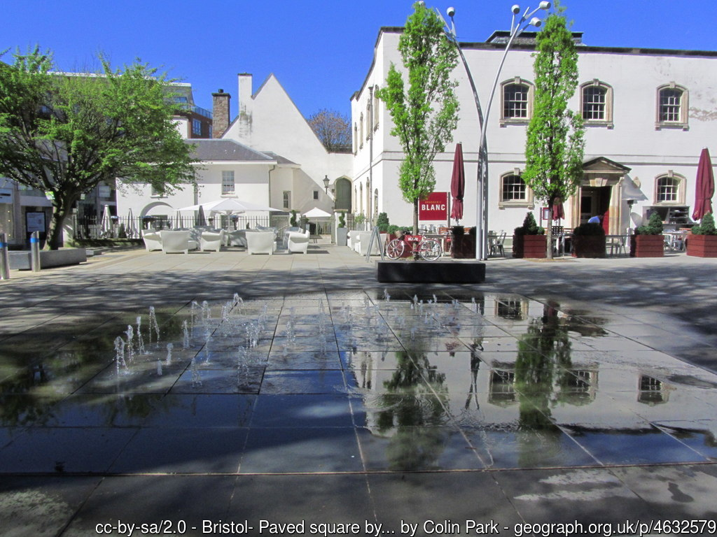
High quality car free public spaces
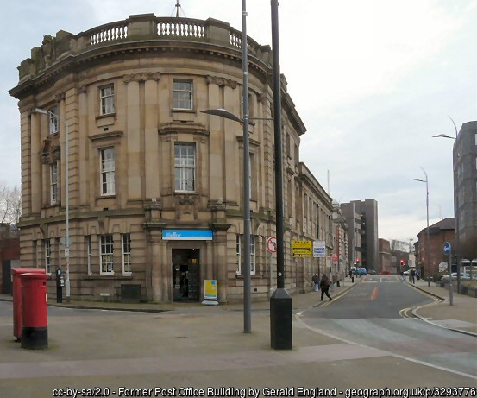
Employment uses

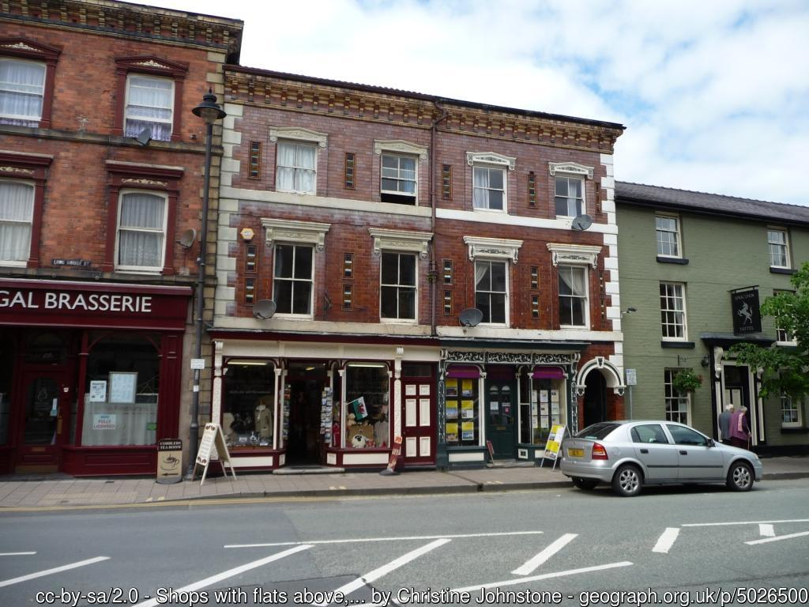
Housing on upper floors above shops

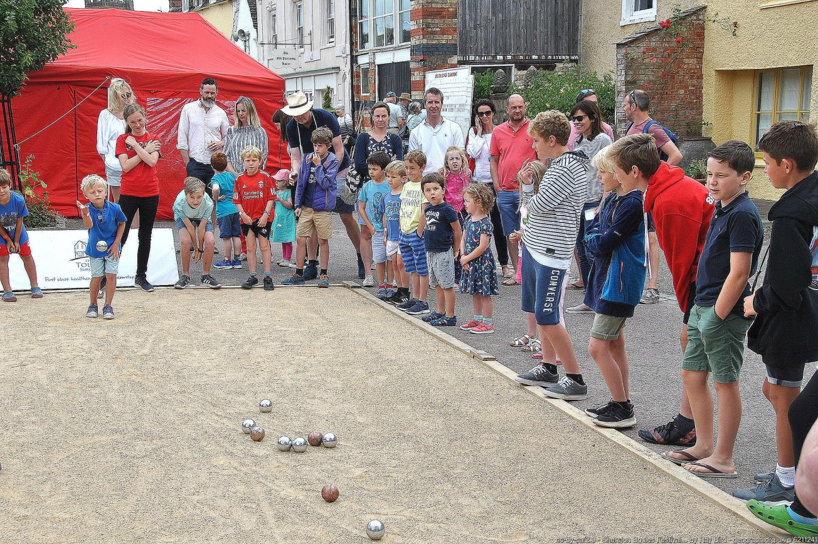
Free outdoor leisure

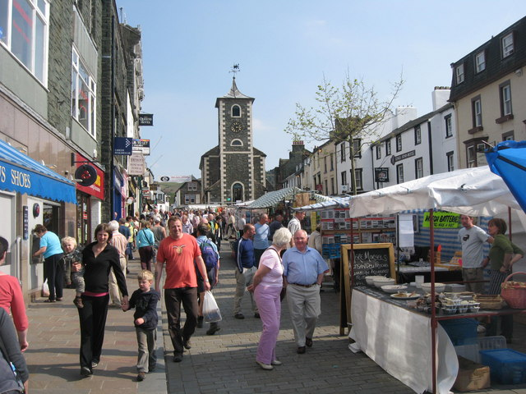
Markets – Image Source: Wikimedia commons - Paul Anderson / Market Day Keswick

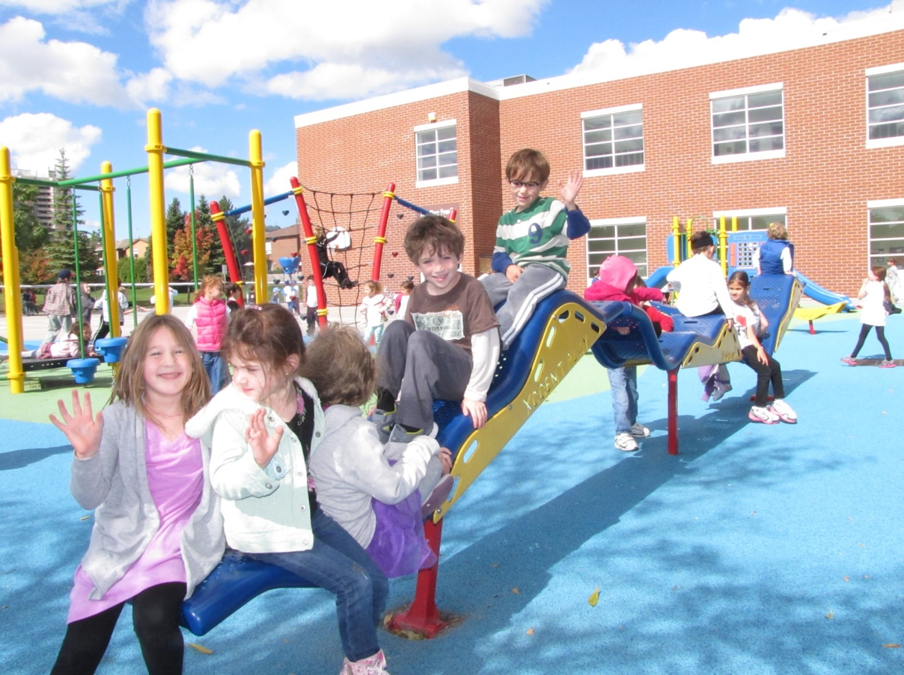
Children’s play space – Image Source: Jlbirman1 [CC BY-SA 3.0 (httpscreativecommons.orglicensesby-sa3.0)]

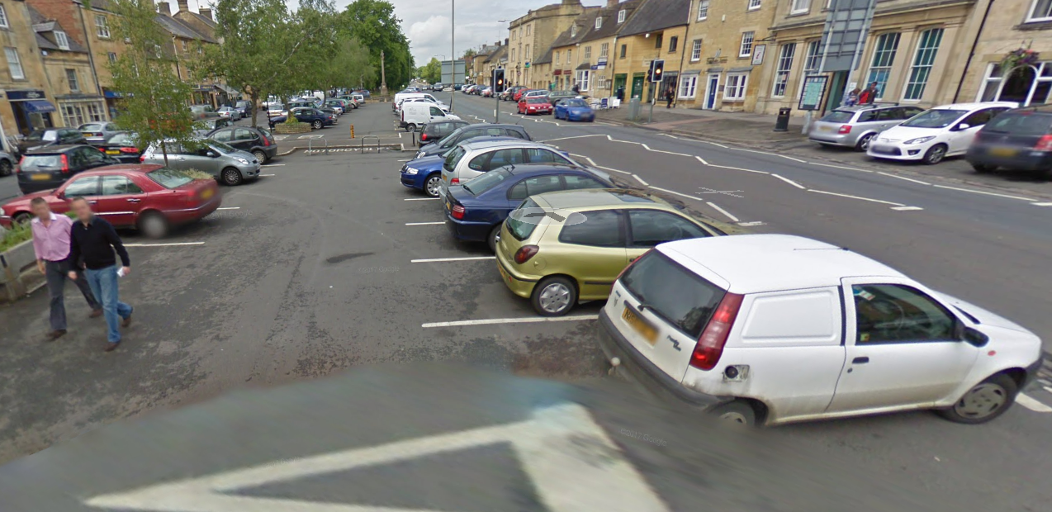
More parking – Image Source: google streetview


More shops – Image source: NoDerivs 2.0 Generic (CC BY-ND 2.0)
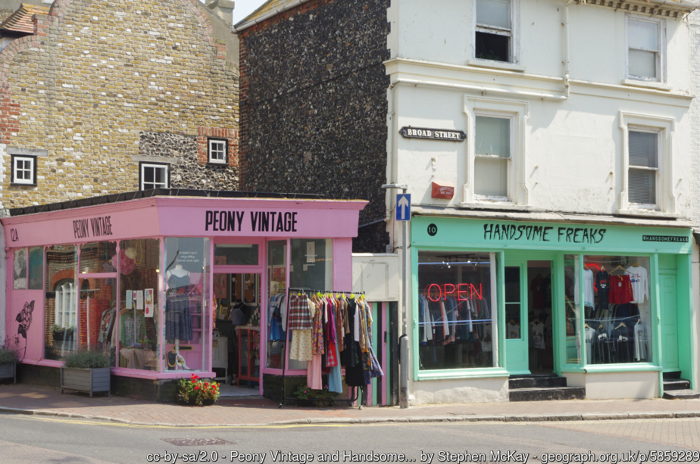
More independent shops

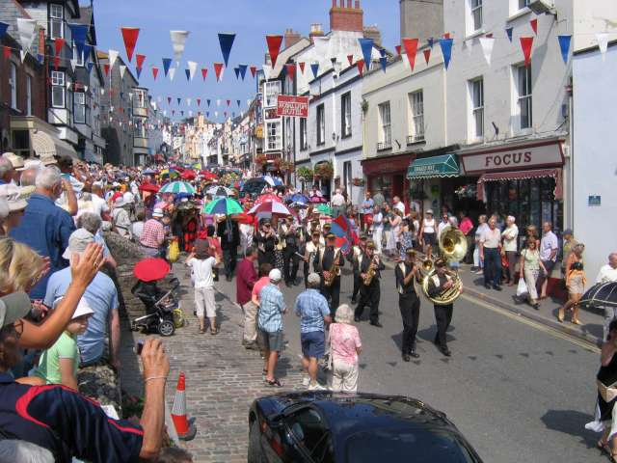
Cultural events and activities – music, street theatre – Image source - CC BY-SA 2.0 (httpscreativecommons.orglicensesby-sa2.0)

Wildlife, Biodiversity and Green Space

- Use 3 words to describe the natural environment in the area.

- What 3 things could be done to improve the quality of the natural environment for local residents?

- Should the neighbourhood plan do more to protect and enhance wildlife and biodiversity and habitat provision?

Very much so | Somewhat | Not at all | Comments

- The neighbourhood plan should map and record existing wildlife corridors (such as hedgerows, rivers, streams and railway lines) and require adjoining developments to maintain and enhance the connectivity of these corridors through their layout and landscaping.

Very much so | Somewhat | Not at all | Comments

- The neighbourhood plan should ensure that new developments incorporate habitat provision to achieve a net gain in wildlife and biodiversity, for instance through including bat and swift boxes, wildlife ponds, native species in landscaping which are of benefit to UK species.

Very much so | Somewhat | Not at all | Comments

- Are there any green spaces that are important to you that should be protected from development?

- Should the neighbourhood plan allocate land for the provision of allotments for local food growing?
Very much so | Somewhat | Not at all | Comments

Good Jobs and a Thriving Economy
- How is the balance between housing and employment provision?

Well balanced – a good balance of jobs to houses | Relatively well balanced – slightly too much housing for the employment available | Poorly balanced – not enough employment for the number of residents / too much housing | No opinion

- Are there a wide enough range of jobs available in the area? If not what types of jobs do we need?

Yes | No | No opinion

- Please indicate the actions the neighbourhood plan should take to encourage a sustainable local economy and the type of economic development that is needed? E.g. Retail, Light Industrial, Offices.

Please read the following statements and indicate the strength of your agreement by placing a cross in the relevant box. Comments explaining your response are welcome.

- The neighbourhood plan should allocate additional land or sites for employment uses.

Strongly agree | Agree | Disagree | Strongly disagree | Comments

- The neighbourhood plan should promote the use of upper floors in the town centre for employment uses.

Strongly agree | Agree | Disagree | Strongly disagree | Comments
- Future housing developments should include space for home working.

Strongly agree | Agree | Disagree | Strongly disagree | Comments

- The neighbourhood plan should develop policies or initiatives to enable residents to work locally, for instance the development of a work-hub, offering facilities for small-scale businesses and start-ups: bookable ‘hot’ desks, high speed broadband and meeting spaces.

Strongly agree | Agree | Disagree | Strongly disagree | Comments

- Do you run your own business or work from home?

Yes | No

- What would make you work from home more often? OR Would you want to work from home more if you could? What three things could help you?

Affordable Housing that is fit for the future.
Housing type / housing need
- What type of housing is needed most in the area?
 | This is needed the most | This is needed the second most | This is neutral | This is overprovided
Large family homes 4 + beds

Small family homes – 2 – 3 beds

Flats / apartments

Rented Housing

Sheltered housing (over 60's)

Self-build – where bare plots are provided enabling residents to design and build their own houses

Co-housing - co-housing is where a group of houses share a joint facility, eg, communal garden, communal laundry.
Community land trust – community led housing run by ordinary people, providing local affordable housing in perpetuity
Other

Please provide further comments if you wish:

Please read the following statements and indicate the strength of your agreement by placing a cross in the relevant box. Comments explaining your response are welcome.
- The Neighbourhood Plan should allocate additional sites for housing (above and beyond the housing sites identified by your council) to meet local needs?
Strongly agree | Agree | Disagree | Strongly disagree | Comments
Please provide further comments if you wish:

- Are there enough affordable homes in the area?

- Are the new affordable homes in the right place, i.e. within the new developments?
- What other types of affordable housing should be considered?

Feedback on the suggested questions and how they could be improved or amended would be welcomed: neighbourhoodplanning@cse.org.uk. All images are used under creative commons licence and are fully attributed.
For more detailed advice, contact Dan or Graham at the Centre for Sustainable Energy using the details below. Subject to capacity, we can help with:
- Helping you plan and deliver your initial consultation events and surveys to build support for sustainability measures.
- Helping you identify relevant sustainability and climate issues in your area.
- Supporting you to developing and draft planning policies.
- Reviewing your draft neighbourhood plan.
- Supporting the delivery of public events and workshops.
- Research for developing an evidence base.

We will tailor the support we offer depending on the resources we have available, what is needed and the progress your neighbourhood plan has already made.

neighbourhoodplanning@cse.org.uk
0117 934 1400
www.cse.org.uk
St James Court, St James Parade, Bristol BS1 3LH

