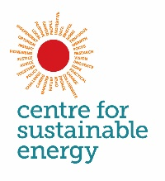

Energy “managers” interview topic guide

Intro / recruitment  (3-5 mins) | [Initial invite to participate]  Good MORNING / AFTERNOON / EVENING, I’m NAME from Centre for Sustainable Energy, an independent charity in Bristol.  The Centre for Sustainable Energy an energy and sustainability charity based in Bristol.  Would you be able to talk about your views and experience looking after the buildings and equipment in your building and any wider energy management issues? The interview will take about 45-50 minutes.  [If agree to proceed, continue to next section].  [If prefer call back, arrange time and check contact details]  [If want to think about it, offer to send an email with information about survey]
Start of interview  (1 min) | Thanks and introduction. Introduce yourself and CSE – independent charity that delivers practical projects and conducts research on energy issues.  Audio recording: Ask for permission to record. (explain this is to accurately capture their views and so we can listen back and analyse the data)
Warm up  Introductions  (2 mins) | - Can you just briefly describe where you work and what your role involves?
Energy management  (5 mins) | - How is energy use managed at your building?  By “managed” we mean who:  - decides system settings (e.g. timing of heating, set point temperatures),  - decides investment in new energy efficient heating or cooling or other technology,  - decides any energy policies,  - monitors bills and energy consumption,  - if and how to use feedback to staff/ pupils / managers on energy consumption  Prompt for:  - Organisational structures – e.g. role of facilities and site managers, contractors  - Use of energy management software  - Use of BEMs and monitoring systems  - how the energy is procured – via a supplier, broker; and directly by the building or by a buildings group/council?
- Can you position your energy management on the following dimensions
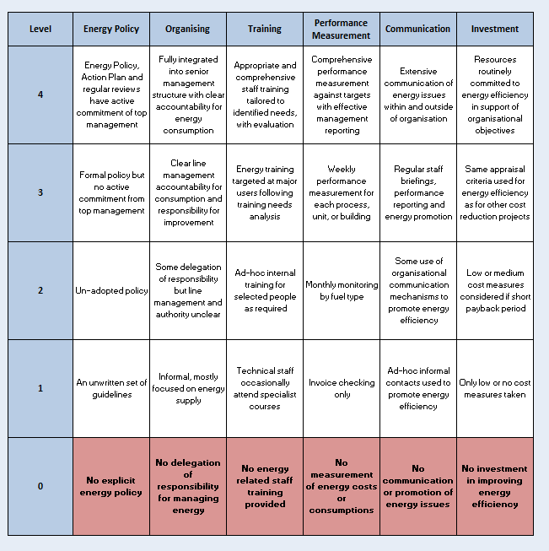

Choosing your energy supplier  (2 mins) | - How do you choose you energy supplier? Prompt for:  - Is the profile of your energy consumption through the day ever a factor in choosing which tariff you or your broker go for?
Use of energy information  (5 mins) | - Is energy consumption monitored?  If yes – how? Who?  If no – what are reasons?  - Prompt for different types of monitoring serving different purposes  - monitoring bills versus detailed monitoring of end uses  - real time versus historical monitoring  - using energy data to make comparisons  - What kind of energy information would help you do your job? (e.g. data showing consumption every half hour of the day, or information showing which parts of the building were using a lot of energy)  - Is this kind of information already available through the Building Management Systems or monitoring systems?  - Any thoughts on how that information could be presented in usable or friendly way? (website/portal/dedicated screen in building/via BMS system)  - Do you currently get notifications and alerts about high energy usage?  e.g. the energy bill arrives and is much higher than usual and someone is asked (by the business manager) to investigate?  Probe for:  - how would you like to receive alerts and notifications? What is the best way to send alerts if energy usage much higher than normal – email, text, via web portal?  - Would it be useful to have alerts in real time about very high (or very low) energy use?  - Imagine a dedicated energy screen in reception showing real-time energy usage which aimed at engaging the staff in the energy usage of the building.  - Would that affect your job?  - What if displayed total cost of energy usage on a counter or compared the buildings energy consumption with others buildings?
Influences of building users on energy consumption  (5 mins) | - To what extent are the building users able to control or influence the energy use of the building?  - What can they change (temp set points? Radiator valves, leave windows doors open etc.)  - Would it be better if they had more / less influence
Changes to building energy use  (5 mins) | - Do you have any plans to reduce energy consumption, shift tariff or use more renewable energy?  - Is energy management a priority?  - What is the process for making any changes to the way the building uses energy – e.g. if you wanted to propose a re-lamp?  - Are you expected to gather evidence to make the case for energy efficiency activities?
Engaging building users in behaviour change  (5 mins) | - Have you ever tried to shift behaviour to be more energy efficient? (E.g. using awareness campaigns etc.). If yes,  - What worked?  - What didn’t  - Do you think it is possible to shift energy consumption around during the building day? E.g. Can you ask staff to run pottery kilns or to do large print runs outside the hours of 4-7pm?
Capability  (5 mins) | - Do building users have the skills and knowledge to make the building run more energy efficiently?  E.g. do people know ow to change the settings on air conditioning units and that a setting of cooling to 19 degrees is considered too low?  Do energy managers know how to change heating systems settings? Probe for:  - Energy managers’ skills (training etc.)  - Building users knowledge
Opportunity – physical and social  (5 mins) | - Does the way the building is built and equipped and the way that heating and appliances are controlled allow users to behave more energy efficiently? E.g. do users have access to heating controls on radiators?  - Does the “culture” of the building encourage energy managers and users to take energy savings acts? Probe for:  - Whether there is any peer pressure for energy saving  - Whether there is any energy policy which sets expectations about how energy should be used (by building occupants) and managed in the building
Motivations  (5 mins) | - Are energy managers and users motivated to make the building more energy efficient? E.g. Does using the building heating systems and equipment efficiently align with people’s values and wishes? Prompt for:  - What is the root of any motivations? – e.g. environmental values, values related to not wasting things ? etc.  - Are some groups in the building more motivated than others?  - Which groups feel more personally responsible for acting on energy issues (if any)
Main barriers  (2 mins) | - What are main barriers to your building operating more efficiently and/or make savings?
Main opportunities  (2 mins) | - What are main opportunities for your building to operate more efficiently/and or make savings?
Closing up and thank you  (1 min) | - Is there anything else you would like to add?
 | Many thanks for your time.

